How Many Ways to Win at Tic-Tac-Toe?
*Credit to Peter Liljedahl

Problem:

There are 8 ways to win a traditional Tic-Tac-Toe game. 3 Horizontal Lines, 3 Vertical Lines and 2 Horizontal Lines.

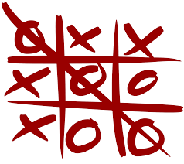

What if it was a three dimensional game board? How many ways would there be to win?

Extension:
What if it wasn’t a 3 by 3 by 3 board? What if it was a 4 by 4 by 4 board? An n by n by n sized board?

The Painted Cube

Problem:

Picture a Rubik’s Cube. Now drop it into paint so that it is completely covered. When the paint is dry, imagine smashing it on the floor and it breaking it apart into the smaller cubes.
How many of the cubes have one face covered in paint? How many cubes have two faces covered in paint? How many have three faces covered in paint? How many have zero faces covered in paint?

How could you predict the above for any size Rubik’s cube?

What about a 4 x 4 x 4? 5 x 5 x 5? 6 x 6 x 6? N x N x N?
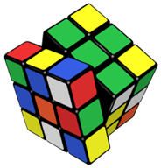

Extension:

What if it wasn’t a cube?

Open Lockers

Problem:
Imagine that you are in a school that has a row of 100 closed lockers. Suppose a student goes along and opens every locker. Then a second student goes along and shuts every second locker. Now a third student changes the state of every third locker (if the locker is open the student closes it, and if the locker is closed, the student opens it). A fourth student changes the state of every fourth locker. This continues until 100 students have followed this pattern with the lockers.
When finished, which lockers are open? How do you know? Why are these lockers still open?

Extension:
Can you determine the list of open lockers all the way to 1000?

Checkerboard

Problem:

How many squares are there on a standard 8x8 checkerboard? The answer is not 64!

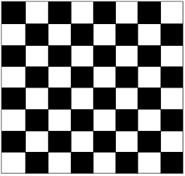

Extension:
If the checkerboard was a different size, could you find a solution?
If the checkerboard was NxN (any size), could you find an algebraic expression?
What if you had to could the squares that are positioned diagonally?

