Teaching Through Problems Worth Solving

-Grade 3 (Version 1.0)-

Inquiry-based, Curriculum-linked, Differentiated Math Problems for Grade 3
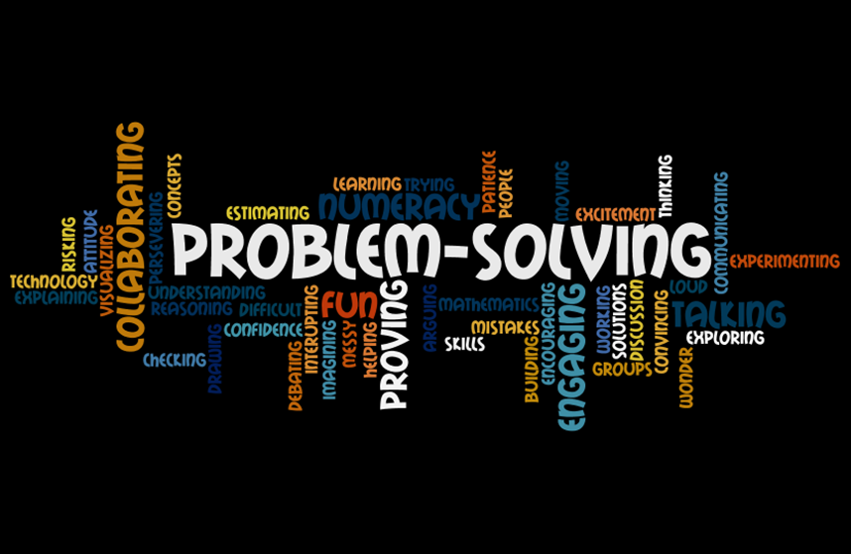
Alicia Burdess
Katelyn Redl
Brian Andrews
Krystal Zhang
Kayla Mutch
Kirsten Manz

With thanks to the ATA Educational Trust for their financial support.
A 21st Century Learning Promise: I promise to do all I can to keep the spark of
curiosity, creativity, and learning alive in every child; to help all children discover
their talents, develop their passions, deepen their understanding, and apply
all this to helping others, and to creating a better world for us all.
-author unknown
Link to Thinking Classroom Problems
Link to Curricular Problems

The inspiration for this compilation of problems has come from many sources. Thank you to:
Peter Liljedahl, David Pimm, Nathalie Sinclair, and Rina Zazkis
Grande Prairie Master of Education Cohort, Simon Fraser University, 2012-2014
James Tanton, Professional Development and Resources
Geri Lorway, Junior High and Elementary Cohorts, NRLC, Thinking 101
Jessie Shirley and Grande Prairie Catholic School Division
Math Council of the Alberta Teachers’ Association
National Council of Teachers of Mathematics

Please go to www.aliciaburdess.com for a free digital copy and updated versions!
Read This First

This resource is the result of 2 year-long collaborative project to identify and compile problems that align with the grade 3 curriculum outlined by the Alberta Mathematics Program of Studies (2007). It is an initial attempt to answer our essential question, “How can teaching through problem solving engage every student and drive learning forward?”

This resource is not meant as a bank of worksheets to be given arbitrarily to students. Rather, it is designed to be a journey through problem solving for the entire math classroom. Problems worth solving take time. Some problems may take only one block, others will take longer. Use your professional judgment to choose your problems, guide your teaching, and facilitate student learning. The focus is meant to be on the experience of the problem solving process - the thinking, the connections, and the understanding. Sample solutions are provided as a single example of many possible problem solving strategies. Our intent is for you the teacher to be deeply involved in the problem solving process with your students and hopefully with your colleagues. Take risks, make mistakes, and don’t worry as much about the destination as about the journey. Complement these problems with mini-lessons, games, and projects to teach the Grade 3 Program of Studies.

This is our first draft. Some outcomes have more problems linked to them than others. This project is ongoing; it will continue to be tested with students and improved.

A Problem Solving Classroom
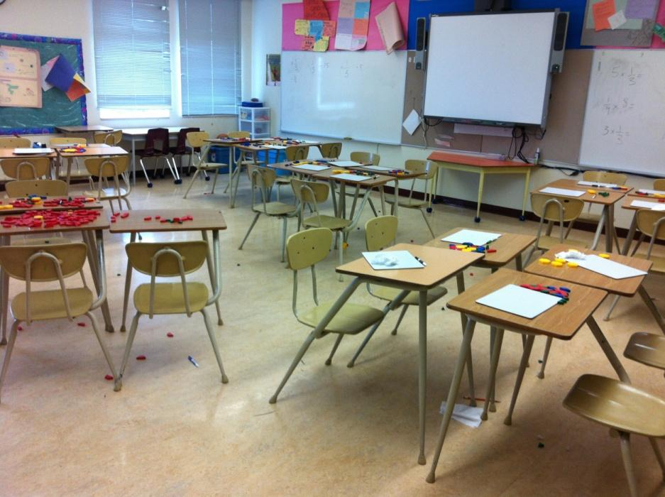
“Problem solving is a powerful teaching tool that fosters multiple, creative and innovative solutions. Creating an environment where students openly look for, and engage in, finding a variety of strategies for solving problems empowers students to explore alternatives and develops confident, cognitive mathematical risk takers. Learning through problem solving should be the focus of mathematics at all grade levels. When students encounter new situations and respond to questions of the type How would you …? or How could you …?, the problem-solving approach is being modeled. Students develop their own problem-solving strategies by listening to, discussing and trying different strategies” (Alberta Mathematics Program of Studies, 2007).

Teaching through problem solving is about inviting students to think about mathematics, to take risks, and to persevere. Collaboration is the key component of problem solving. Students need to be working together, sharing strategies, and learning from one another. The role of the teacher is to inspire, facilitate, and regulate. No telling, no showing, no giving answers. Your job is to motivate, question, and direct attention to big ideas!

Problem solving is our focus and problem solving is our lesson. This collection includes low- floor, high-ceiling problems with multiple entry points enabling all students to access and experience success with the problems. In our experience, teaching through problem solving levels the playing field. Students will struggle; this struggle will help them deepen their understanding and expand their skills. Problem solving gives the chance for all learners to be creative, think outside the box, and have a voice.
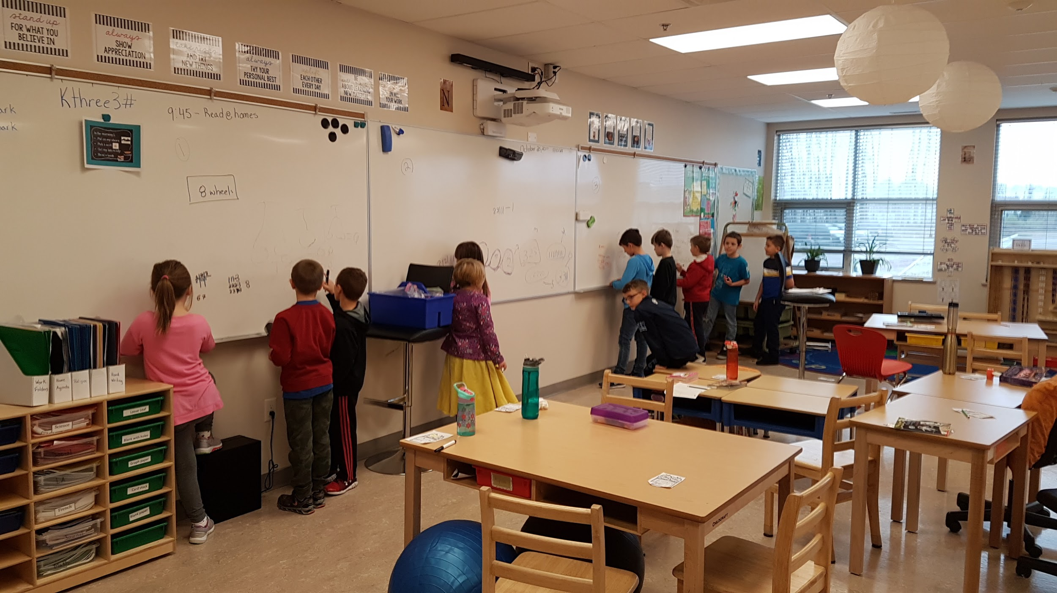
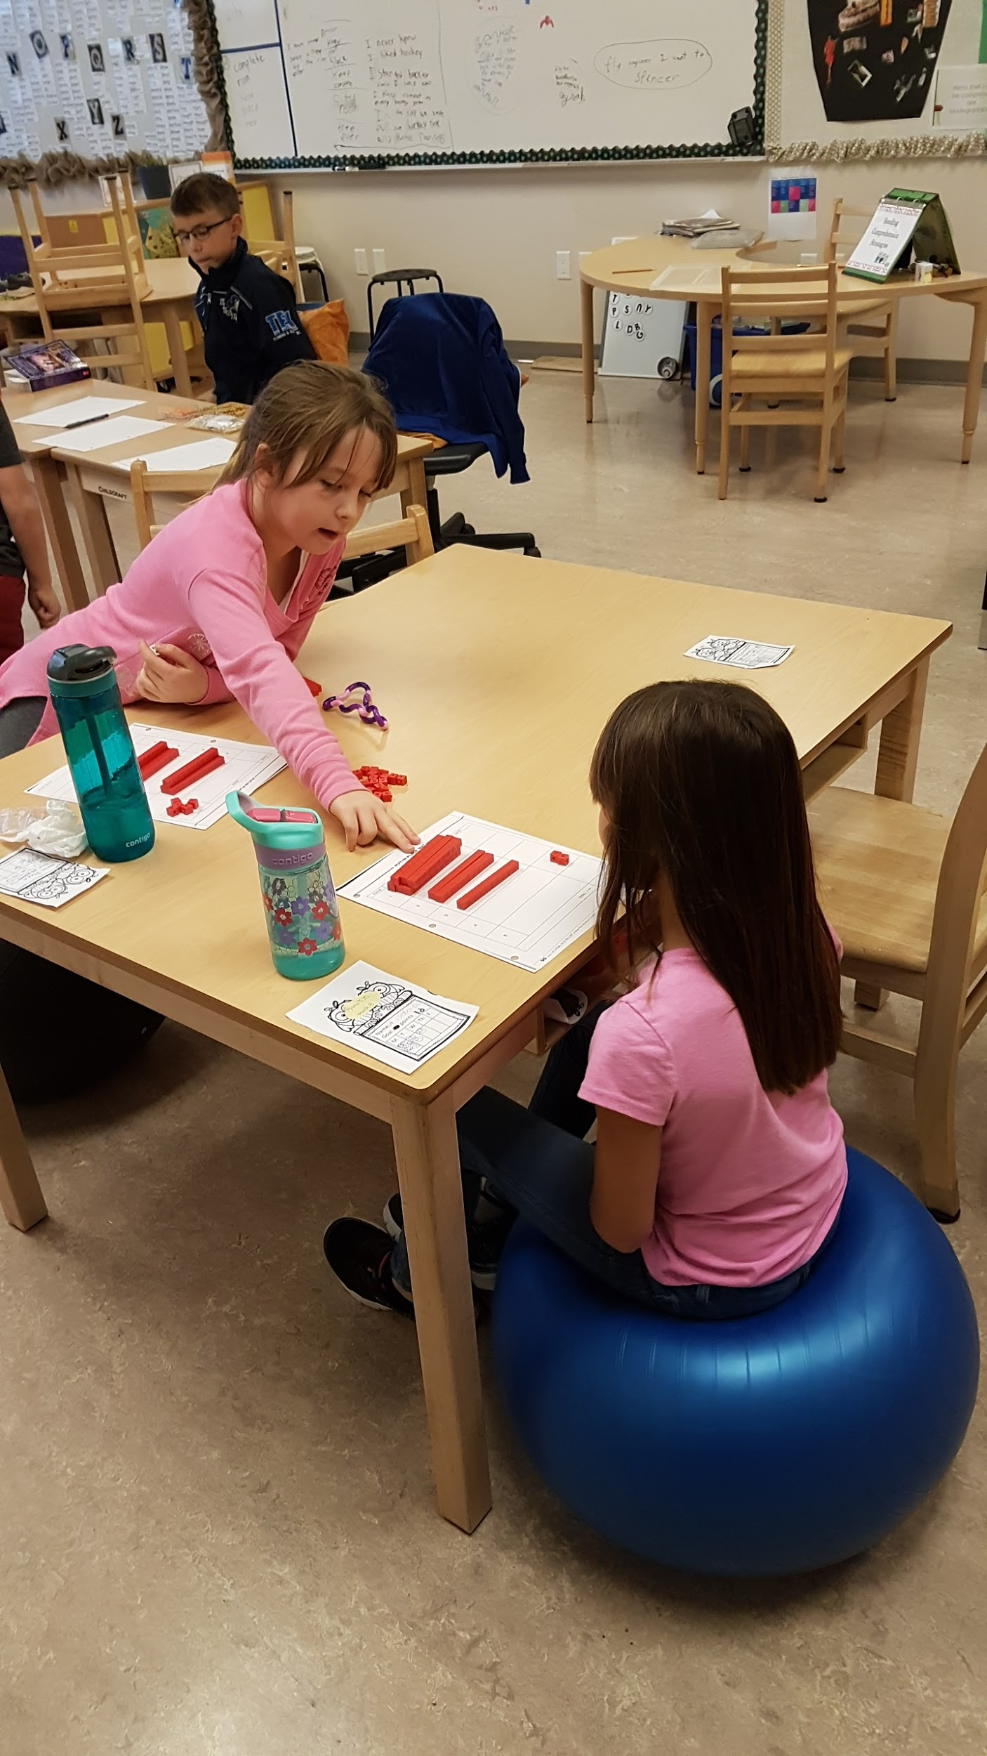
“Coming to know something is not a spectator sport although numerous textbooks, especially in mathematics, and traditional modes of instruction may give that impression” (Brown and Walter, The Art of Problem Posing).
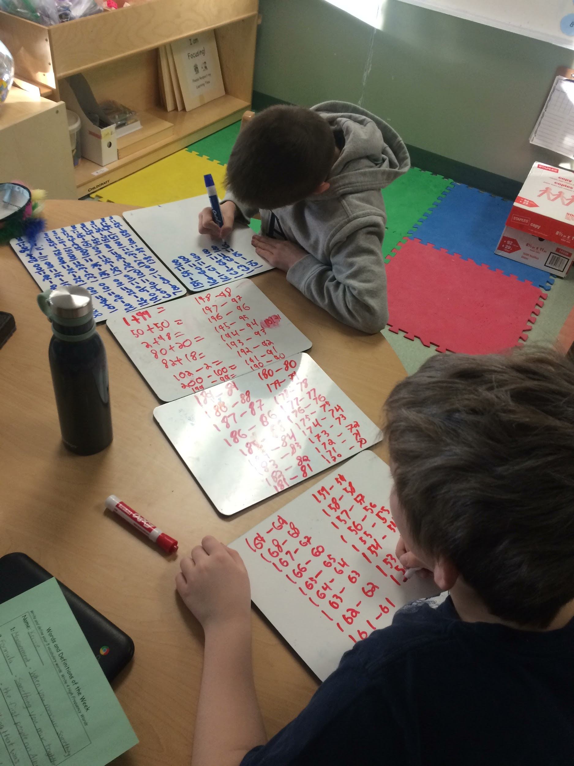
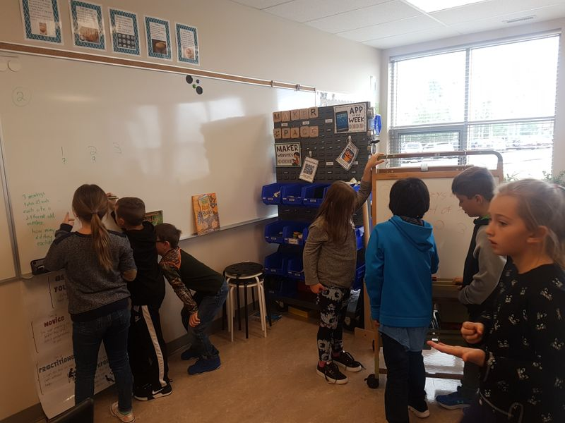
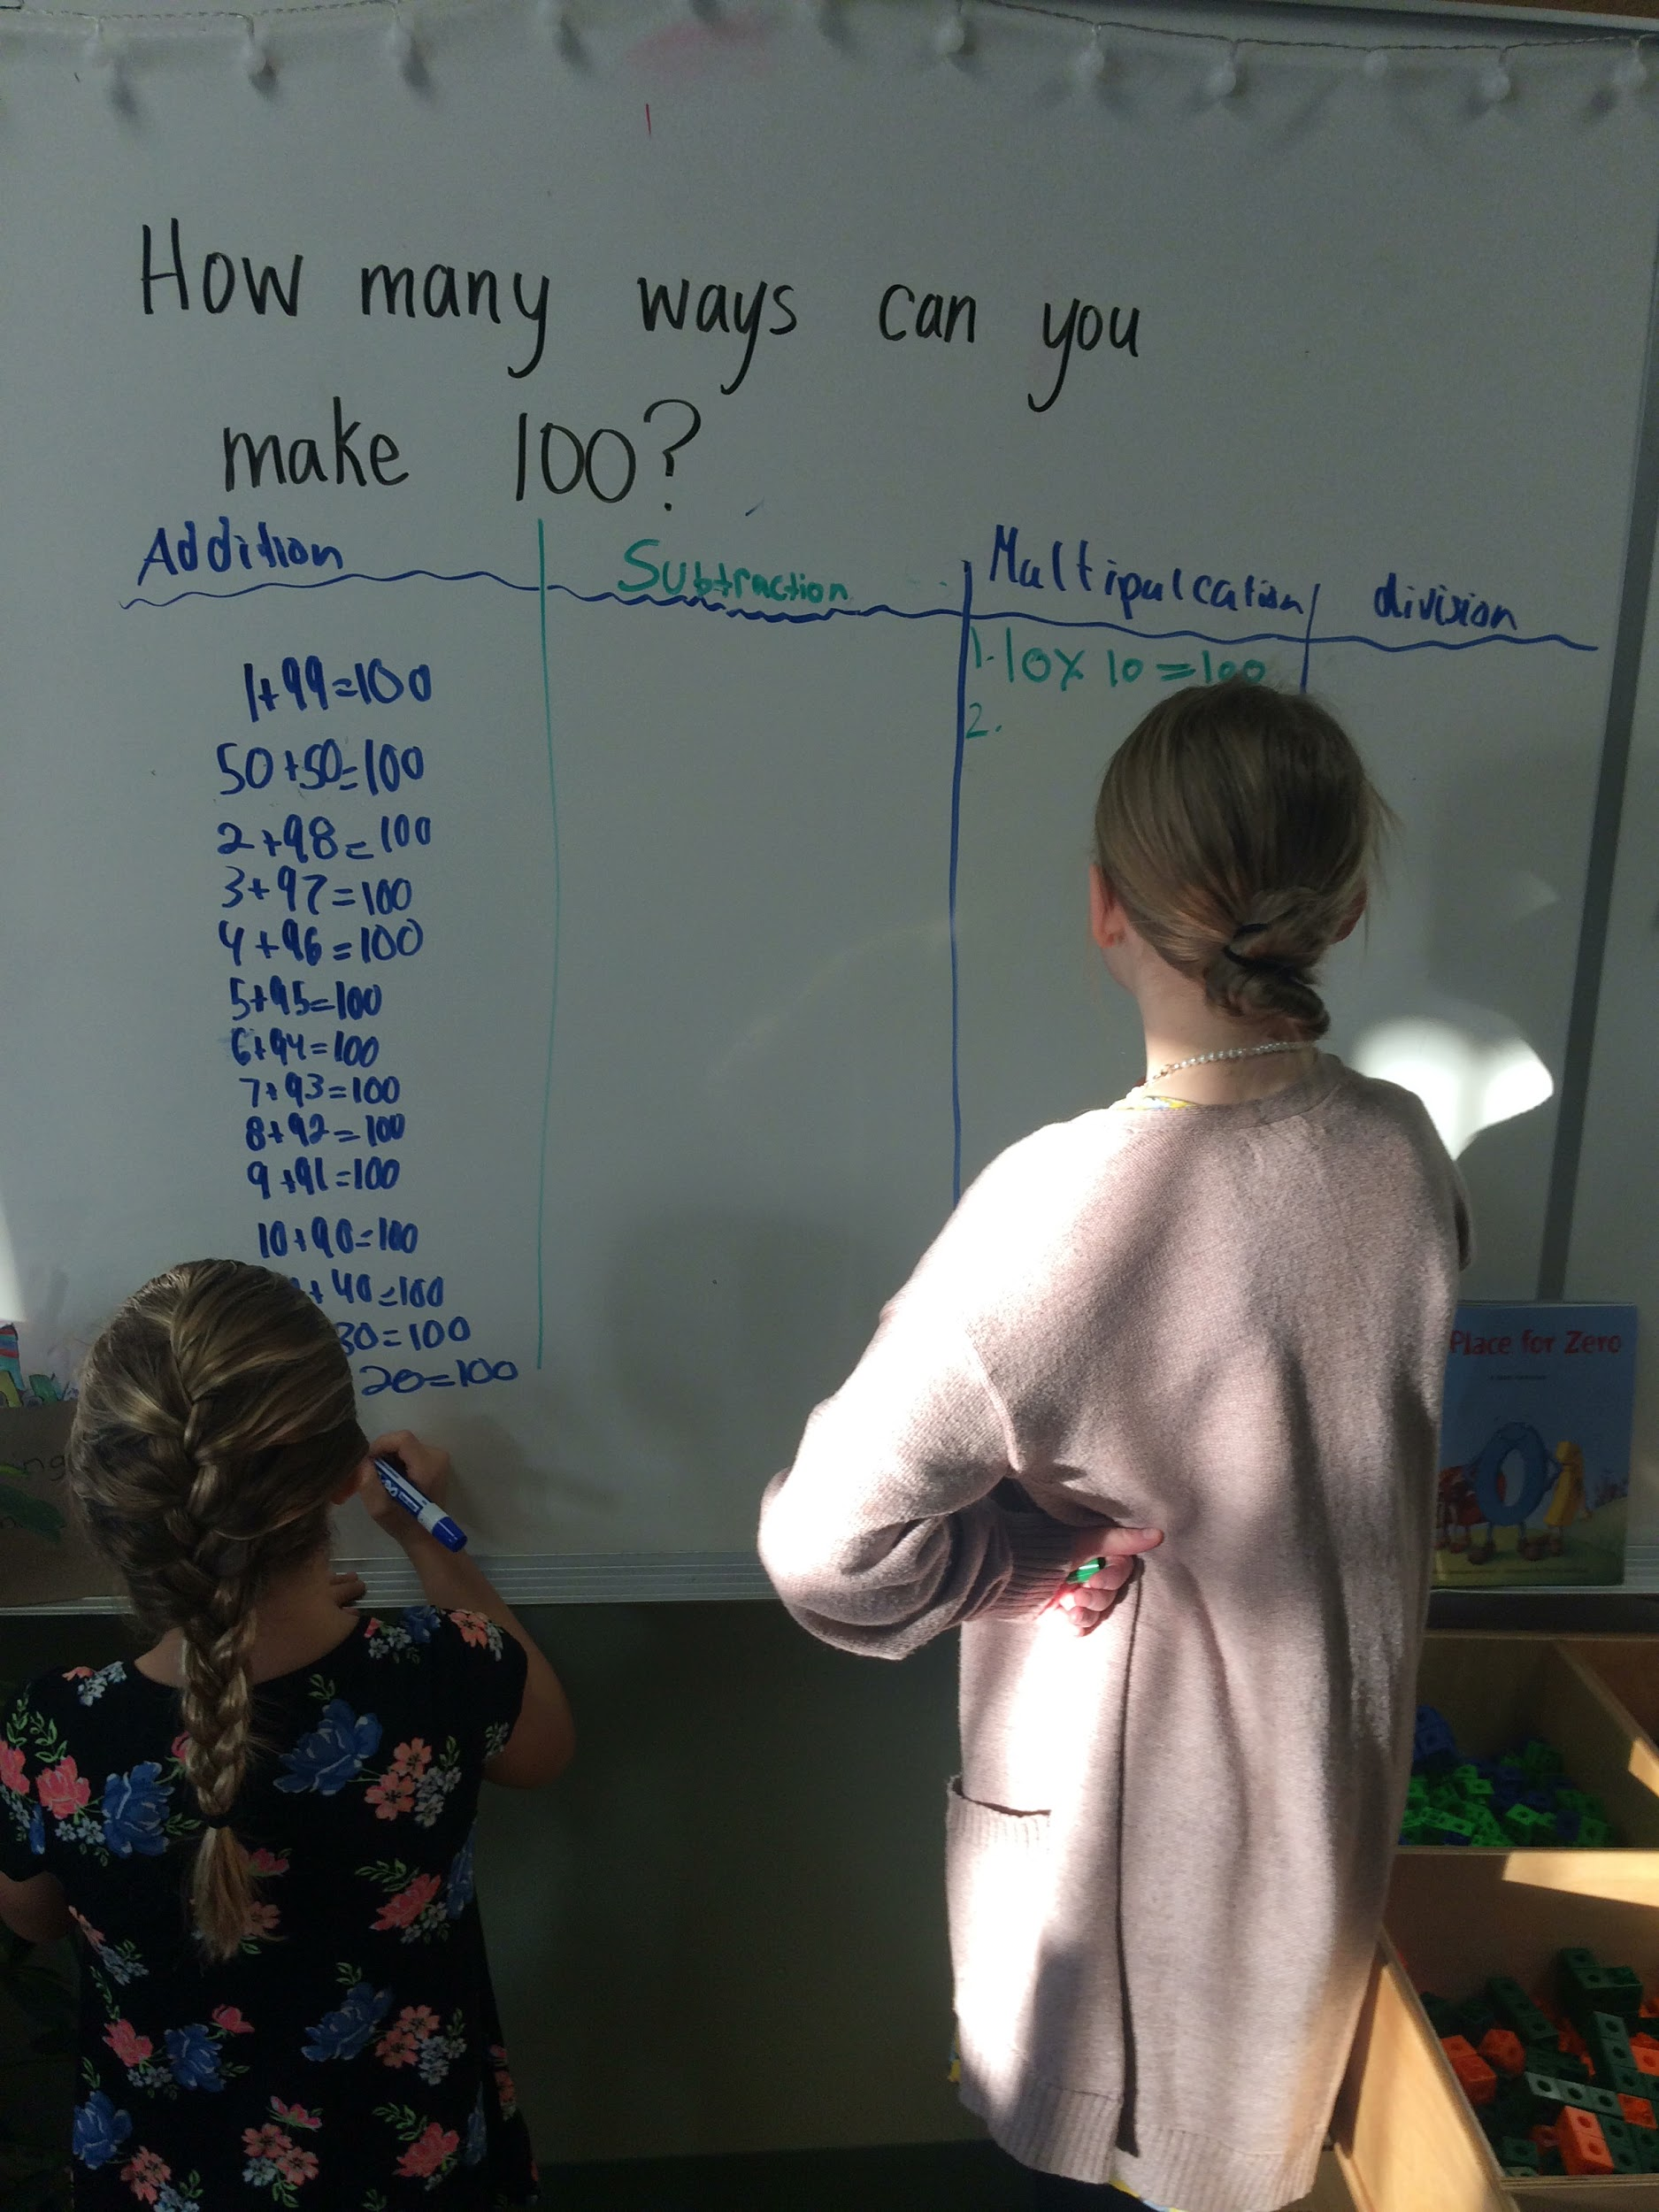
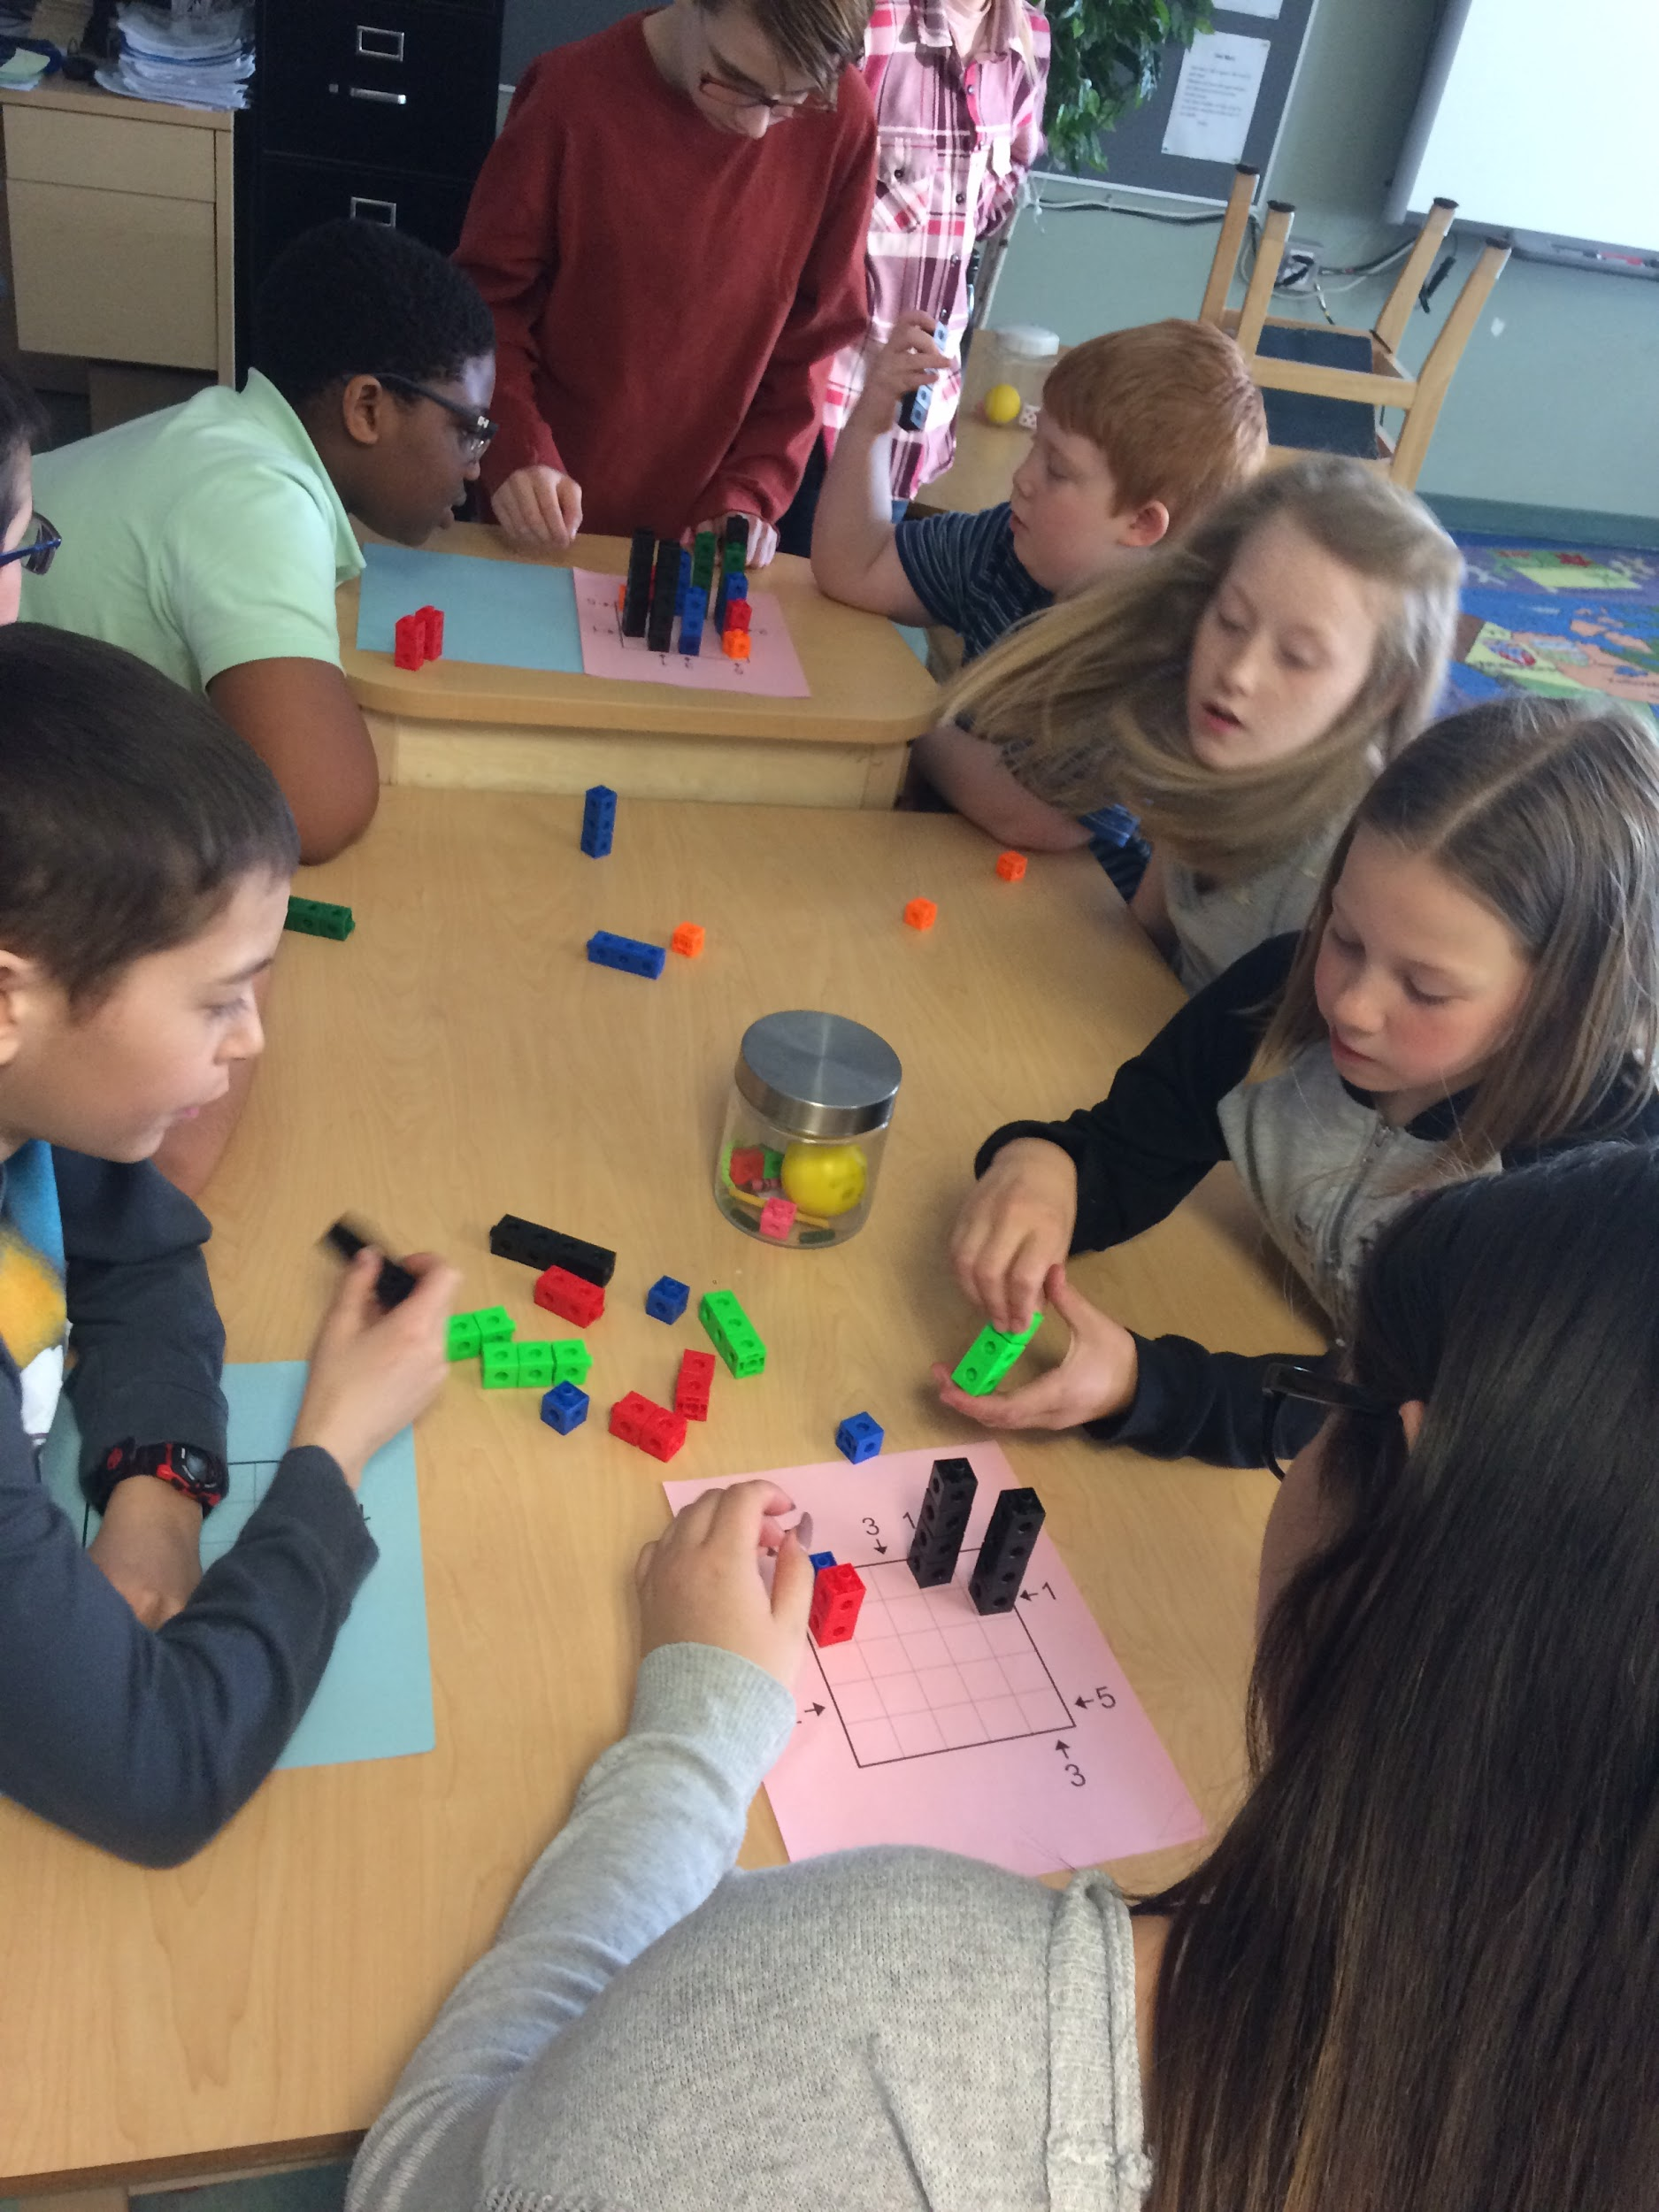

Snapshots of Problem Solving Classrooms
Getting Started With Students
Random Groups + Non-Permanent Pen + Vertical Surfaces + Group Work, Collaboration, Communication + Different Skills and Strategies = A Thinking Classroom

Students should work in random groups. This can be done using Popsicle sticks, a deck of cards, the random group generator on the Smart Board, etc. This will teach students how to work with everybody and anybody. This helps break down social barriers and nurtures a learning community in which students feel safe to take risks and make mistakes. This also helps prevent students from being labeled and grouped based on their “pre-conceived” mathematical abilities. If it is always random, it is always fair; the students know that the groups will always change and that they are expected to be able to work with everybody.
(For more information, please read THE AFFORDANCES OF USING VISIBLY RANDOM GROUPS IN A MATHEMATICS CLASSROOM by Peter Liljedahl, Simon Fraser University, Canada – In press)

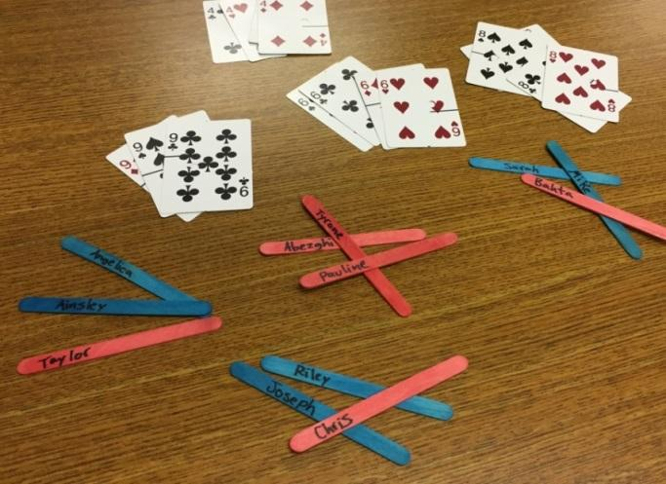

Students should work at vertical surfaces. This allows everyone to have access to the workspace. It also allows for the teacher to easily see how each group is working, and who needs some direction, motivation, or extra help. Vertical surfaces are easily accessible by teachers for formative assessment. By standing in the middle of the room, it is possible to see where everybody is at. It allows both students and teachers to see at-a-glance the problem solving process, identify misconceptions, direct questioning, redirect the students, motivate group work, plan for discussions, mini-lessons and future lessons. Students’ initial work should be on a non-permanent surface which encourages the risk-taking necessary for true problem solving. The non-permanence of the surface allows students to make mistakes without any long term consequences.
Whiteboards, windows, lockers, filing cabinets, shower curtains, shelf liner, writable paint, table and desktops, and interactive whiteboards are a few examples of non-permanent vertical surfaces. Be sure to check the surface to ensure that the dry erase marker comes off prior to students writing on it.

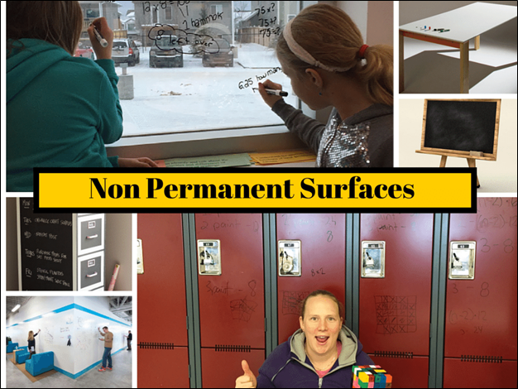

Students need to develop and practice group work, collaboration, and communication skills. They need to learn how to listen to each other, to share their ideas, to question, and to trust their abilities and the abilities of others. Different skills and strategies need to be embraced while helping each other to create a safe learning environment.

(For more information, please read BUILDING THINKING CLASSROOMS: CONDITIONS FOR PROBLEM SOLVING by Peter Liljedahl, Simon Fraser University, Canada – In press)
Suggestions for Teaching Through Problem Solving:

Group sizes depend on the teacher, the students, and the specific problem. We like 3 as a rule, but often have groups of 4 and occasionally students work in partners.

Students solve their problems in random groups at a vertical surface. There is only one pen per group and it must be shared. The person with the pen is not allowed to write down his or her ideas. Remind them not to hog the pen! This helps keep the groups working together.

Gallery Walks / Mobilization of knowledge: encourage the students to walk around the classroom to see other groups for ideas, to see different strategies, to get unstuck. This is also a great way to provide feedback instigate new discussions, and direct your teaching.

When you want to utilize a specific group’s work to discuss a strategy, some specific math, misconceptions, etc., first move all of the students to the center of the room, away from the work in order to remove ownership of it (alleviate fear, embarrassment, etc.). Then move students back to the work to discuss it.

Encourage students to work together to work through the problem and get an answer. Tell them to work with their answer to see if they can find a more elegant way, to use a different strategy, to explain their ideas, and to present their solution.

Use non-traditional assessments such as observations, checklists, posters, videos, photos of work, written solutions that tell the story of how the problem was solved, etc. This can be done individually or in partners or groups. This allows students to show their problem solving process, to explain their thinking, and to showcase their understanding. Students can “present” their solutions as a group, in partners, or individually depending on what the teacher is assessing or needs to see.

Remember that problem solving takes practice. The more “traditional” learners may struggle to communicate and collaborate. It may take practice listening to other people’s ideas and strategies. It can be frustrating working in groups and some students may find it difficult to explain their ideas. Many students lack confidence in math as well as in problem solving. Students need to be taught how to think, how to collaborate, how to communicate, how to problem solve, and how to persevere.
What is a Problem Worth Solving?

A problem worth solving is accessible to all students. It has multiple entry points, has a low floor, wide walls, and a high ceiling. These problems lend themselves to natural differentiation where all students are able to address the problem at their level and experience success. A problem worth solving allows the use of multiple strategies and varying facets of mathematics.

“A problem-solving activity must ask students to determine a way to get from what is known to what is sought. If students have already been given ways to solve the problem, it is not a problem, but practice. A true problem requires students to use prior learnings in new ways and contexts. Problem solving requires and builds depth of conceptual understanding and student engagement”.
(Alberta Mathematics Program of Studies, 2007).

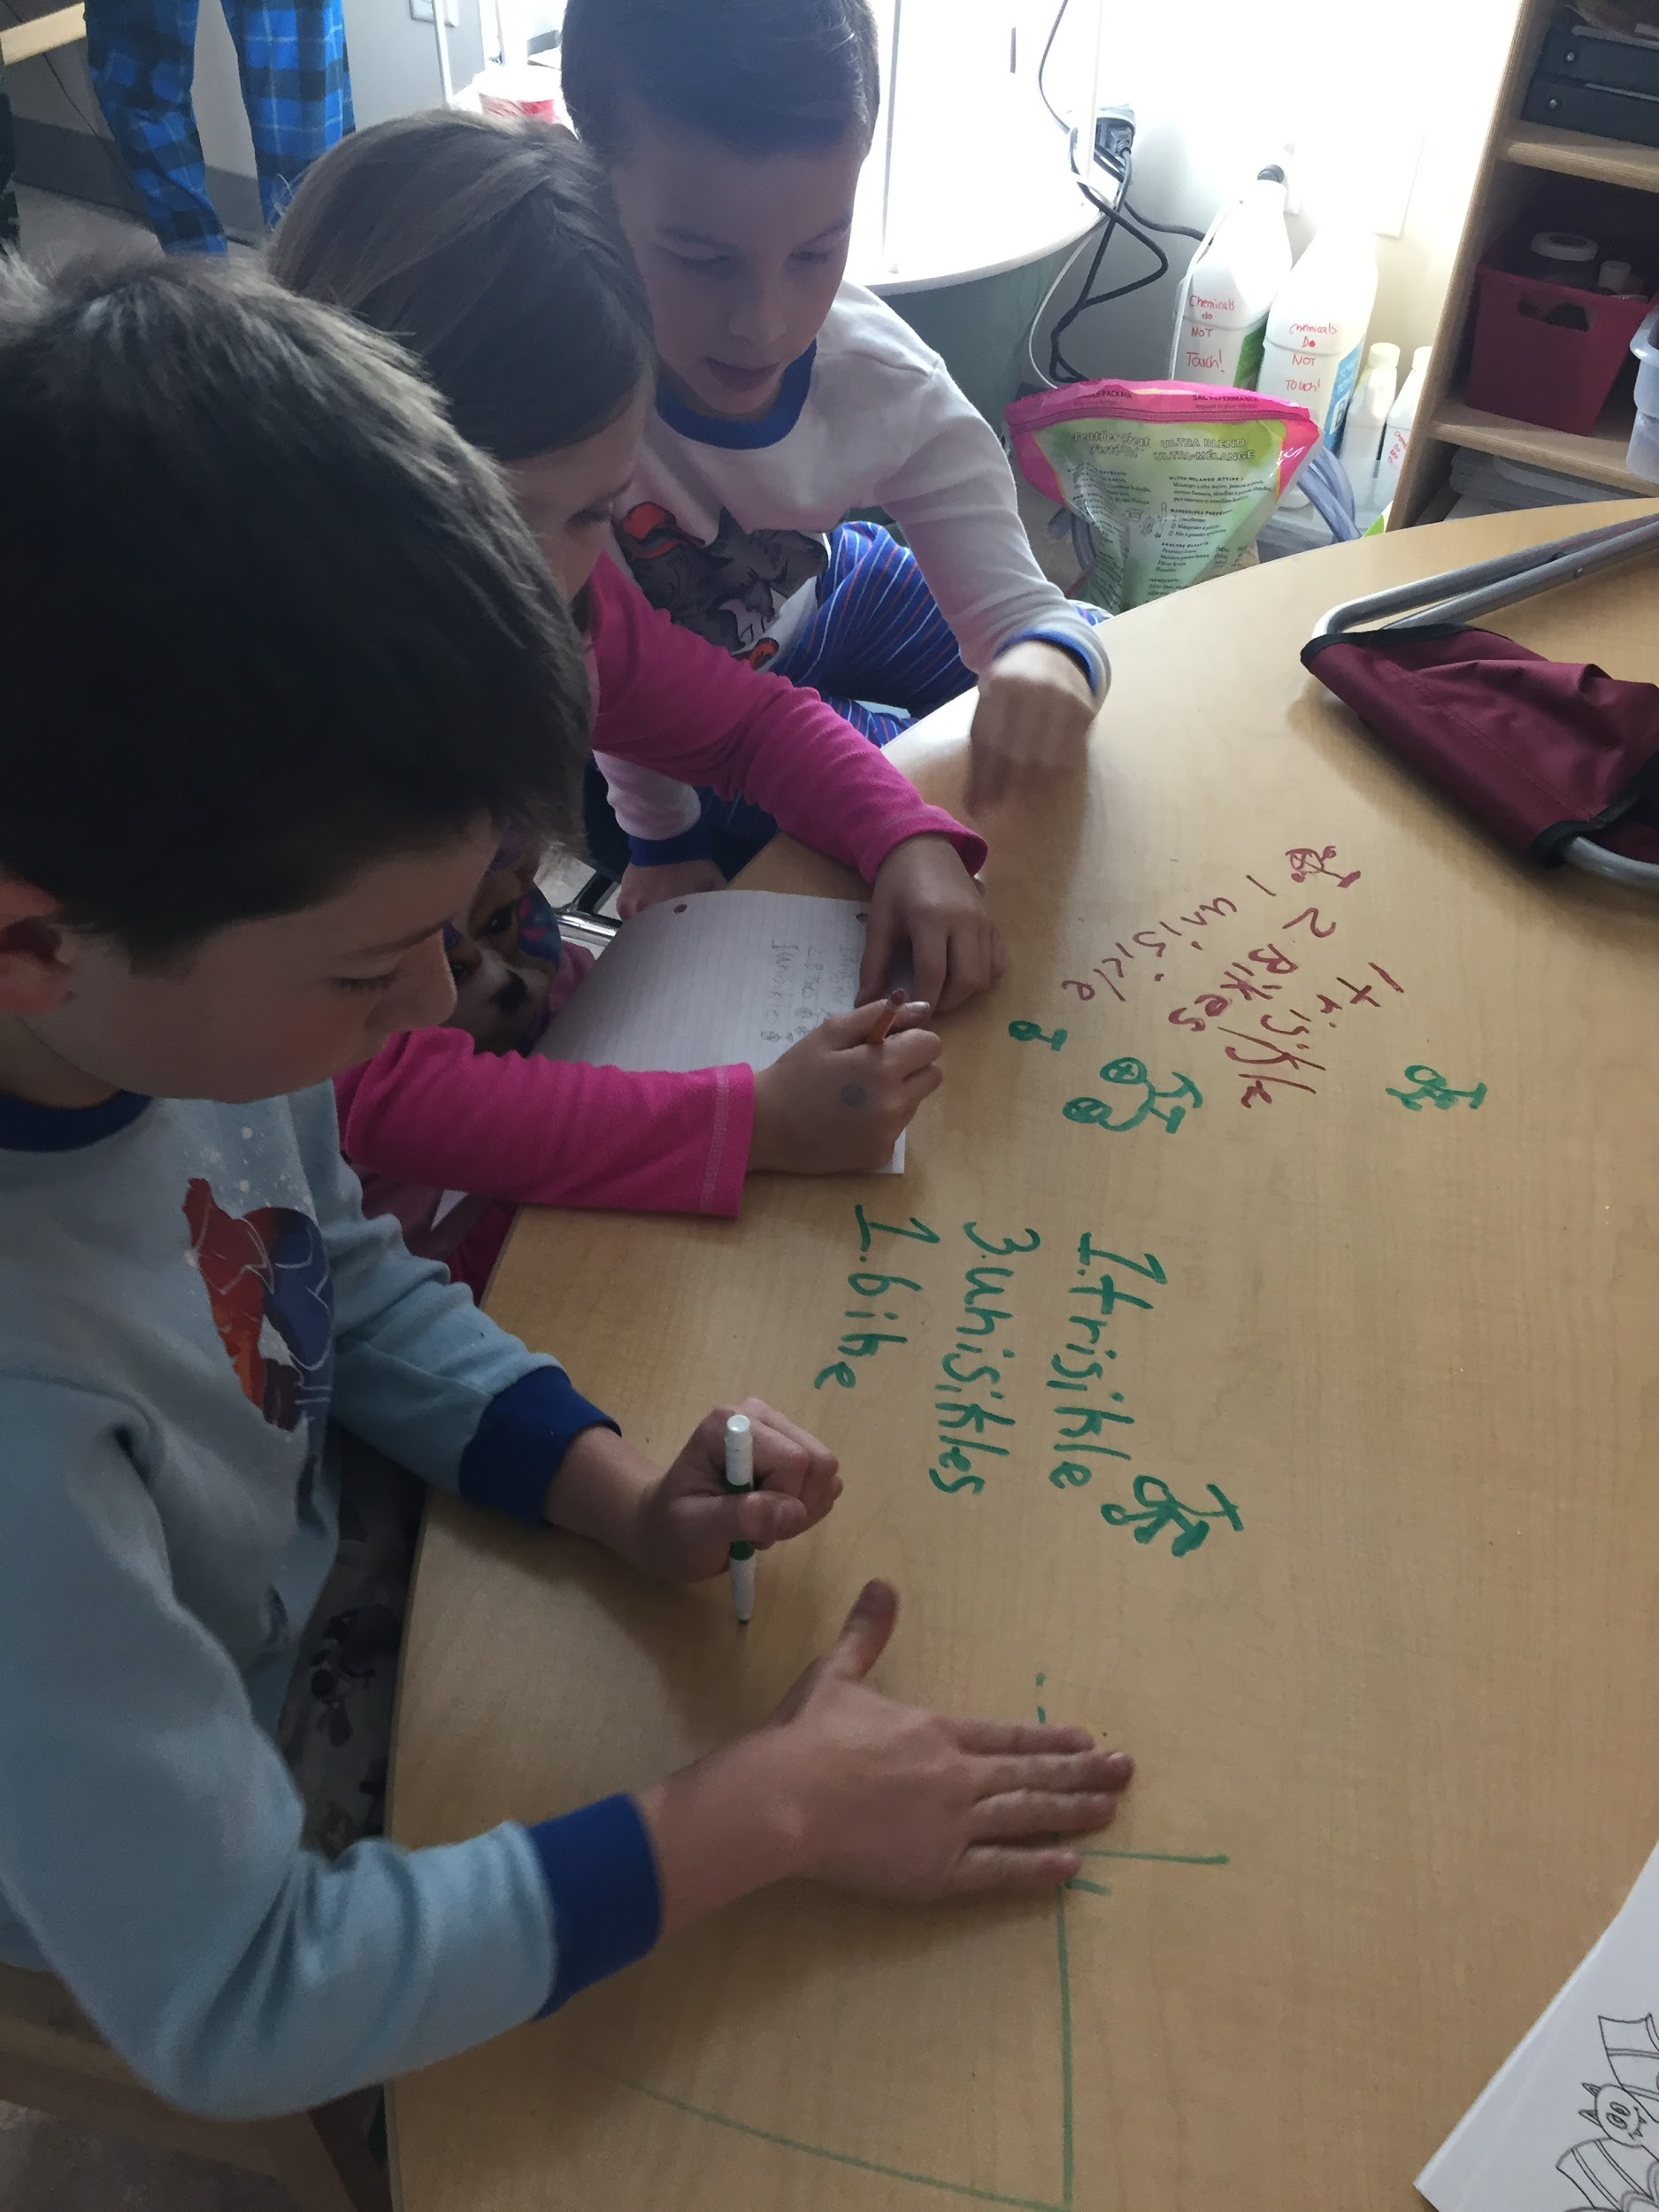
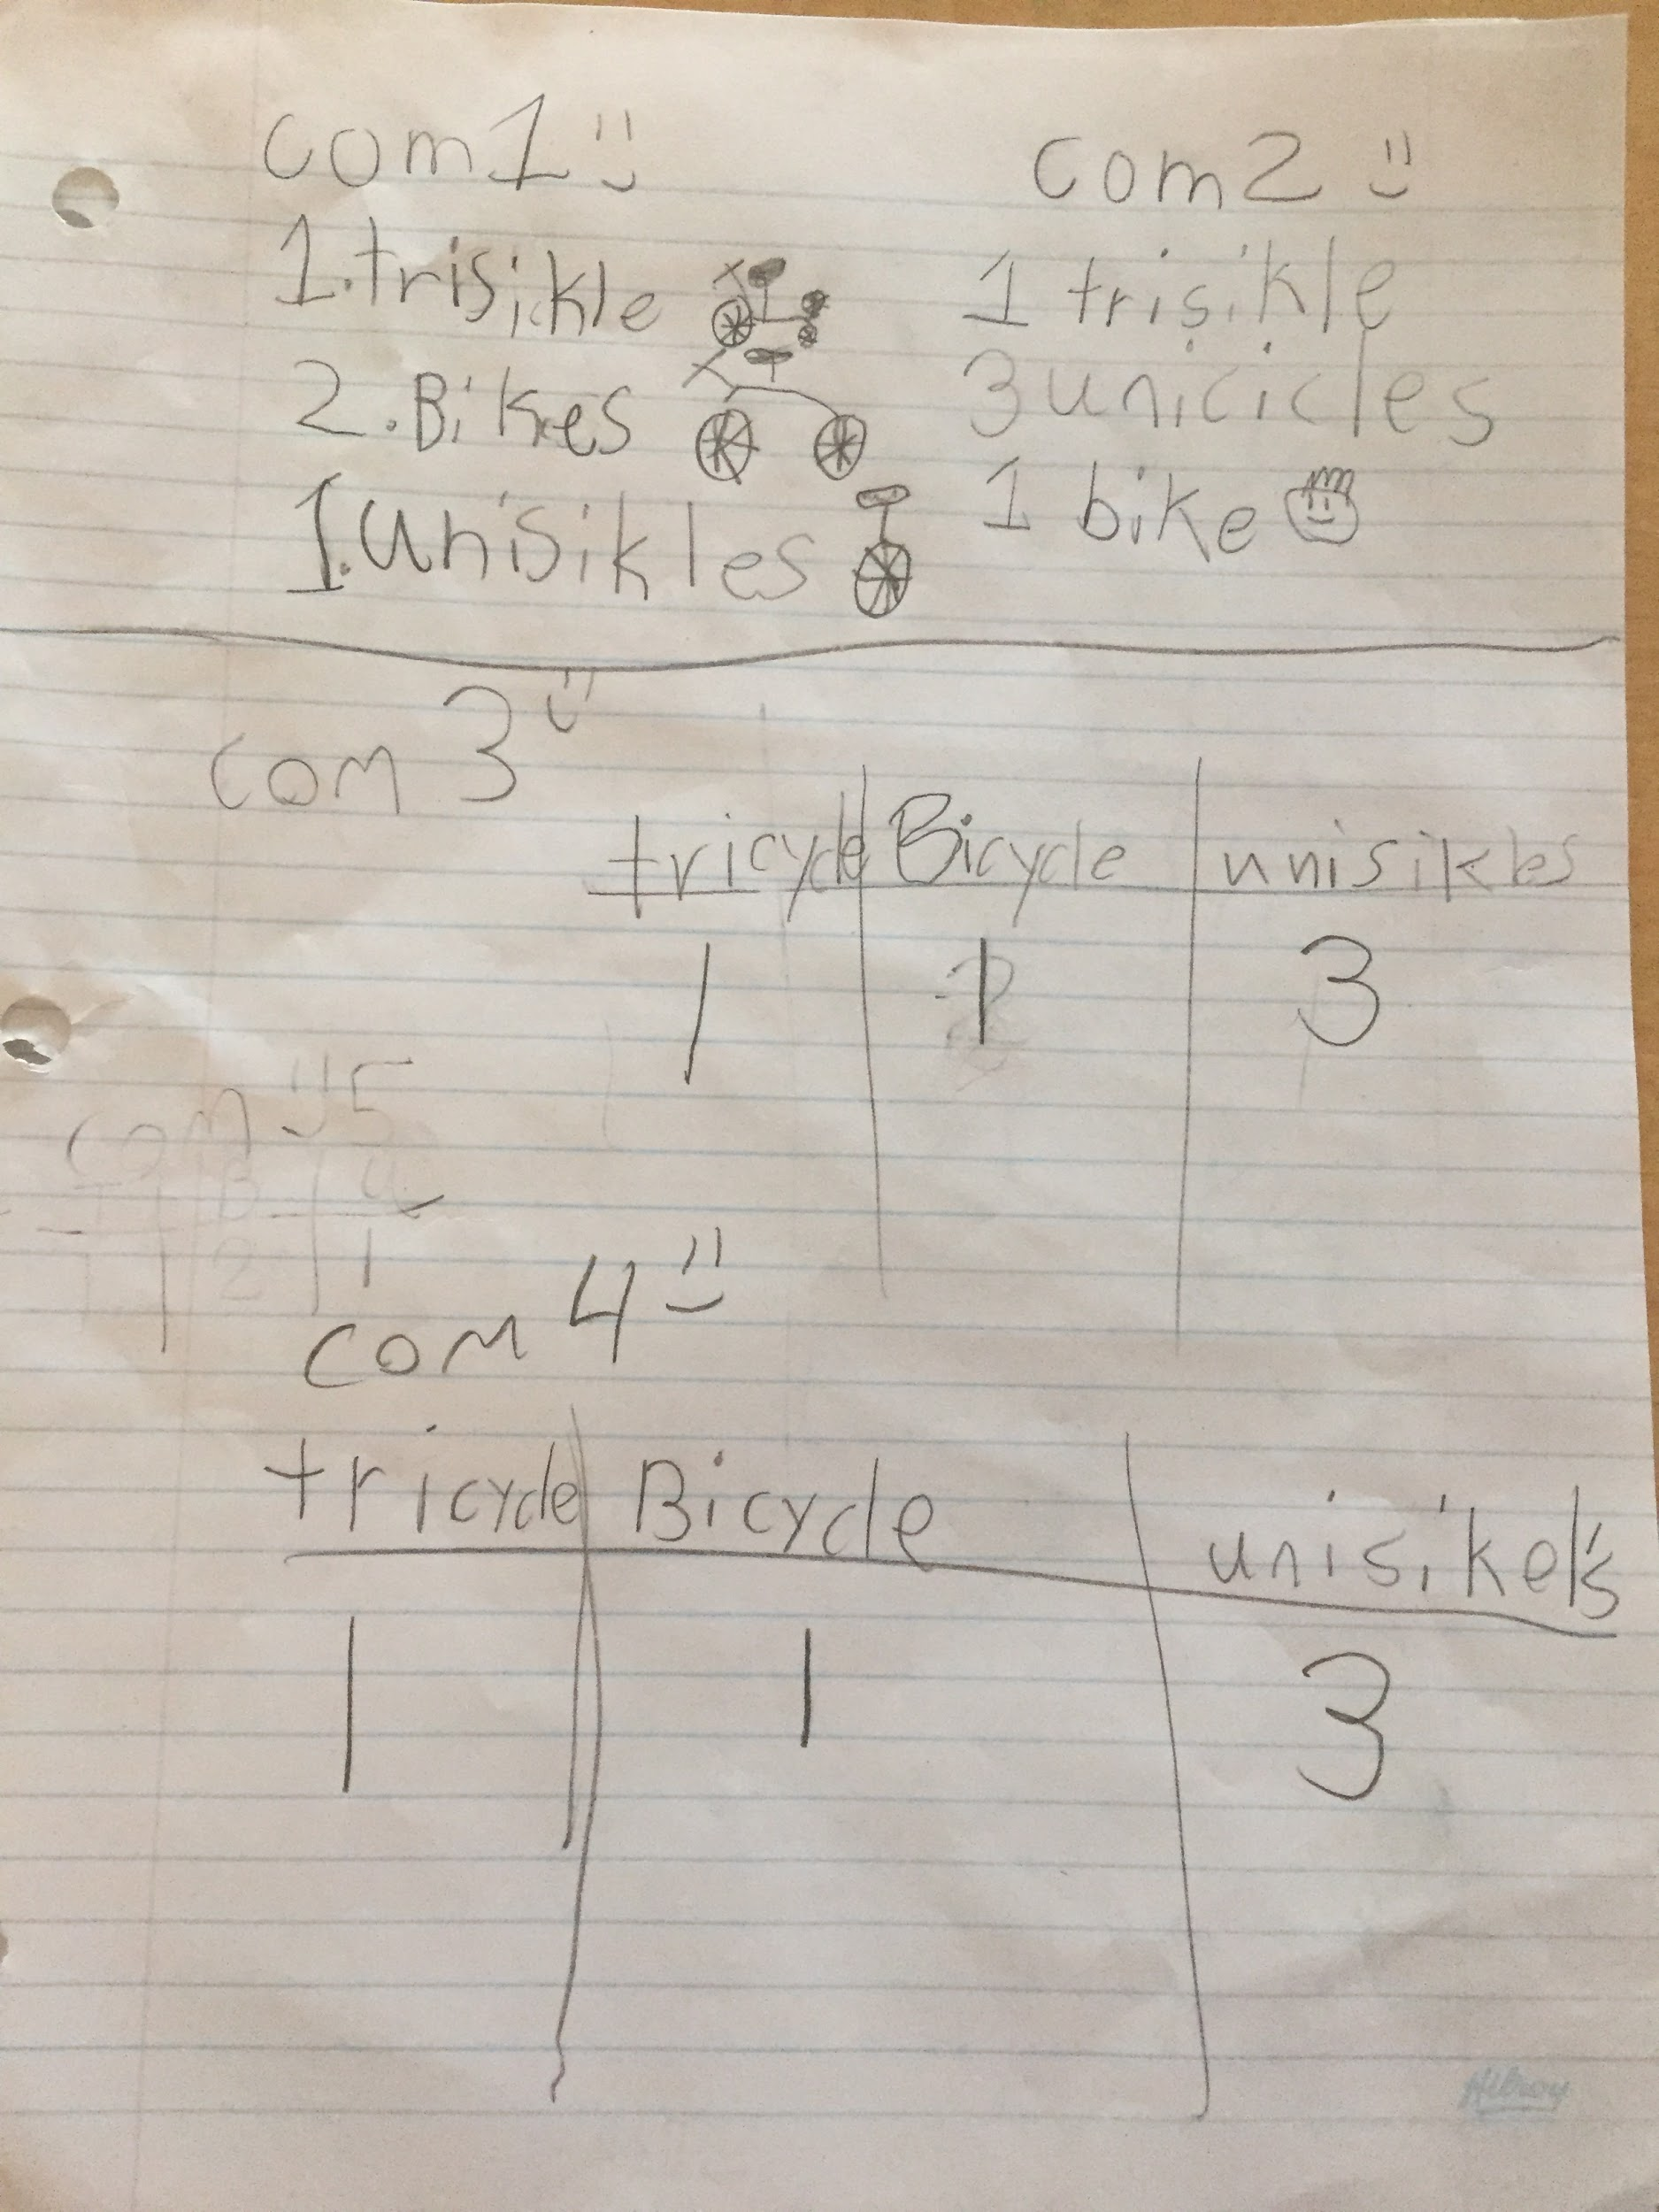
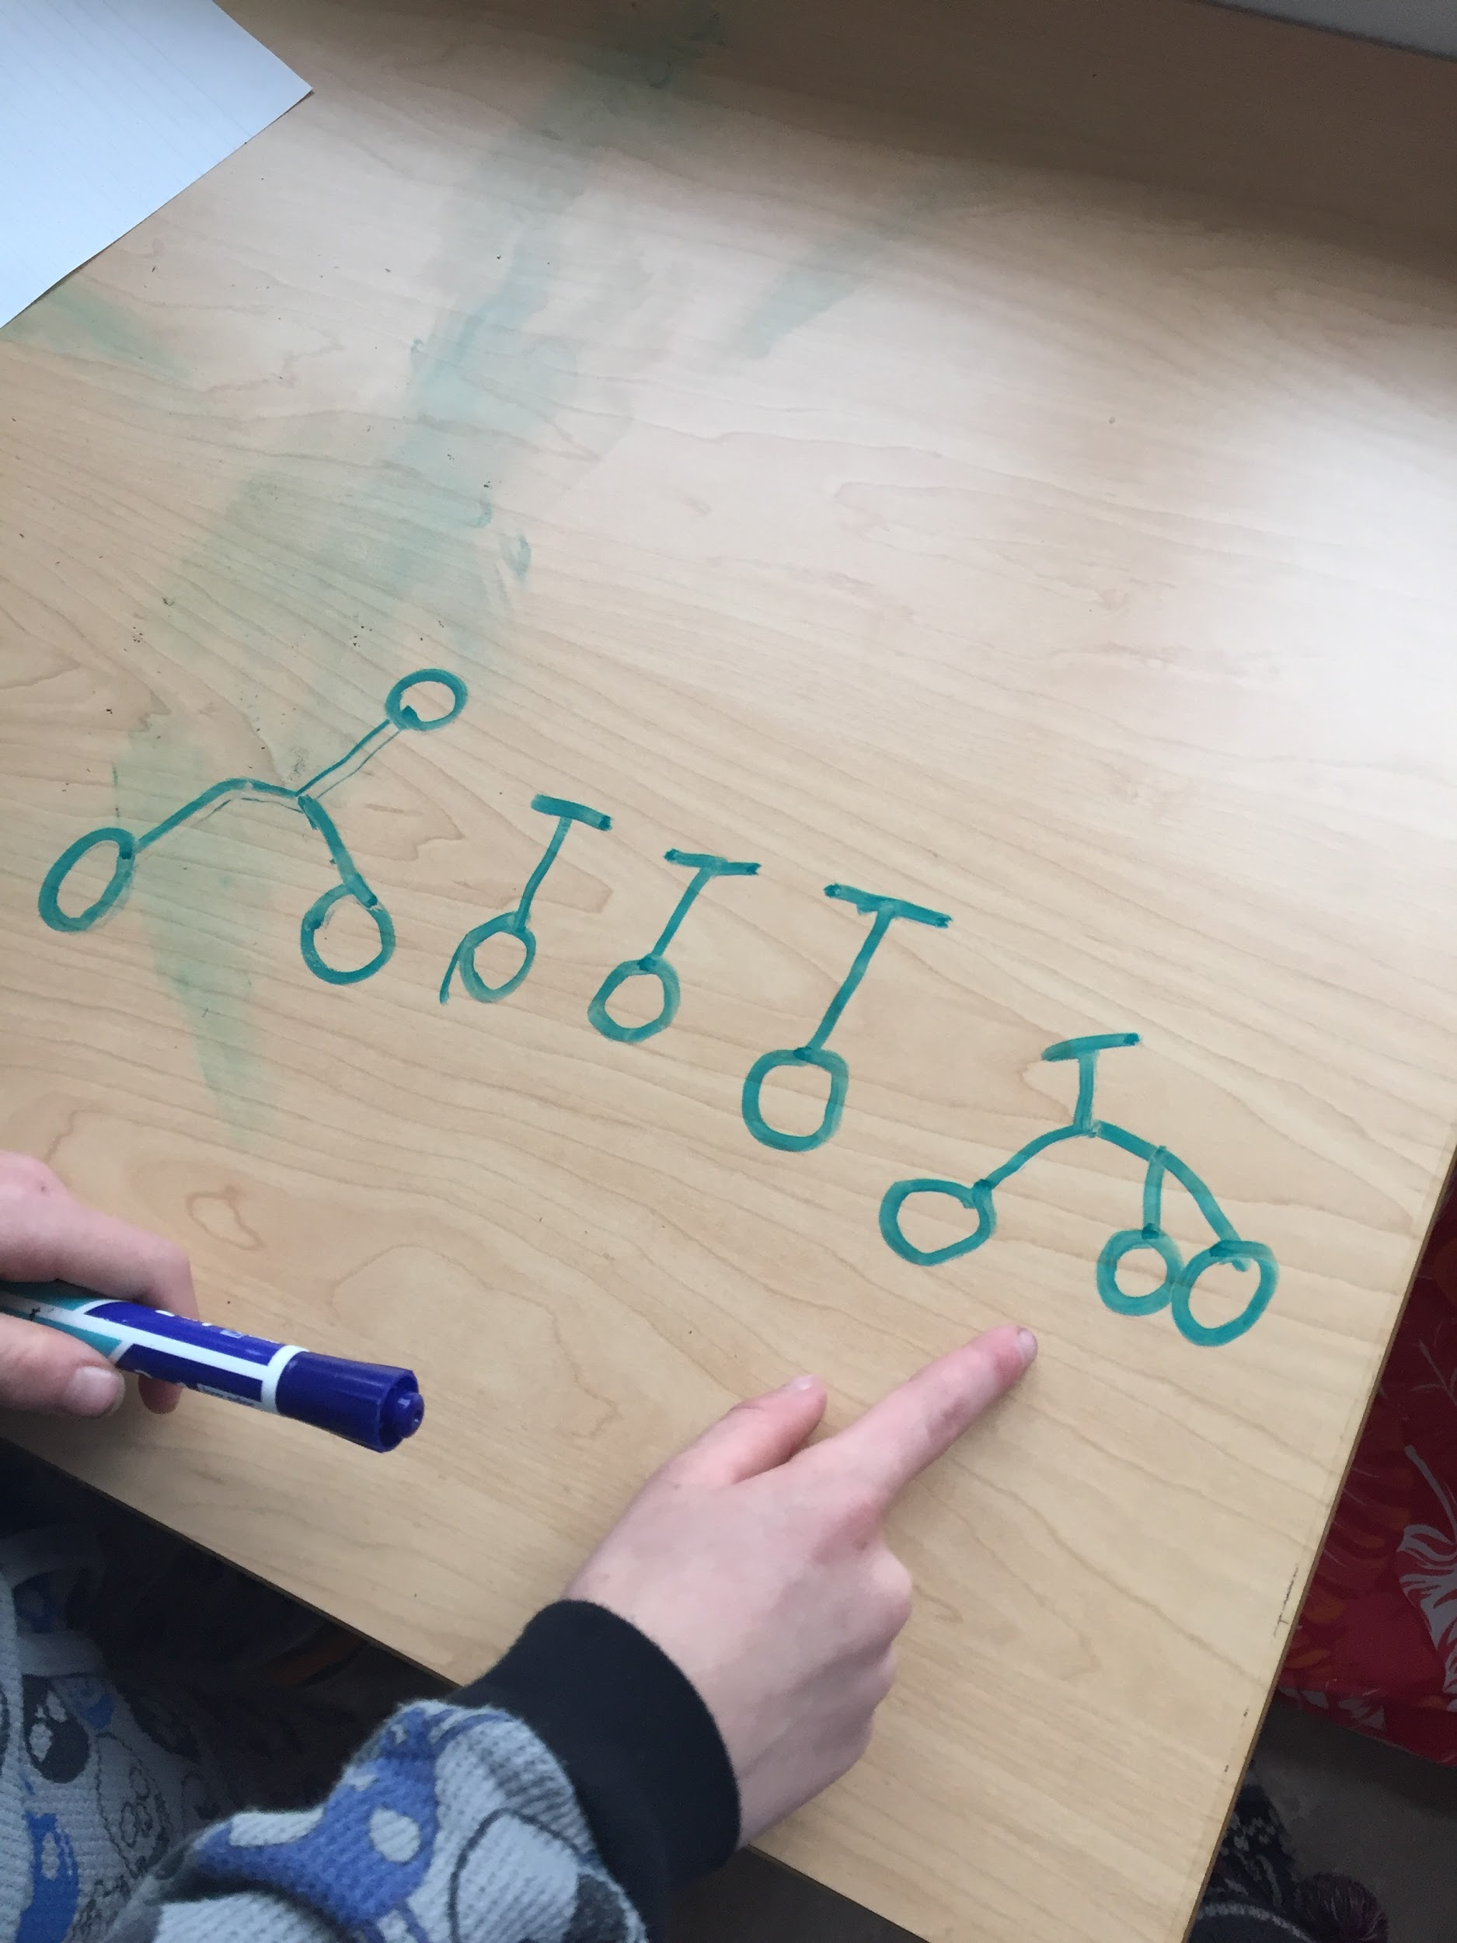
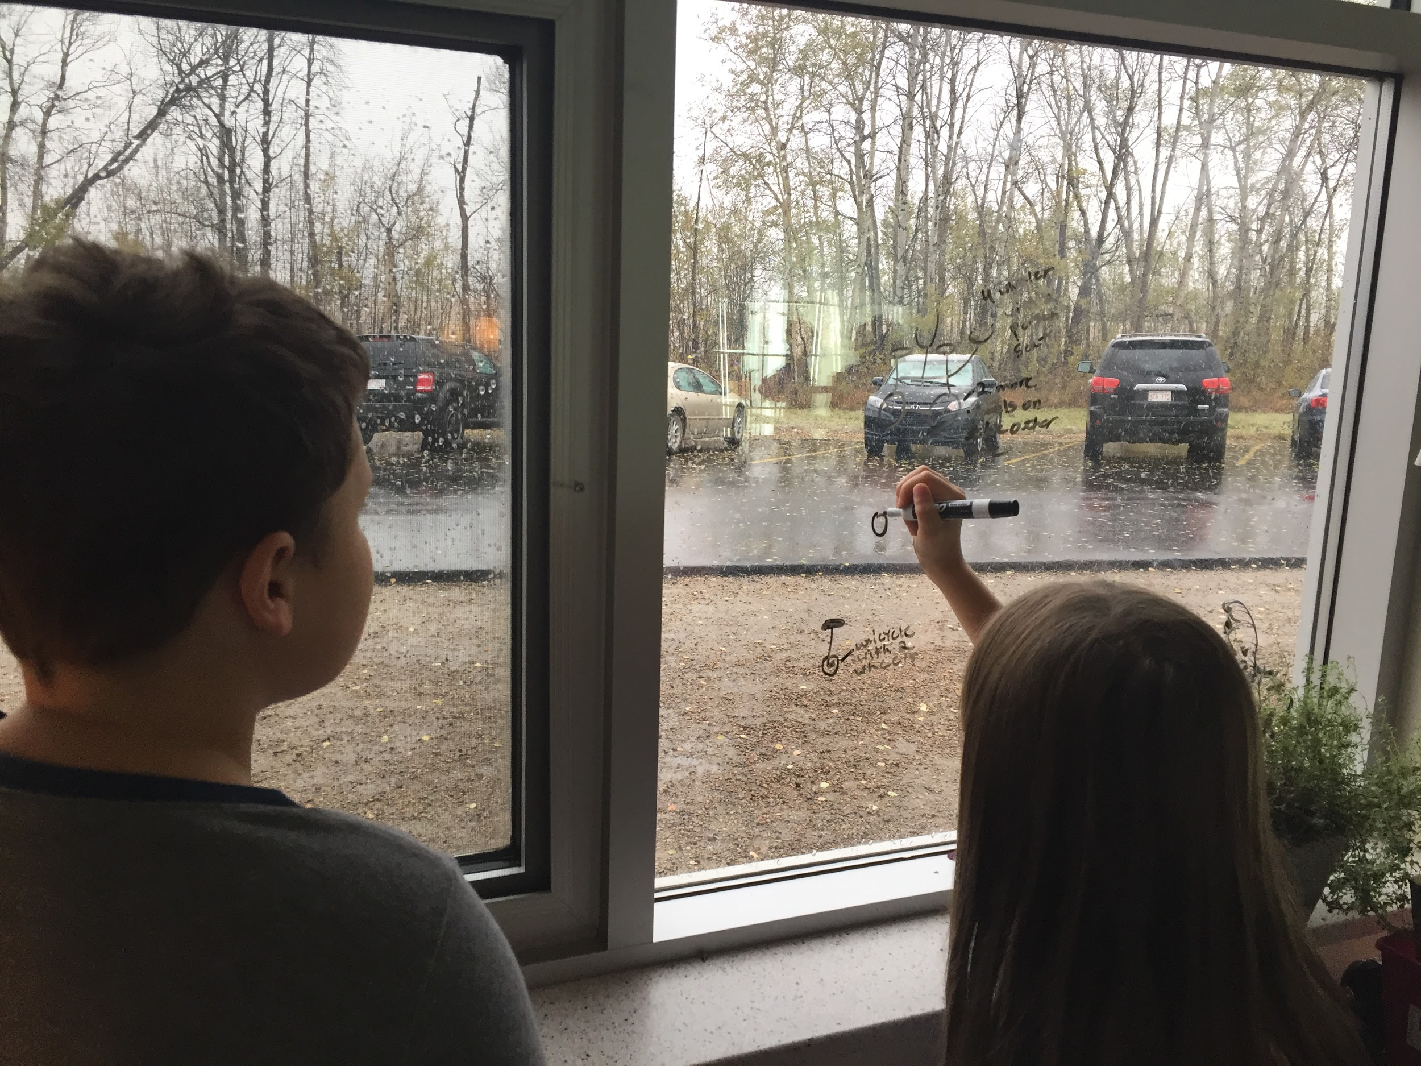
The The Cycling Shop is an exemplary problem and it is our favourite example of a problem worth solving.
How to Use This Resource

Section 1: Pages 14 - 26
Problems to Create a Thinking Classroom (Problems to Target the Front Matter)

The first section of problems is meant to be used to create a thinking classroom. Use these problems to teach students how to solve problems. These problems are included to address the Front-Matter of the curriculum as well as previous math concepts and outcomes. Students will go through the processes of learning to communicate, collaborate, reason, visualize, take risks, and persevere. The math classroom should become a culture of respect, responsibility, and thinking. Continue using these problems throughout the year!
*No curriculum links are provided for these problems. We want the teachers to learn with the students, take risks, make mistakes, and persevere! Feel free to google answers as a last resort if you really get stuck.

Section 2: Pages 31 - 143
Problems to Target Curricular Outcomes (as Well as the Front Matter)

The second section of problems continues to build on these skills. These problems are linked to the specific outcomes in the grade 3 curriculum. As you are planning your lessons, select the problems in section two to best support your practice and to satisfy the needs of your students.

As you work your way through the grade 3 math curriculum by teaching through problem solving, please contact us with feedback, new ideas, exemplary problems, sample student solutions, etc. at stone_alicia44@hotmail.com.

Thinking Classroom

Problems to Create a Thinking Classroom

Page # | Problem
14 | Milk Crate
15 | 25 Coins
16 | Hot Chocolate
17 | Handshakes
18 | Circles of Students
19 | Christmas Gifts
20 | Wardrobe
21 | Sail Away
22 | Wolf, Sheep, and Cabbage
23 | Divide and Conquer
24 | The Professor’s Toad
25 | Climbing Steps
26 | Cycling Shop

BACK to the Front Page

Milk Crate Thinking Classroom
*Credit to John Mason – Thinking Mathematically

Problem:

A certain milk crate can hold 36 bottles of milk. Can you arrange 14 bottles in the crate so that each row and column has an even number of bottles?

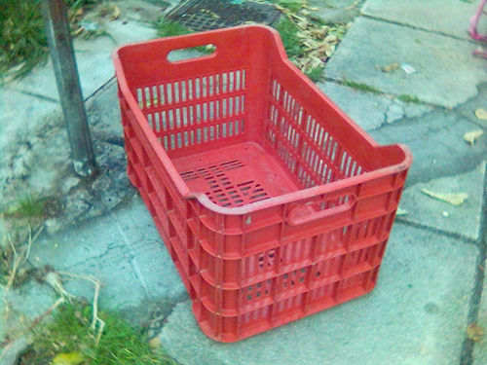

Extension:

What is the smallest array that can fit 14 bottles under this rule? What about 15 bottles?

Notes:

BACK

25 Coins Thinking Classroom
*Credit to John Mason – Thinking Mathematically

Problem:

25 coins are arranged in a 5 by 5 array. A fly lands on one, and tries to hop onto every coin exactly once, at each stage moving only to the adjacent coin in the same row or column. Is this possible?
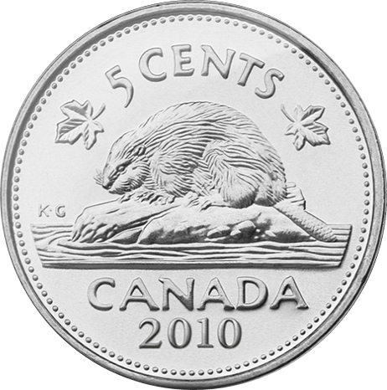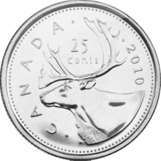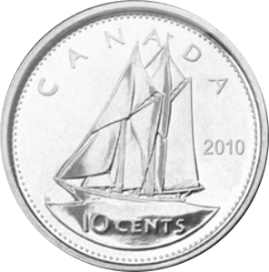

Extension:

Can you explain why some starting locations are not possible?
What if there were 4 dimensions?
What about rectangles?

Notes:

BACK

Hot Chocolate Thinking Classroom
*Credit unknown

Problem:

How many different types of hot chocolate can you make if you have 5 ingredients but can only use 3 at a time?

Extension:

What if there was a different number of ingredients per hot chocolate and/or a different number of ingredients to choose from?
Can you find any patterns?

Notes:
Manipulatives are essential for this problem! Linking cubes or color tiles work great. Different colours to represent the different ingredients. Kids can build towers to solve. Let them struggle first, then offer the cubes.
BACK

Handshakes Thinking Classrooms
*Credit www.nrich.maths.org

Problem:

There are 12 people at a party. If everyone shakes hands with everyone else at the party, how many handshakes take place?

Extension:

What if there were more people? What if there were 24 people?
What if there were more handshakes? What if they had to shake hands with certain people (6 boys and 6 girls, or occupations)?

Notes:

BACK

Circles of Students Thinking Classrooms
*Credit to Cheryl Kantecki and Lee E. Yunker, West Chicago Community High School

Problem:

Miss Young has her 18 students seated in a circle. They are evenly spaced and numbered in order. Which student is directly opposite: student number 1, student number 2, student number 18?

Mr. Evans seated his students in the same way as Miss Young’s. Student number 5 is directly opposite number 26. How many students are in Mr. Evan’s cass?

Mrs. White teaches Phys. Ed. She had her students space themselves evenly around a circle and then count off. Student number 16 is directly opposite number 47. How many students are in Mrs. White’s class?

Extension:

A large number of people are standing in a circle and are evenly spaced. The 7th person is directly opposite the 791st. How many people are there altogether?

Notes:

BACK

Christmas Gifts Thinking Classrooms
*Credit to Cheryl Kantecki and Lee E. Yunker, West Chicago Community High School

Problem:

It is traditional in many families at Christmas time for each family member to give a gift to each of the other members. How many gifts would be given if there were 10 family members?

Extension:

How about for your family which has ____ members?

Notes:

BACK

Wardrobe Thinking Classrooms
*Credit to Dale Seymour and Favorite Problems

Problem:

My favourite clothes include 4 t-shirts, three pairs of jeans, and two pairs of sandals. How many days in a row could I wear a different outfit using my favourite clothes?

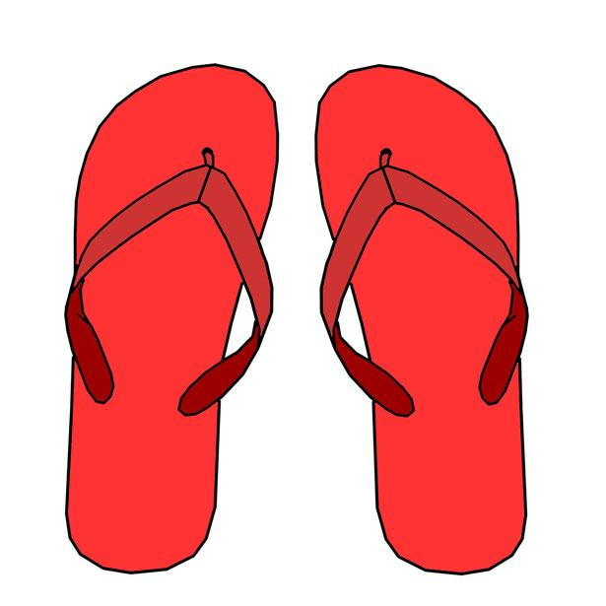

Extension:

What if I had more favourite clothes?

Notes:

BACK

Sail Away Thinking Classroom
*Credit to Mathematical Challenges for Able Pupils

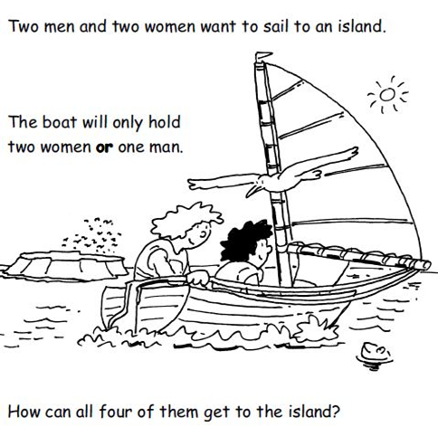
Problem:
How many trips will it take?

Extension:

Notes:

BACK

Wolf, Sheep, and Cabbage Thinking Classroom
*Credit to nrich.maths.org

Problem:

You need to move the wolf, sheep, and cabbage to the opposite shore by rowing them over one at a time in a boat. It gets more difficult though because when you are not around, the wolf will eat the sheep, the sheep will also do the same when alone with the poor little cabbage. How do you do this?

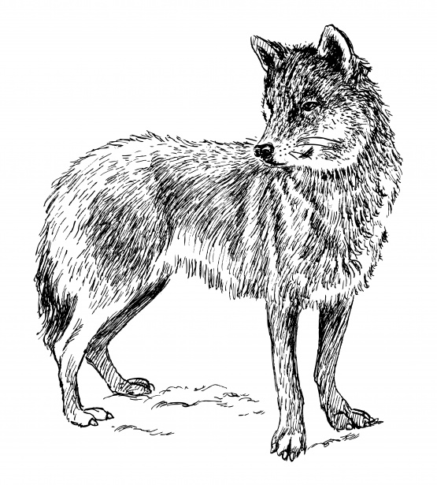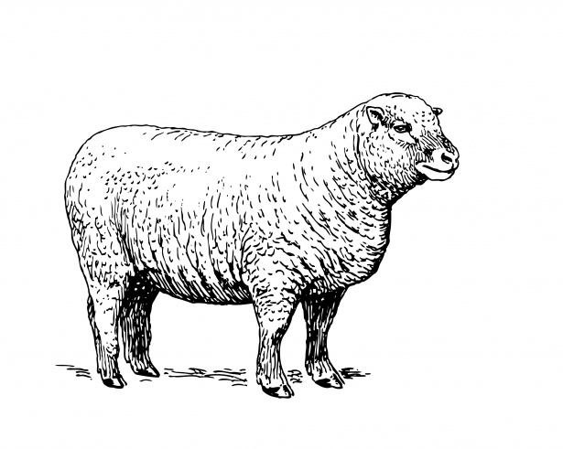

Extension:

Is there another way to solve this problem?

Notes:
BACK

Divide and Conquer Thinking Classroom
*Credit to Alicia Burdess
Problem:

I once had a teacher who could guess my number (between 1 and 100) in seven or less guesses.

Is this true?

How does he do it?

Extension:

What if it was a number between 1 and 1000?
What if it was a number between 1 and 5000?
What if it was a number between 1 and n?

Notes:
BACK

The Professor’s Toads Thinking Classroom
*Credit to @scottmckenzie

Problem:

A professor is buying toads and frogs at the university. He is paying $3 for each toad and $5 for each frog. Two boys brought him a bag with 10 animals inside. He gave them $38. How many were toads and how many were frogs?

How many different ways can you solve the problem?

Extension:

What if it wasn’t 10 animals?

Notes:
BACK

Climbing Steps Thinking Classroom
*Credit to https://playwithyourmath.com/2017/07/27/7-step-up/

Problem:

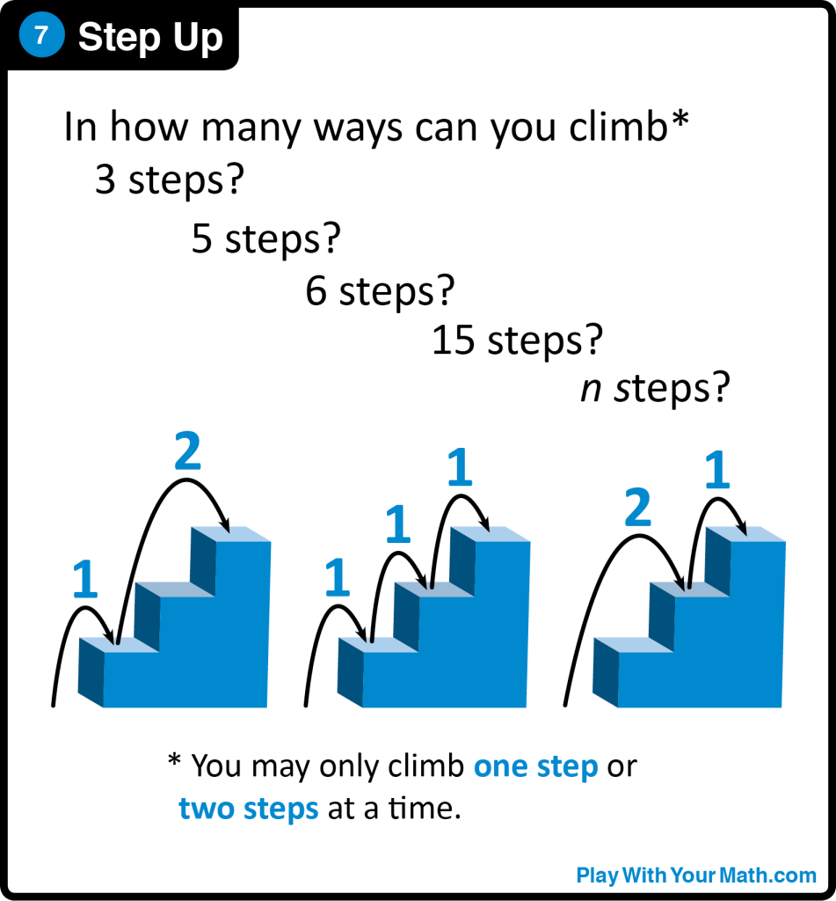

Extension:

What did you notice and why?
What if you could also climb three steps at a time?

Notes:
BACK

Cycling Shop Thinking Classrooms
*Credit to Teaching Children Mathematics, August 2016

Problem:

Imagine you work at a cycling shop building unicycles, bicycles, and tricycles for customers. One day, you receive a shipment of 8 wheels. Presuming that each cycle uses the same type and size of wheel, what are all the combinations of cycles you can make using all 8 wheels?

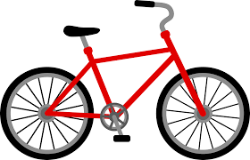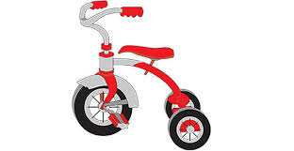

Extension:

What if you had more wheels?

Notes:
BACK

Problems to Target the Curriculum

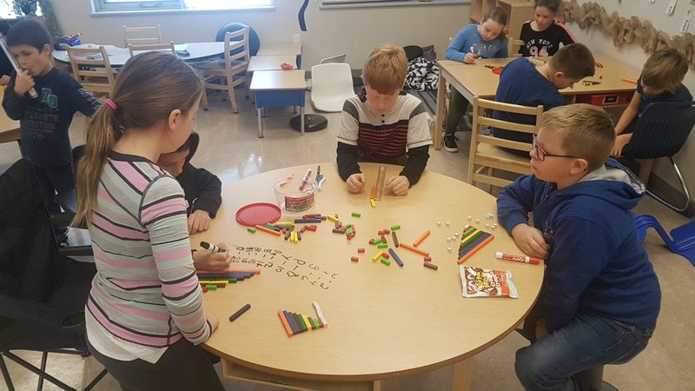

Problems to Target the Curriculum

Number Sense
Page # | Problem | Page # | Problem
31 | Magic Pencil | 72 | Two Darts
33 | How Many Sevens? | 73 | How Many A’s?
34 | Thirteens | 75 | A Mountainous Decision
36 | Pigs and Chickens | 78 | Picnic Tables
38 | Susie the Snake | 80 | Checkerboard
40 | Mash-Up Math Intro | 82 | Perfect Numbers
41 | Mash -Up Math | 84 | Sum Sum Sum
43 | Building Three Digit Numbers | 85 | Dice Thrice
45 | Neighbors | 86 | Split 25
47 | Queen Esmeralda’s Coins | 88 | Sharing Bacon
49 | Next Door Numbers | 90 | A Piece of Cake
51 | Class Party | 92 | Pizza Peril
53 | The Class Pet | 94 | Fraction Talks - Design Tasks
55 | Consecutive Numbers
57 | Seed Numbers
58 | Secret Numbers
60 | Chico’s Card Tricks
62 | 30 Scratch
64 | The Last Number
65 | Pattern Block Estimation
67 | Palindromes
69 | Consecutive Odd Numbers
70 | Math Exploration

Problems to Target the Curriculum Continued

Patterns and Relations
Page # | Problem | Page # | Problem
97 | Climbing | 105 | Visual Patterns
99 | Tile Problem | 107 | Points on a Circle
101 | Cubes Tower | 109 | 12 Days of Christmas
103 | Pile of Fruit | 111 | Triangular and Square Numbers

Shape and Space: Measurement
Page # | Problem | Page # | Problem
114 | Garden Fence | 121 | City Planner
116 | Pentominoes | 123 | Passage of Time Activities
118 | 9 Square Tiles | 124 | Approaching Midnight
119 | New Years Resolution | 125 | Ping Pong Balls

Shape and Space:  2D and 3D Shapes |  | Statistics and Probability
Page # | Problem | Page # | Problem
128 | Ship Shape | 140 | Horse Races
133 | Folding Cubes | 142 | The T-Shirt Order
135 | 2D Views | 144 | Prize Inside
137 | Which one Doesn’t Belong? | 145 | Ice Cream Scoop
138 | How Many Triangles?

BACK to the Front Page

Number Sense

Magic Pencil NS1 NS11 PR1 PR2
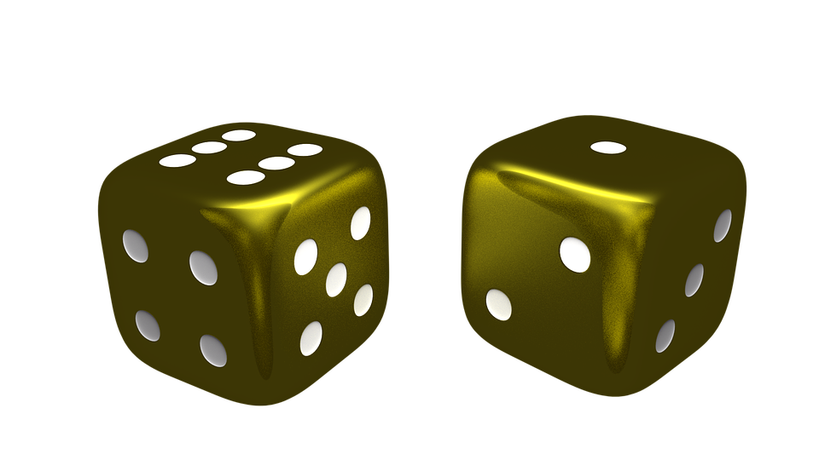
*Credit to Christie Watson
Problem (Note: This is a game and not a problem):

How to Play:
- Pick your order. Start with the youngest person to the oldest person. Sit in that order around the die.
- Decide your skip counting rule. Rock paper scissors for disagreements. You can count by:
  - 3s, 4s, 5s, 10s, 25s, 100s.
- You stop at 1000 or if you run out of time.
- Your Magic Pencil Numbers are 1 or 6.
- The youngest person rolls the die first. If they get a 1 or a 6, they grab The Magic Pencil and start skip counting on the paper, writing down all the numbers they can.
- MEANWHILE, the other players are rolling the die trying to also get a 1 or a 6. If another player rolls a 1 or a 6 they get to GRAB the Magic Pencil from the writer’s hand and continue skip counting from where that person left off.
- The game continues this way until you:
  - Run out of time;
  - You reach 1000;
- The person to reach the highest number in skip counting wins.

Extension:

For students who have no problem counting by any of these numbers they could try a less common multiple. i.e. by 7’s, 8’s, 9’s. Students can also work from a high number, then move backwards. The goal of the game would be the first person to reach 0 is the winner.

Outcome Objectives:
NS1: Say the number sequence 0 to 1000 forward and backward by:
- 5s, 10s or 100s, using any starting point.
- 3s, using starting points that are multiples of 3.
- 4s, using starting points that are multiples of 4.
- 25s, using starting points that are multiples of 25. [C, CN, ME]
NS11: Demonstrate an understanding of multiplication to 5x5 by: representing and explaining multiplication using equal grouping and arrays. Creating and solving problems in context that involve multiplication. Modelling multiplication using concrete and visual representations, and recording the process symbolically. Relating multiplication to repeated addition. Relating multiplication to division. [C, CN, PS, R]
PR1: Demonstrate an understanding of increasing patterns by: describing, extending, comparing, creating numerical (numbers to 1000) and non-numerical patterns, using manipulatives, diagrams sounds and actions. [C, CN, PS, R, V]
PR2: Demonstrate an understanding of decreasing patterns by: describing, extending, comparing, creating numerical (numbers to 1000) and non-numerical patterns, using manipulatives, diagrams sounds and actions. [C, CN, PS, R, V]
Material Suggestions:
- A group of 3 or more people
- A die
- A piece of loose leaf
- The Magic Pencil
*could also be done on a whiteboard surface with dry erase.

Notes: As mentioned this is a game that can be played and not a problem. It is a great way to meet objective NS1 and fun for the students.
BACK

How Many Sevens? NS1 NS2 NS5

*Credit to Peter Liljedahl

Problem:

If you write out the numbers from 1 to 1000, how many times will you write the number 7?

Extension:

How many times will you write the number 7 up to 10,000?

Outcome Objectives:
NS1: Say the number sequence 0 to 1000 forward and backward by: 5s, 10s or 100s, using any starting point. 3s, using starting points that are multiples of 3. 4s, using starting points that are multiples of 4. 25s, using starting points that are multiples of 25. [C, CN, ME]
NS2: Represent and describe numbers to 100, concretely, pictorially, and symbolically. [C, CN, V]
NS5: Illustrate concretely and pictorially the meaning of place value for numerals to 1000. [C,CN,R,V]

Notes:

BACK

Thirteens NS11 NS6 NS8
*Credit to http://www.playwithyourmath.com/

Problem:
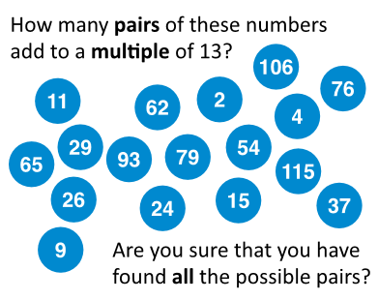

Extension:

In how many ways can a number n be written as the sum of two or more consecutive positive integers?

Outcome Objectives:
NS6. Describe and apply mental math strategies for adding two digit numerals [C, CN, ME, PS, R, V]
NS8: Apply estimation strategies to predict sums and differences of two 2-digit numerals in a problem solving context [C, ME, PS, R]
NS11. Demonstrate an understanding of multiplication to 5x5 by:
- Representing and explaining multiplication using equal grouping and arrays.
- Creating and solving problems in context that involve multiplication.
- Modeling multiplication using concrete and visual representations, and recording the process symbolically.
- Relating multiplication to repeated addition.
- Relating multiplication to division. [C, CN, PS, R]

Notes:

Visit http://www.playwithyourmath.com/ for more Play With Your Math tasks.

BACK

Pigs and Chickens NS12 NS6 NS7
*Credit to unknown

Problem:

Farmer Fiona has pigs and chickens. Last Tuesday, she counted 34 eyes and 46 feet. How many chickens does she have?
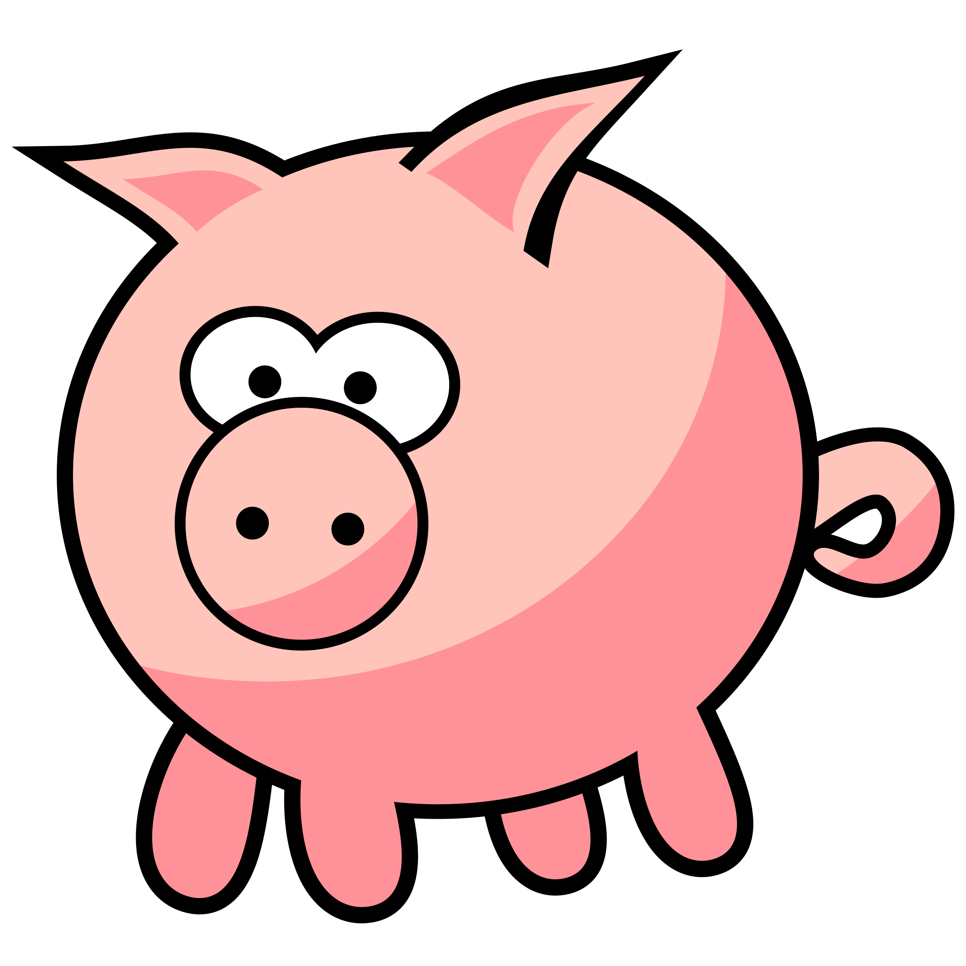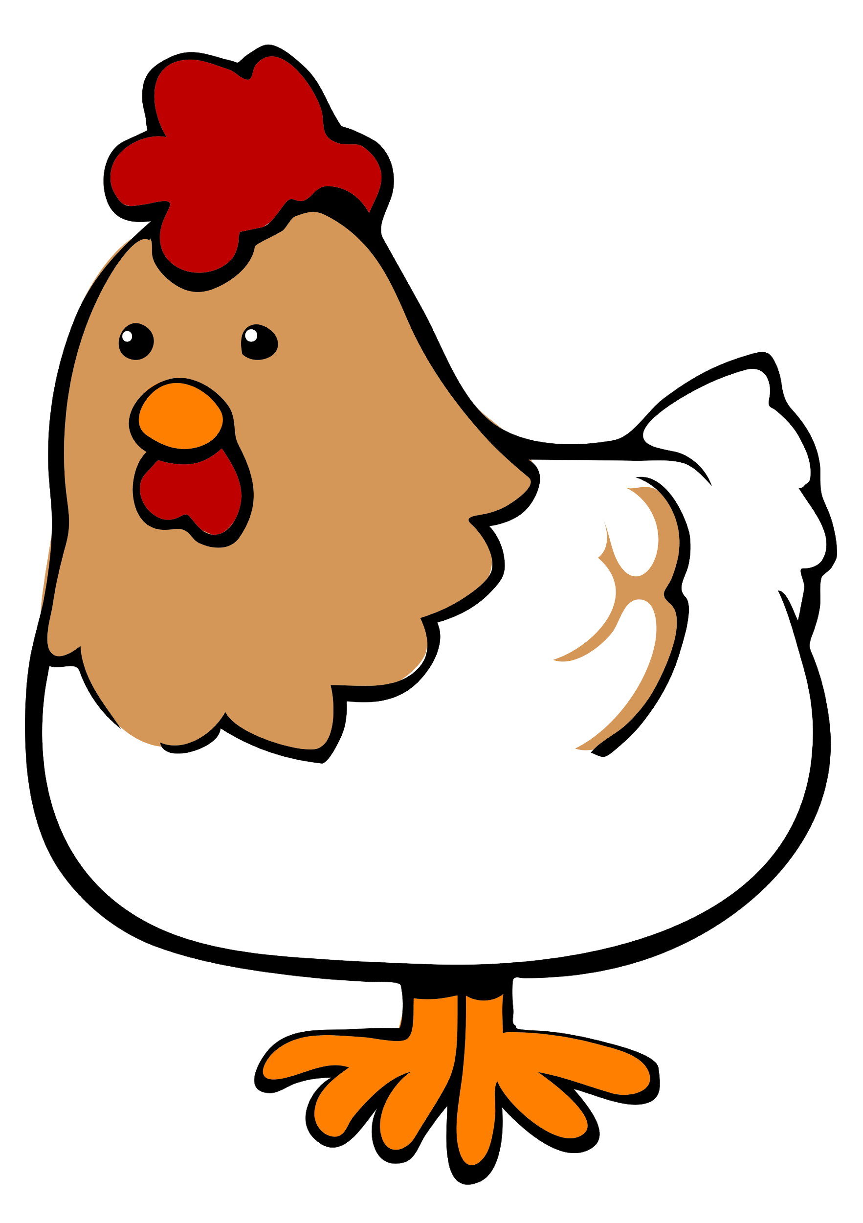

Extension:

How many pigs and chickens does she have if she counted 68 eyes and 92 feet?

Outcome Objectives:
NS6. Describe and apply mental math strategies for adding two digit numerals [C, CN, ME, PS, R, V]
NS7. Describe and apply mental math strategies for subtracting two digit numerals [C, CN, ME, PS, R, V]
NS12: Demonstrate an understanding of division (limited to division related to multiplication facts up to 5x5) by
- representing and explaining division using equal sharing and equal grouping
- creating and solving problems in context that involve equal sharing and equal grouping
- modeling equal sharing and equal grouping using concrete and visual representations and recording the process symbolically
- relating division to repeated subtraction
- relating division to multiplication [C, CN, PS, R]

Notes:

BACK

Susie the Snake NS1 NS6 NS10 NS11
*Credit to Mathematical Challenges for Able Pupils

Problem:

Susie the snake has up to 20 eggs.

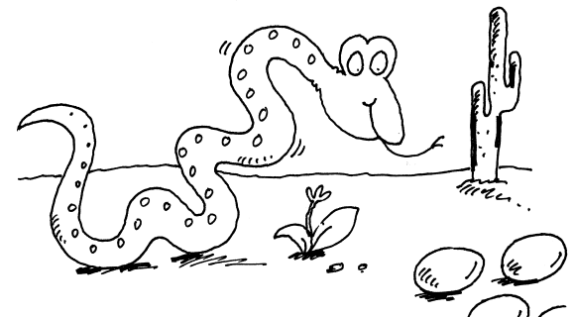
She counted her eggs in fours. She had 3 left over.

She counted them in fives. She had 4 left over.

How many eggs does Susie have?

Extension:

Susie has up to 60 eggs and counted them the same way. How many eggs does Susie have?

Outcome Objectives:
NS1: Say the number sequence 0 to 1000 forward and backward by:
- 5s, 10s or 100s, using any starting point.
- 3s, using starting points that are multiples of 3.
- 4s, using starting points that are multiples of 4.
- 25s, using starting points that are multiples of 25. [C, CN, ME]
NS6. Describe and apply mental math strategies for adding two digit numerals [C, CN, ME, PS, R, V]
NS10. Apply mental mathematics strategies and number properties in order to understand and recall basic addition facts and related subtraction facts to 18. [C, CN, ME, PS, R, V]
NS11. Demonstrate an understanding of multiplication to 5x5 by:
- Representing and explaining multiplication using equal grouping and arrays.
- Creating and solving problems in context that involve multiplication.
- Modeling multiplication using concrete and visual representations, and recording the process symbolically.
- Relating multiplication to repeated addition.
- Relating multiplication to division. [C, CN, PS, R]
Material Suggestions:
- Counters, pennies. or other manipulatives to represent eggs.
- Whiteboard Markers
- Vertical Surfaces

Notes:

BACK

Mash-up Math Intro NS10
*Credit to http://mashupmath.com/weekly-math-challenges/ and @mashupmath

Problem:

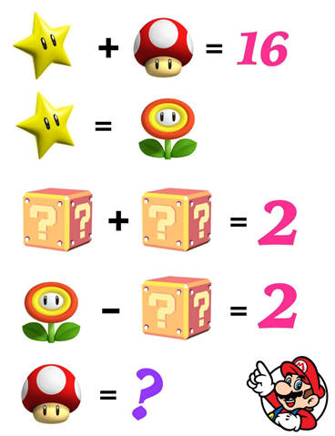

Extension:

Many more puzzles at http://mashupmath.com/weekly-math-challenges/

Outcome Objectives:
NS10. Apply mental mathematics strategies and number properties in order to understand and recall basic addition facts and related subtraction facts to 18. [C, CN, ME, PS, R, V]

Notes:
BACK

Mash-up Math NS11
*Credit to http://mashupmath.com/weekly-math-challenges/ and @mashupmath

Problem:

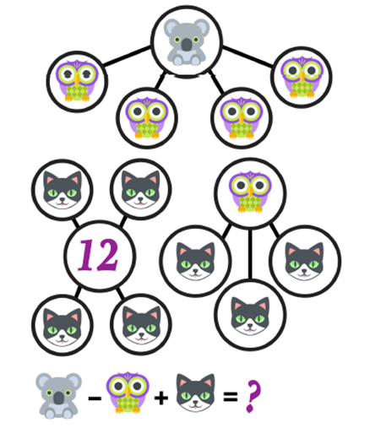
Extension:

Many more puzzles at http://mashupmath.com/weekly-math-challenges/

Outcome Objectives:
NS11. Demonstrate an understanding of multiplication to 5x5 by:
- Representing and explaining multiplication using equal grouping and arrays.
- Creating and solving problems in context that involve multiplication.
- Modeling multiplication using concrete and visual representations, and recording the process symbolically.
- Relating multiplication to repeated addition.
- Relating multiplication to division. [C, CN, PS, R]

Notes:

BACK

Building Three Digit Numbers NS2
*Credit to Math Makes Sense 3

Problem:

How many three Digit numbers can you building using the 3 of the base 10 blocks below? You may use any combination of the blocks below but you can only use three blocks in total.

Example: you can make the number 210 by using 2 - 100’s, 1 - 10’s and 0 - 1’s.
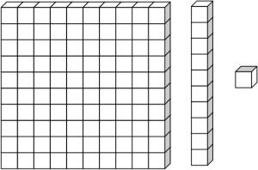

Extension:

How do you know you have built all the possible numbers? Can you prove it to me?

Outcome Objectives:
NS2. Represent and describe numbers to 1000, concretely, pictorially and symbolically.

Notes:

BACK

Neighbors NS3
*Credit to Mathematical Challenges for Able Pupils

Problem:

Use each of the numbers 1 to 6 once.
Write one in each circle.

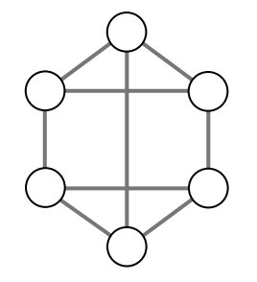

Numbers next to each other must not be joined.

For example, 3 must not be joined to 2 or 4.

1 2 3 4 5 6

Extension:

Is there another way to arrange the numbers to satisfy the problem?

Outcome Objectives:
NS3. Compare and order numbers to 1000 [C, CN, R, V]

Material Suggestions:
- Whiteboard markers
- Vertical Surfaces
- Playing cards (numbers 1-6)

Notes:

BACK

Queen Esmeralda's Coins NS3
*Credit to Mathematical Challenges for Able Pupils

Problem:

Queen Esmeralda had 20 gold coins.

She put them in four piles.

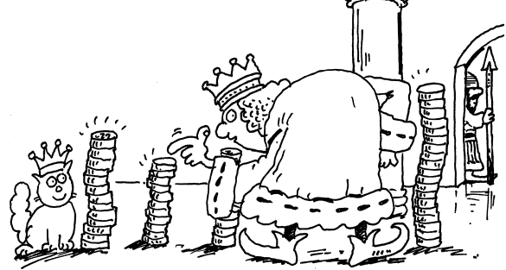

◆ The first pile had four more coins than the second.

◆ The second pile had one less coin than the third.

◆ The fourth pile had twice as many coins as the second.

How many gold coins did Esmeralda put in each pile?

Extension:

How many gold coins did Esmeralda put in each pile if she had 60 gold coins.

Outcome Objectives:
NS3. Compare and order numbers to 1000 [C, CN, R, V]

Material Suggestions:
- Manipulatives to represent gold coins - snap cubes, pennies, counters.
- Whiteboard markers
- Vertical Surfaces

Notes:

BACK

Next Door Numbers NS3
*Credit to Mathematical Challenges for Able Pupils

Problem:

Take ten cards numbered 0 to 9.
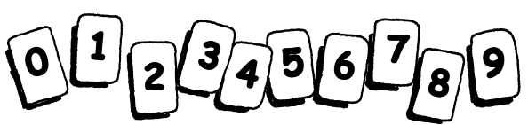

Arrange the cards like this.
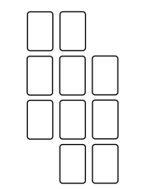

Do it so that no two consecutive numbers are next to each other, horizontally, vertically or diagonally.

Extension:

There are lots of ways to do it. How many ways can you find?

Outcome Objectives:

NS3. Compare and order numbers to 1000 [C, CN, R, V]

Material Suggestions:
- Cards Numbered 0-9
- Whiteboard markers
- Vertical Surfaces

Notes:

BACK

Classroom Party NS4 NS8 NS9
*Credit to Peter Liljedahl

Problem:

You are planning a class party. There are 24 students in the class and you have been given a budget of $70 to spend on pop, chips, and pizza.
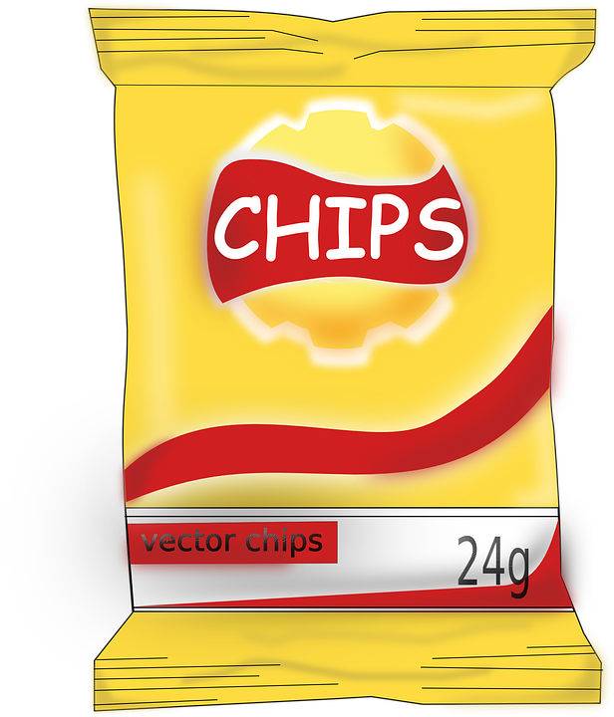
A 2 litre bottle of pop costs $1.79

1 large bag of chips costs $3.45

1 large pizza (10 slices) costs $8.50

How would you spend the money? You must make the decision how to spend the money.

Extension:

There are many different ways that the money could be spent. Be sure to choose the solution that you think is the best. You must explain and defend why your solution is the best solution.

How would your decision change if you were given 10 more students but no more money?

Outcome Objectives:
NS4. Estimate quantities less than 1000, using referents. [ME, PS, R, V]
NS8. Apply estimation strategies to predict sums and differences of two-digit numerals in a problem-solving context. [C,ME, PS, R]
NS9. Demonstrate an understanding of addition and subtraction of numbers with answers to 1000 (limited to 1-, 2-, and 3-digit numerals), concretely, pictorially and symbolically, by: using personal strategies for adding and subtracting with and without the support of manipulatives. Creating and solving problems in context that involve addition and subtraction of numbers. [C, CN, ME, PS, R, V]

Material Suggestions:
- Dry erase markers
- Vertical surfaces
- Manipulatives to represent party supplies

Notes:

Students should understand the idea of rounding the prices of objects to provide a good estimate for their party budget.

BACK

The Class Pet NS4 NS9
*Credit to Peter Liljedahl

Problem:

Your class wants a class pet. Look at the details of those available and design a budget for each pet. Remember you must take care of all their needs and some of their wants (extras), so that the pet will be healthy and happy. Based on your work, the PAC will decide how much money they will give your class. Show all the work you’ve done to make your decision. Then answer the question, “ Which pet do you think the PAC will agree to give you the money for?” and explain why.

 | Hamster  $ 11.95 | Beta Fish  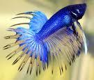  $5.00 | Hermit Crab  $ 7.49  (includes the shell it wears only)
Needs:
 | Food: $4.50/ pkg  (Your class will need 6 packages each year) | Food: $2.00 / container  (Your class will need 5 containers a year) | Food: $ 5.00 / box  (Your class must will need 10 packages)
 | Basic Cage: $20.00 | Aquarium: $25.00 | Habitat $ 11.99
 | Bedding: $9.00/ bag  (Your class will need 3 bags each year) | Water Treatment:  $5.00/ bottle  (You will need 2 bottles) | Shells  Stage 1: $3.00/1  Stage 2: $ 5.99/ 2  Stage 3: $ $7.00/ 1
 |  | Living Plants: $10 | Deodorant $ 10.00
 |  | Pebbles: $3.00 | Spray bottle: $2.00
Extras:
 | Exercise ball:$9.95 | Plastic Plants: $3.50 | Toys: $10.00
 | Treats $ 6.50 |  | Shells: (refer to above costs)
 | Vitamins $4.50 | Posts: $5.00
 | Deluxe Cage: $39.50 | Castle: $10.00
 | Deluxe Chlorophyll Bedding: $1.00 extra/ bag | Pirate Ship: $17.50
 | Chew toys (for teeth)  $6.00 | Coloured Pebbles: $5.00
 | Hideaway: $6.50 | Large Rocks: $0.50, $1.50, $4.00
Important Info:
 | It is not possible to have two hamsters in one cage, they will fight each other. | It is not possible to have two beta fish in one cage, they will fight each other. | The hermit crab will need at least 2 shells at all stages of its growth. It grows in three stages.

Extension:

Outcome Objectives:
NS4: Estimate quantities less than 1000, using referents. [ME, PS, R, V
NS9: Demonstrate an understanding of addition and subtraction of numbers with answers to 1000 (limited to 1-, 2-, and 3-digit numerals), concretely, pictorially and symbolically, by: using personal strategies for adding and subtracting with and without the support of manipulatives. Creating and solving problems in context that involve addition and subtraction of numbers. [C, CN, ME, PS, R, V]

Material Suggestions:
- Chart of the animal needs, extras, and costs for each group.
- Dry erase marker
- Vertical surfaces

Notes:

BACK

Consecutive Numbers NS6 NS7 NS10 NS11 NS12
*Credit to nrich.maths.org

Problem:

Choose any four consecutive numbers and place them in a row with space between them, like this:

4 5 6 7

Don't change your 4 numbers or their order. You are stuck with them! You also can not change the order of your numbers.

Use the + and - symbols to turn these consecutive numbers into number operations.

4 + 5 - 6 + 7 =

How many combinations of operations can you find using addition and subtraction for this set of consecutive numbers?

Extension:

How many combinations of operations can you find using addition, subtraction, multiplication, and division?

Outcome Objectives:
NS6. Describe and apply mental math strategies for adding two digit numerals [C, CN, ME, PS, R, V]
NS7. Describe and apply mental math strategies for subtracting two digit numerals [C, CN, ME, PS, R, V]
NS10. Apply mental mathematics strategies and number properties in order to understand and recall basic addition facts and related subtraction facts to 18. [C, CN, ME, PS, R, V]
NS11. Demonstrate an understanding of multiplication to 5x5 by:
- Representing and explaining multiplication using equal grouping and arrays.
- Creating and solving problems in context that involve multiplication.
- Modeling multiplication using concrete and visual representations, and recording the process symbolically.
- Relating multiplication to repeated addition.
- Relating multiplication to division. [C, CN, PS, R]
NS12. Demonstrate an understanding of division (limited to division related to multiplication facts up to 5x5) by:
- Representing and explaining division using equal grouping and equal sharing.
- Creating and solving problems in context that involve equal sharing and equal grouping.
- Modeling equal sharing and equal grouping using concrete and visual representations, and recording the process symbolically.
- Relating division to repeated subtraction
- Relating division to multiplication. [C, CN, PS, R]

Material Suggestions:
- Vertical Surfaces
- Whiteboard Markers

Notes:
BACK

Seed Numbers NS6
*Credit to Peter Liljedahl

Problem:

Find the missing numbers!

The rules are:
- The first 2 numbers add to the third number.
- The second and third numbers add to the fourth number.
- The the third and fourth numbers add to 100.
- You may NOT repeat any numbers.

____, ____, ____, ____, 100

Extension:

Find as many solutions as you can!

Outcome Objectives:
NS6. Describe and apply mental math strategies for adding two digit numerals [C, CN, ME, PS, R, V]

Notes:
BACK

Secret Numbers NS6 NS7 NS8
*Credit to John Mason

Problem:

A secret number is assigned to each vertex of a triangle. On each side of the triangle is written the sum of the secret numbers at its ends. Explain a simple rule for revealing the secret numbers. An example has been given below.
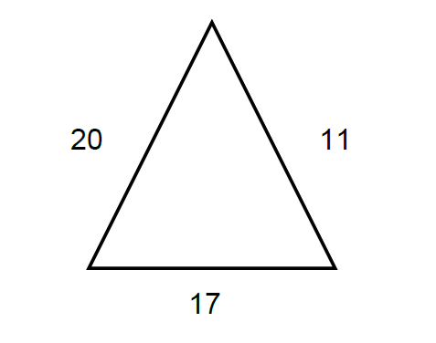

Extension:

Can you make your own Secret Numbers Puzzle?

Outcome Objectives:
NS6. Describe and apply mental math strategies for adding two digit numerals [C, CN, ME, PS, R, V]
NS7. Describe and apply mental math strategies for subtracting two digit numerals [C, CN, ME, PS, R, V]
NS8: Apply estimation strategies to predict sums and differences of two-digit numerals in a problem-solving context. [C,ME, PS, R]

Notes:

BACK

Chico’s Card Tricks NS6
*Credit to Mathematical Challenges for Able Pupils

Problem:

Chico’s cards are all different.

There is a number from 1 to 8 on each card.

Chico has chosen four cards that add up to 20.

What are they?

Extension:

There are seven different possibilities. Try to find them all!

What if Chico has three cards that add up to 16?

Outcome Objectives:
NS6. Describe and apply mental math strategies for adding two digit numerals [C, CN, ME, PS, R, V]

Material Suggestions:
- Cards with numbers 1-8
- Vertical Surfaces
- Whiteboard Markers

Notes:

BACK

30 Scratch NS6 NS7 NS10 NS11 NS12
*Credit to John Grant McLoughlin

Problem:
Choose any 4 digits from 1-9.
Using those numbers, in any combinations, using any operations, make all the numbers from 1-30.
1 2 3 4 5 6 7 8 9 10
11 12 13 14 15 16 17 18 19 20
21 22 23 24 25 26 27 28 29 30

Extension:

How many more numbers above 30 can you make?

Outcome Objectives:
NS6. Describe and apply mental math strategies for adding two digit numerals [C, CN, ME, PS, R, V]
NS7. Describe and apply mental math strategies for subtracting two digit numerals [C, CN, ME, PS, R, V]
NS10. Apply mental mathematics strategies and number properties in order to understand and recall basic addition facts and related subtraction facts to 18. [C, CN, ME, PS, R, V]
NS11. Demonstrate an understanding of multiplication to 5x5 by:
- Representing and explaining multiplication using equal grouping and arrays.
- Creating and solving problems in context that involve multiplication.
- Modeling multiplication using concrete and visual representations, and recording the process symbolically.
- Relating multiplication to repeated addition.
- Relating multiplication to division. [C, CN, PS, R]
NS12. Demonstrate an understanding of division (limited to division related to multiplication facts up to 5x5) by:
- Representing and explaining division using equal grouping and equal sharing.
- Creating and solving problems in context that involve equal sharing and equal grouping.
- Modeling equal sharing and equal grouping using concrete and visual representations, and recording the process symbolically.
- Relating division to repeated subtraction
- Relating division to multiplication. [C, CN, PS, R]
Material Suggestions:
- Vertical Surfaces
- Whiteboard Markers

Notes:
BACK

The Last Number NS6 NS7
*Credit to Richard Hoshino

Problem:
Consider the string 1, 2, 3, 4, 5, 6, 7, 8, 9, 10.
Cross out any two numbers in this list and add their difference as a new number at the end of the list. Continue the process of crossing out two numbers and adding the difference as a new number until only one number remains.
What can you say about the last number?

Extension:

Once you have a conjecture, how are you going to check that it’s true?

Outcome Objectives:
NS6. Describe and apply mental math strategies for adding two digit numerals [C, CN, ME, PS, R, V]
NS7. Describe and apply mental math strategies for subtracting two digit numerals [C, CN, ME, PS, R, V]

Notes:

BACK

Pattern Block Estimation NS8
*Credit to The Super Source Pattern Blocks

Problem:

Dump a pile of assorted pattern blocks onto the workspace.

Assign each pattern block a value, for example, hexagons are worth 10, trapezoids are worth 5, etc. Blocks can only be valued up to 50.
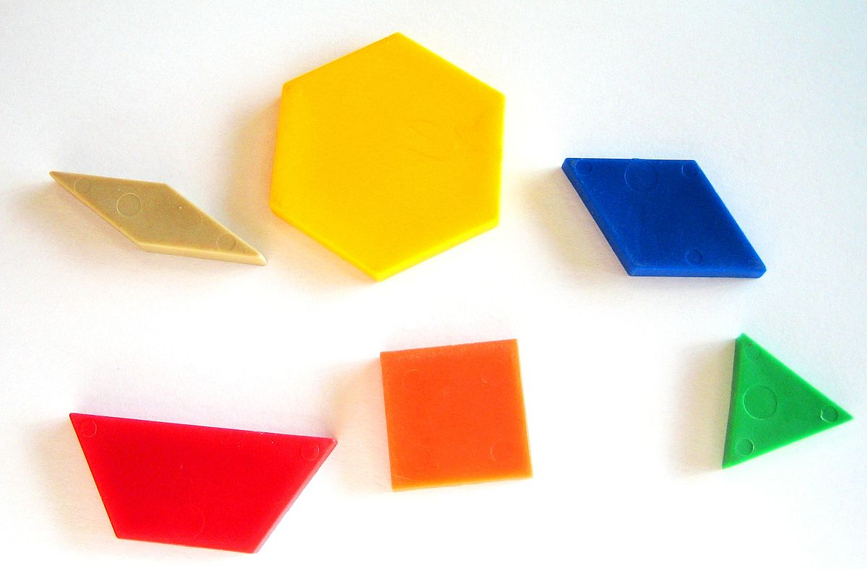
Write down your values so you don’t forget! An option is to write the value directly onto the pattern block using a whiteboard marker.

Explore:
- What is the value of your pile.
- How can you make a number between 40 and 50.
- Estimate who in the room has the greatest value, the least value.
- Determine who in the room has the greatest value, the least value.
- Make a picture with the pattern blocks which have a value near 100.
- How can you change the value of the blocks so that you maximize your pile’s value?

Extension:

Make a table of values reflecting your pile, and then create a bar graph of your pile.
Ask the same type of questions finding solutions from the exposed graphs.

Outcome Objectives:
NS8. Apply estimation strategies to predict sums and differences of two digit numerals in a problem solving context. [C, ME, PS, R]

Material Suggestions:
- Pattern Blocks
- Whiteboard Markers
- Vertical Surfaces

Notes:

BACK

Palindromes NS9 NS6
*Credit to Peter Liljedahl
Problem:

A palindrome is a number, word, phrase, or sequence that reads the same backward as forward, e.g., madam or 363
Consider a two-digit number – for example 84. 84 is not a palindrome. So, reverse the digits and add it to the original number – 84 + 48 = 132. Repeat this process until the sum becomes a palindrome. 132 + 231 = 363. The number of times the process is repeated determines the depth of the palindrome. For 84, the depth is two. Find the depth of all two digit numbers.

Extension:

What about a three digit number?

What about the depth for the second time of becoming a palindrome?

What happens when you shade a Hundreds Chart according to the number’s depth?

Outcome Objectives:
NS6. Describe and apply mental math strategies for adding two digit numerals [C, CN, ME, PS, R, V]
NS9. Demonstrate an understanding of addition and subtraction of numbers with answers to 1000 (limited to 1-, 2-, and 3-digit numerals), concretely, pictorially and symbolically, by: using personal strategies for adding and subtracting with and without the support of manipulatives. Creating and solving problems in context that involve addition and subtraction of numbers. [C, CN, ME, PS, R, V]

Notes:

http://www.magic-squares.net/palindromes.htm

BACK

Consecutive Odd Numbers NS9
*Credit to Unknown

Problem:
1, 3, 5, ...

What happens when we add consecutive odd numbers? Can you show this with manipulatives or a picture?

Start with one, add three, then five, then seven….

Extension:

Outcome Objectives:
NS9. Demonstrate an understanding of addition and subtraction of numbers with answers to 1000 (limited to 1-, 2-, and 3-digit numerals), concretely, pictorially and symbolically, by: using personal strategies for adding and subtracting with and without the support of manipulatives. Creating and solving problems in context that involve addition and subtraction of numbers. [C, CN, ME, PS, R, V]

Notes:

BACK

Math Exploration NS9 NS10 NS11
*Credit to Steven Strogatz

Problem:

What whole numbers can you make by adding 3s and 5s? Prove your conjecture!

Extension:

Outcome Objectives:
NS9. Demonstrate an understanding of addition and subtraction of numbers with answers to 1000 (limited to 1-, 2-, and 3-digit numerals), concretely, pictorially and symbolically, by: using personal strategies for adding and subtracting with and without the support of manipulatives. Creating and solving problems in context that involve addition and subtraction of numbers. [C, CN, ME, PS, R, V]
NS10. Apply mental mathematics strategies and number properties in order to understand and recall basic addition facts and related subtraction facts to 18. [C, CN, ME, PS, R, V]
NS11. Demonstrate an understanding of multiplication to 5x5 by:
- Representing and explaining multiplication using equal grouping and arrays.
- Creating and solving problems in context that involve multiplication.
- Modeling multiplication using concrete and visual representations, and recording the process symbolically.
- Relating multiplication to repeated addition.
- Relating multiplication to division. [C, CN, PS, R]

Notes:

BACK

Two Darts NS9
*Credit to Peter Liljedahl

Problem:

You have two darts that you can throw over and over again. The dart board has 2 rings. One is worth 4 points if you hit it and the other is worth 9 points. How can you make 26 points? How can you make 19 points? Are there numbers you can’t get?

Extension:
What is the biggest number you can’t get?
What if you had two rings, 3 and 7?
Two rings, 2 and 11? Two rings, 6 and 9?
Three rings, 2, 5, and 7?

Outcome Objectives:
NS9. Demonstrate an understanding of addition and subtraction of numbers with answers to 1000 (limited to 1-, 2-, and 3-digit numerals), concretely, pictorially and symbolically, by: using personal strategies for adding and subtracting with and without the support of manipulatives. Creating and solving problems in context that involve addition and subtraction of numbers. [C, CN, ME, PS, R, V]

Notes: BACK

How Many A’s NS9 NS12 NS13 PR4
*A Math Puzzle Each Day! Vol 2 By: Clinton Atkins

Problem:

There are less than 30 students in Mrs. Atkins math class. ¼ of the students in the class received a C on a test, ¼ received a B, ⅓ of the students received a D or lower. Find out how many students were in the class and how many of them received an A.

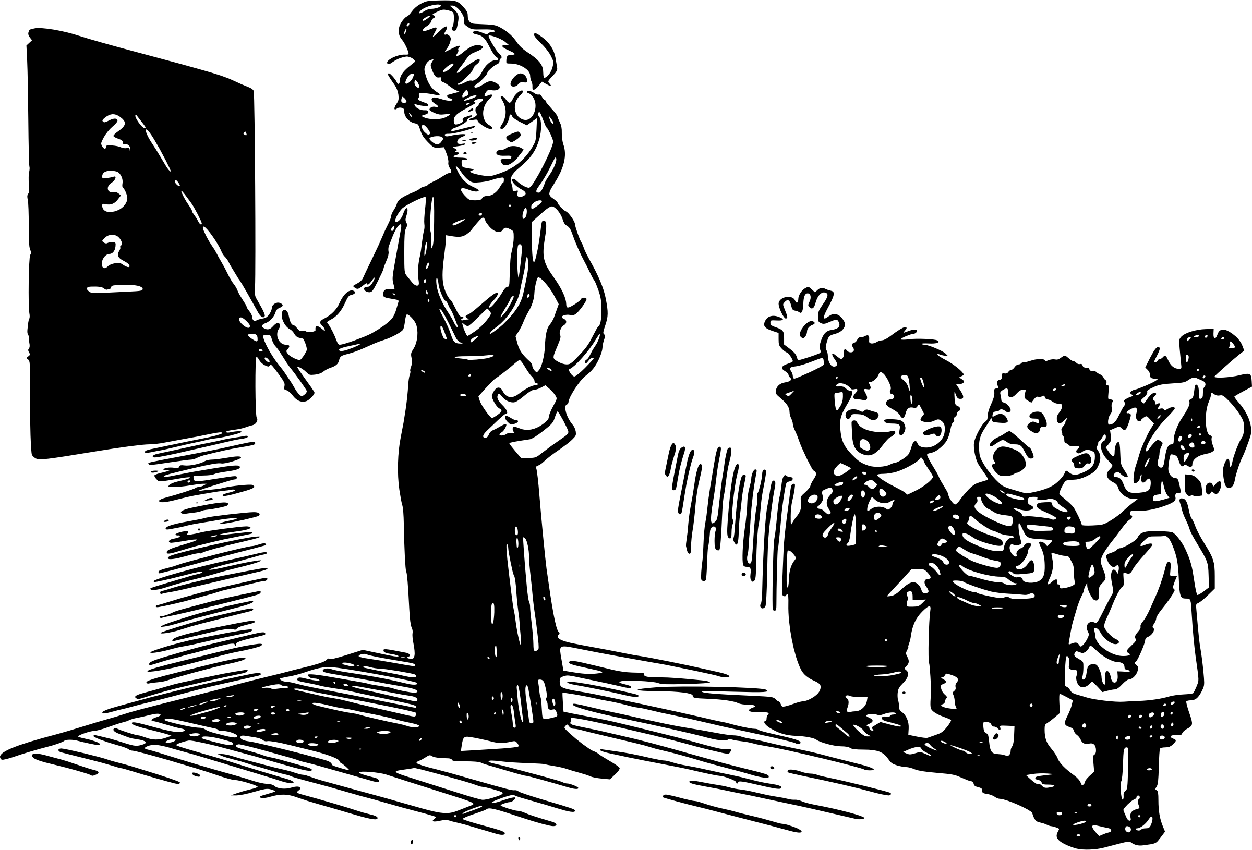

Extension:

Fewer than 30 students. ⅓ received B’s, ¼ received C’s, ⅙ received D’s, and ⅛ received F’s. How many students are in the class and how many received an A?

Outcome Objectives:
NS9. Demonstrate an understanding of addition and subtraction of numbers with answers to 1000 (limited to 1-, 2-, and 3-digit numerals), concretely, pictorially and symbolically, by: using personal strategies for adding and subtracting with and without the support of manipulatives. Creating and solving problems in context that involve addition and subtraction of numbers. [C, CN, ME, PS, R, V]
NS12. Demonstrate an understanding of division (limited to division related to multiplication facts up to 5x5) by: representing and explaining division using equal sharing and equal grouping. Creating and solving problems in context that involve equal sharing and equal grouping. Modelling equal sharing and equal grouping using concrete and visual representations, and recording the process symbolically. Relating division to repeated subtraction. Relating division to multiplication. [C, CN, PS, R]
NS13. Demonstrate an understanding of fractions by: explaining that a fraction represents a part of a whole. Describing situations in which fractions are used. Comparing fractions of the same whole that have like denominators. [C, CN, ME, R, V]
PR4. Solve one-step addition and subtraction equations involving a symbol to represent an unknown number.

Notes:

BACK

A Mountainous Decision NS9 NS12 NS13
*The Book of Perfectly Perilous Math by Sean Connolly
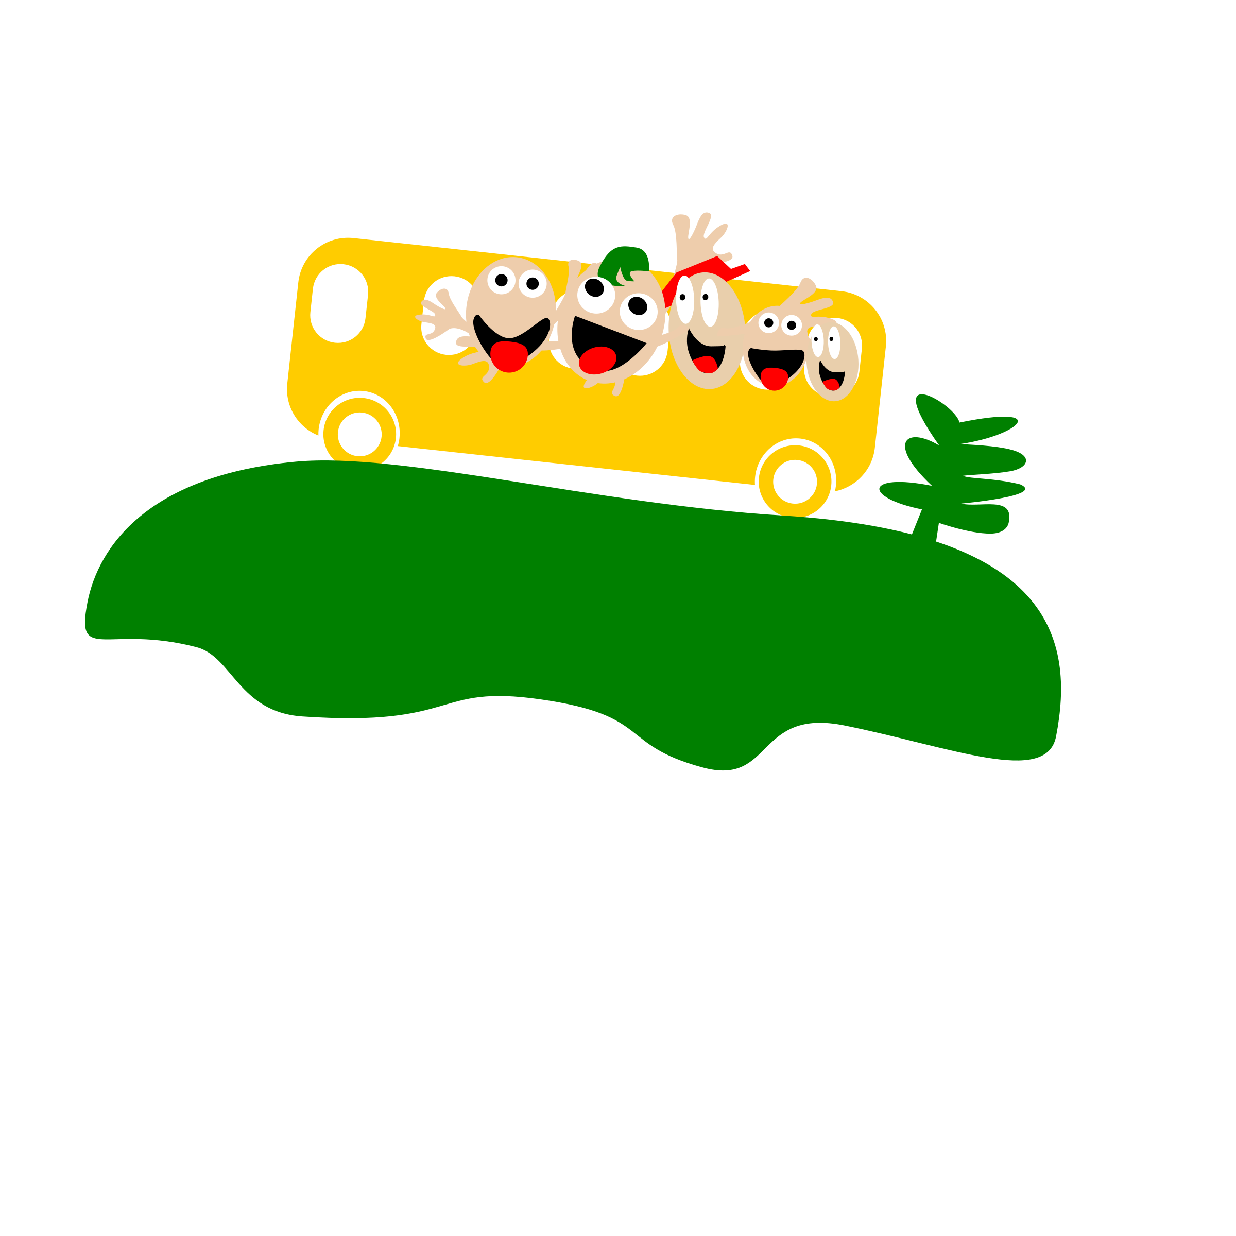
Problem:

You’re on a camping trip, driving from Grande Prairie to Kamloops in British Columbia in an old school bus. After you leave the town of Hinton, you enter the Jasper National Park, filled with tall mountains and large forests of trees. You look around and all you see for everywhere around you are mountains, forests, rivers and the occasional herd of elk on the side of the highway.

As you pass the town of Jasper you see a sign: Last Gas Station for 300 Kilometres. The bus driver looks a bit worried as he pulls into the station. Why? Because he’s read the sign that says: CASH ONLY. NO CREDIT CARDS. Even more troublesome is the other sign over the ATM machine that reads: OUT OF ORDER.

The bus driver only has $2 in his wallet. You and your classmates check your pockets, but your grand total, including the bus driver’s $2, is $23.62. Gas costs $1.15 per litre. The bus driver tells you that the tank of gas hold 80 litres and it is currently right at the ¼ mark.

The bus driver says that it will take about ¾ of a tank of gas to make it the 300 Kilometres to the next gas station. If you fill the bus up using the $23.62 you have will that be enough to get the bus to the next gas station, or will your group end up stranded in the mountains?

Extension:

If there are 10 students on the trip, how much could each student have contributed to the grand total if each student gave at least $1.00.

How much money would the students need to reach the ¾ tank mark and have enough fuel to reach the next gas station.

Outcome Objectives:
NS9. Demonstrate an understanding of addition and subtraction of numbers with answers to 1000 (limited to 1-, 2-, and 3-digit numerals), concretely, pictorially and symbolically, by: using personal strategies for adding and subtracting with and without the support of manipulatives. Creating and solving problems in context that involve addition and subtraction of numbers. [C, CN, ME, PS, R, V]
NS1. Demonstrate an understanding of division (limited to division related to multiplication facts up to 5x5) by: representing and explaining division using equal sharing and equal grouping. Creating and solving problems in context that involve equal sharing and equal grouping. Modelling equal sharing and equal grouping using concrete and visual representations, and recording the process symbolically. Relating division to repeated subtraction. Relating division to multiplication. [C, CN, PS, R]
NS13. Demonstrate an understanding of fractions by: explaining that a fraction represents a part of a whole. Describing situations in which fractions are used. Comparing fractions of the same whole that have like denominators. [C, CN, ME, R, V]
Material Suggestions:
- Having a list printed off of the ‘key math points’ from the story for students is helpful. Would give this to students who are struggling.
  - Bus is at ¼ of a tank
  - Needs ¾ of a tank to reach next gas station
  - Grand total: $23.62
  - Gas costs $1.15 per litre
  - The bus holds a total of 80 litres

Notes:

As the question can be very ‘wordy’ it helps to go over the key points the student will need to help them solve the problem.

This problem can also lead into a great writing activity with students. What would your group do if you decided to gas up with all your money and didn’t make it. How would you survive in the mountains? Make a plan to reach the next gas station safely.

BACK

Picnic Tables NS9 NS11 NS12
*Credit to Super Source Patterns and Functions

Problem:

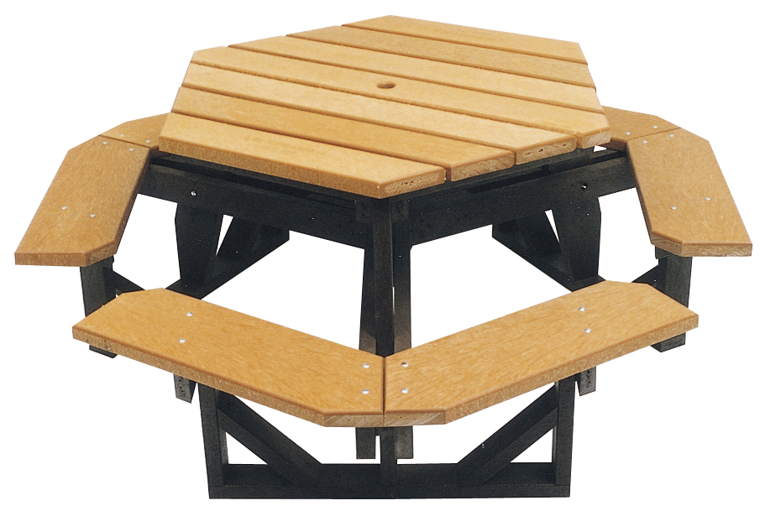
There are 36 students attending the end of the year party. Large tables can hold groups of 6 students and smaller tables are able to hold groups of 3 students. How many different ways can tables be set up to hold all 36 students?
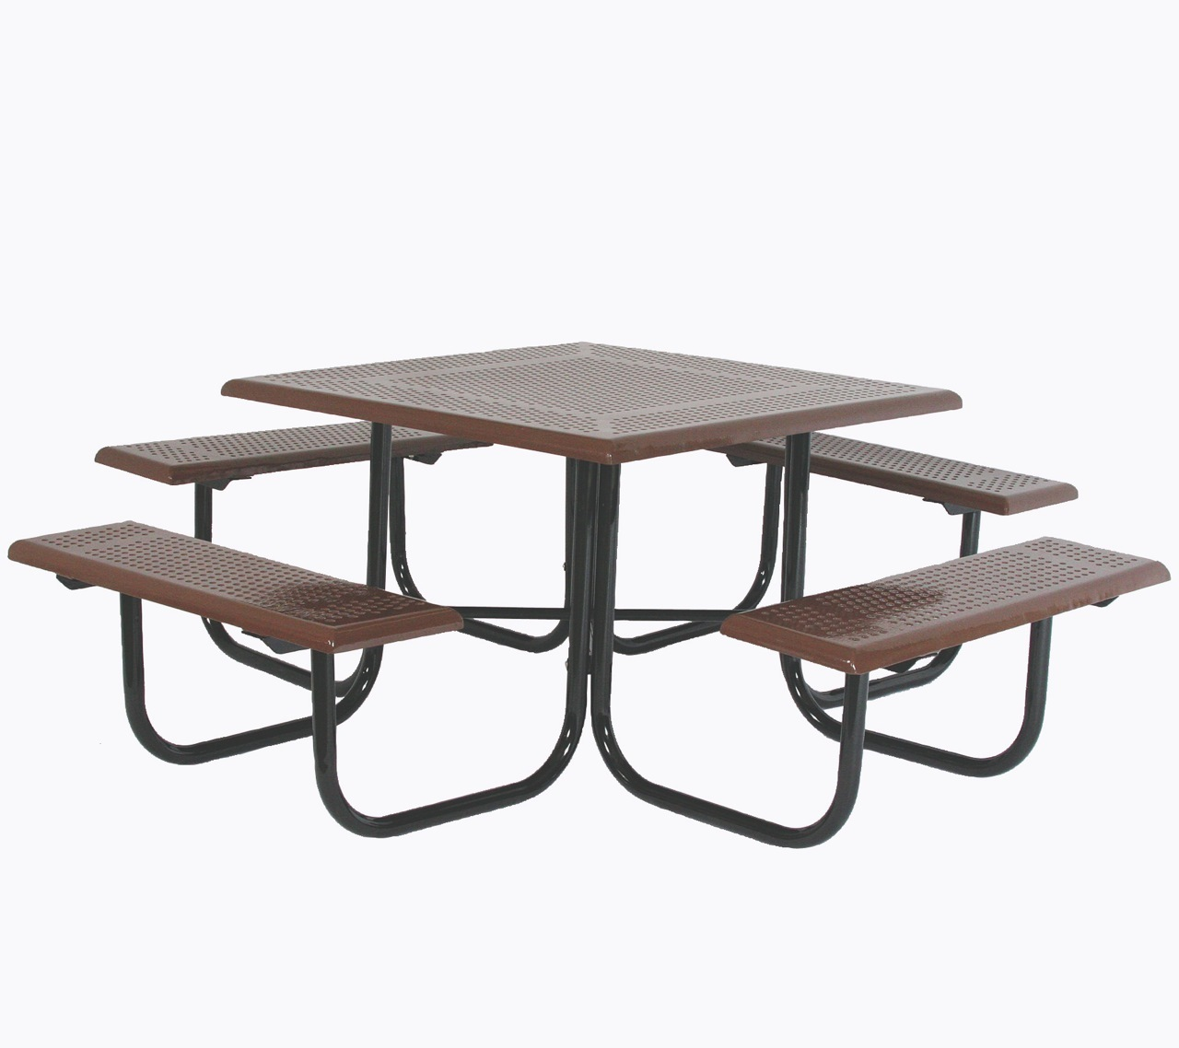

Extension:

48 students attend: large tables hold 6 and smaller tables hold 4.

Outcome Objectives:
NS9. Demonstrate an understanding of addition and subtraction of numbers with answers to 1000 (limited to 1-, 2-, and 3-digit numerals), concretely, pictorially and symbolically, by: using personal strategies for adding and subtracting with and without the support of manipulatives. Creating and solving problems in context that involve addition and subtraction of numbers. [C, CN, ME, PS, R, V]
NS11. Demonstrate an understanding of multiplication to 5x5 by: representing and explaining multiplication using equal grouping and arrays. Creating and solving problems in context that involve multiplication. Modelling multiplication using concrete and visual representations, and recording the process symbolically. Relating multiplication to repeated addition. Relating multiplication to division. [C, CN, PS, R]
NS12. Demonstrate an understanding of division (limited to division related to multiplication facts up to 5x5) by: representing and explaining division using equal sharing and equal grouping. Creating and solving problems in context that involve equal sharing and equal grouping. Modelling equal sharing and equal grouping using concrete and visual representations, and recording the process symbolically. Relating division to repeated subtraction. Relating division to multiplication. [C, CN, PS, R]

Notes:
In my class this problem led to an excellent conversation regarding order of operations. The grade 3 students developed an excellent understanding of this as they discovered it on their own through the problem.

If students decided to use a chart I like to show them this as well:

Tables of 6 | Tables of 3
6 | 0
5 | 2
4 | 4
3 | 6

BACK

Checkerboard NS11
*Credit to Rina Zazkis

Problem:

How many squares are in a 5x5 checkerboard?

Extension:

How about a 6x6? How about a 7x7?

Outcome Objectives:
NS11. Demonstrate an understanding of multiplication to 5x5 by:
- Representing and explaining multiplication using equal grouping and arrays.
- Creating and solving problems in context that involve multiplication.
- Modeling multiplication using concrete and visual representations, and recording the process symbolically.
- Relating multiplication to repeated addition.
- Relating multiplication to division. [C, CN, PS, R]

Material Suggestions:
- Multiple full page checkerboard print-outs
- Scissors
- Whiteboard markers
- Vertical Surfaces

Notes:

The checkerboard print out gives students a visual of the problem.
If needed, students can use scissors to cut the checkerboard into square parts to help them see more than just the 5x5 grid.

BACK

Perfect Numbers NS11
*Credit to Sunil Singh

Problem:

6 is a perfect number because the sum of its factors (other than itself) is equal to itself. 8 is not a perfect number and neither is 12. Can you find other perfect numbers?
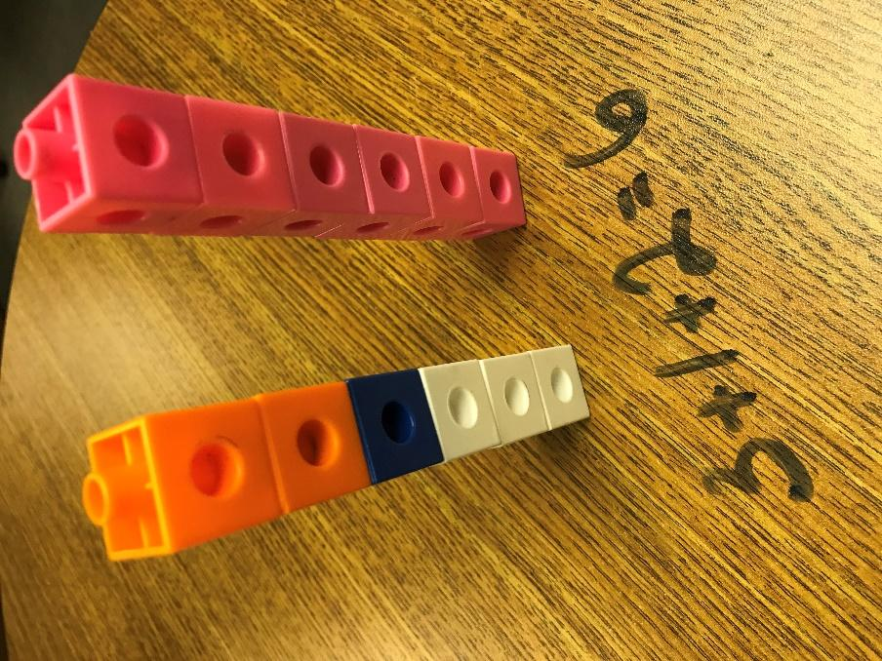

Extension:

It is not known whether there are any odd perfect numbers…

Outcome Objectives:
NS11. Demonstrate an understanding of multiplication to 5x5 by:
- Representing and explaining multiplication using equal grouping and arrays.
- Creating and solving problems in context that involve multiplication.
- Modeling multiplication using concrete and visual representations, and recording the process symbolically.
- Relating multiplication to repeated addition.
- Relating multiplication to division. [C, CN, PS, R]

Notes:

Cuisenaire rods and linking cubes are both excellent manipulatives for this problem.

BACK

Sum Sum Sum NS10
*Credit to Dale Seymour and Favorite Problems

Problem:
Place the numbers 1, 2, 3, 4, 5 in the squares so that the sum of the 3 numbers in a vertical or horizontal line equals 9 or 10?

Extension:

Place the numbers 1, 2, 3, 4, 5, 6, 7, 8 in the eight circles so that the sum of the numbers in any line equals 13.
Is this the only way? What other sums can you find? What sums can’t you find?

Outcome Objectives:
NS10. Apply mental mathematics strategies and number properties in order to understand and recall basic addition facts and related subtraction facts to 18. [C, CN, ME, PS, R, V]

Notes:
BACK

Dice Thrice NS10
*Credit to Dale Seymour and Favorite Problems

Problem:

Rolling three regular dice, what is the smallest sum that could be rolled? What is the largest sum? How many different ways could a sum of ten be rolled?
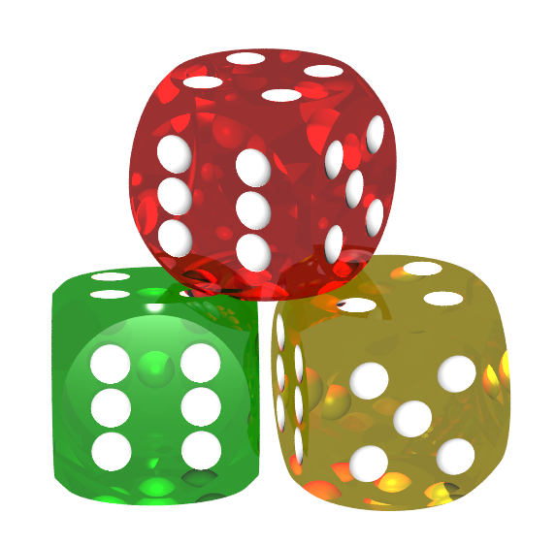

Extension:

Outcome Objectives:
NS10. Apply mental mathematics strategies and number properties in order to understand and recall basic addition facts and related subtraction facts to 18. [C, CN, ME, PS, R, V]

Notes:

Use three different coloured dice.

BACK

Split 25 NS11 NS10
*Credit to http://www.playwithyourmath.com/

Problem:

Take the number 25, and break it up into as many pieces as you want.
25 = 10+10+5
25 = 2+23
25 = 1+1+1+1+1+1+1+1+1+1+1+1+1+1+1+1+1+1+1+1+1+1+1+1+1
What is the biggest product you can make if you multiply those pieces together?

Extension:

Will your strategy work for any number?

Outcome Objectives:
NS10. Apply mental mathematics strategies and number properties in order to understand and recall basic addition facts and related subtraction facts to 18. [C, CN, ME, PS, R, V]
NS11. Demonstrate an understanding of multiplication to 5x5 by:
- Representing and explaining multiplication using equal grouping and arrays.
- Creating and solving problems in context that involve multiplication.
- Modeling multiplication using concrete and visual representations, and recording the process symbolically.
- Relating multiplication to repeated addition.
- Relating multiplication to division. [C, CN, PS, R]

Notes:

Visit http://www.playwithyourmath.com/ for more Play With Your Math tasks.

BACK

Sharing Bacon NS13 NS12
*Credit to John Mason – Thinking Mathematically and @BCAMT

Problem:
You are a chef at a summer camp and you are frying 30 identical strips of bacon for breakfast. A counselor comes in to inform you that there are only 18 campers coming in for breakfast and they all love bacon. How are you going to equally share the bacon between the campers?
What is the minimum number of cuts necessary? How do you know?
What is the minimum number of pieces? How do you know?

Extension:

What about sharing amongst 17 campers? 16 campers? N campers?

Outcome Objectives:
NS13. Demonstrate an understanding of fractions by:
- Explaining that a fraction represents a part of a whole
- Describing situations in which fractions are used
- Comparing fractions of the same whole that have life denominators [C, CN, ME, R, V]
NS12. Demonstrate an understanding of division (limited to division related to multiplication facts up to 5x5) by: representing and explaining division using equal sharing and equal grouping. Creating and solving problems in context that involve equal sharing and equal grouping. Modelling equal sharing and equal grouping using concrete and visual representations, and recording the process symbolically. Relating division to repeated subtraction. Relating division to multiplication. [C, CN, PS, R]

Notes:
Manipulatives, bacon?

BACK

A Piece of Cake NS13
*Credit to Problem Solving in Mathematics Grade 4

Problem:
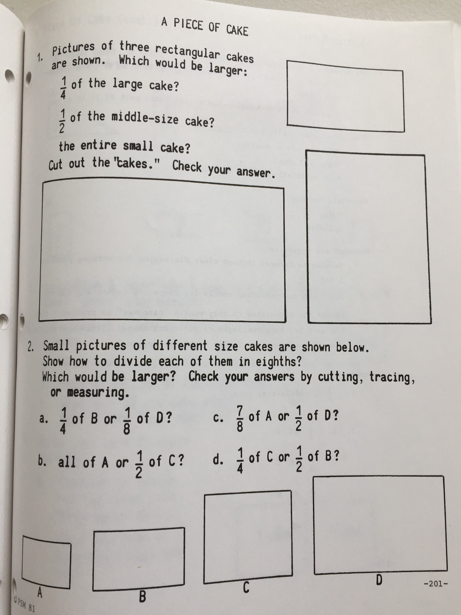

Extension:

Outcome Objectives:
NS13. Demonstrate an understanding of fractions by:
- Explaining that a fraction represents a part of a whole
- Describing situations in which fractions are used
- Comparing fractions of the same whole that have life denominators [C, CN, ME, R, V]

Notes:

BACK

Pizza Peril NS13
*Credit to Perfectly Perilous Math by Sean Connoly
Problem:
It’s your first day of work at Catwalk magazine, a dream come true. You’re starting out as a lowly editorial assistant, but if you’re patient and enthusiastic, the maybe one day you will be flying off to Milan and Paris to check out the latest collections.
But that’s still a daydream. For now, you’re the assistant to the glamorous Catwalk editor, Corey DiFerro - one of the toughest people in the business. People say that she chews up designers, photographers and receptionists - and probably editorial assistants - and spits them out. And you never did find out why the last editorial assistant at Catwalk lasted only one day.
You’re outside the main editorial office when the door opens and someone calls to you, “Ms. DiFerro wants you - now!”
Inside, there is a group huddled around the main table. You recognize fashion designers, supermodels, two pop stars, photographers...and Corey DiFerro, looking you straight in the eye.
“Right. Do we have your attention? We are off to a photo shoot in half an hour and we need some lunch first. Pizza - it’s quick. DaNoi down on seventh avenue doesn't deliver, so I want you to go out and get some for us. Plain cheese only. Now, how hungry is everyone? I’ll call your name and you tell my assistant how much you want.
“Scala twins?”
“One slice each.”
“Art department?”
“Two pizzas.”
“Gino?”
“Half a pizza.”
“Copy editors?”
“We’ll share one pizza.”
“Arturo?”
“Three slices.”
“Steve, our faithful driver?”
“One - one pizza that is!”
“And I’ll have one slice.” said Ms. DiFerro. She hands you are all of the bills and sends you off saying, “They only take cash. Don’t take too long.”
On the elevator down, you count the cash - $90 exactly. Will that be enough? You don’t have any cash of your own in case you run short, and anyway you don't have time to stop for more money.
At Da Noi you’re standing on tiptoes to see over other customers. Each pizza is cut into 12 slices - no exception. The person ahead of you has just paid $36 for two pizzas.
It’s your turn now! Will you have enough money and will you have a job tomorrow?

Extension:

Outcome Objectives:
NS13: Demonstrate an understanding of fractions by:
- Explaining that a fraction represents a part of a whole
- Describing situations in which fractions are used
- Comparing fractions of the same whole that have life denominators [C, CN, ME, R, V]

Notes: BACK

Fraction Talks - Design Tasks NS13
*Credit to Nat Banting and his blog http://musingmathematically.blogspot.ca/2015/06/fraction-talks.html
Problem:
Using only three colours of square tiles can you
build a shape where...

- at least 1/2 is red
- at least 1/4 is blue
- no more than 1/6 is yellow
__________
- at least 1/4 is red
- at least 1/12 is blue
- the number of yellow squares are more than double than the number of red squares
__________
- more than 1/2 is red
- exactly half the number of red squares are blue
- the remaining is yellow

How do you know? How can you prove it? Is there another way?
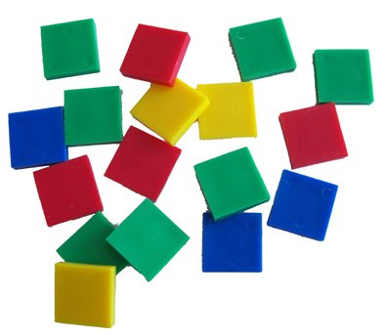

Extension:

If you use a total of 100 squares, how many ways can you meet all requirements?
Can you make your own Design Task?

Notes:
Visit www.fractiontalks.com and https://drive.google.com/file/d/0B9hruAPIgvU5ZlFfMDJvUU5udzA/view to learn more about Design Tasks and Fraction Talks

BACK

Patterns and Relations

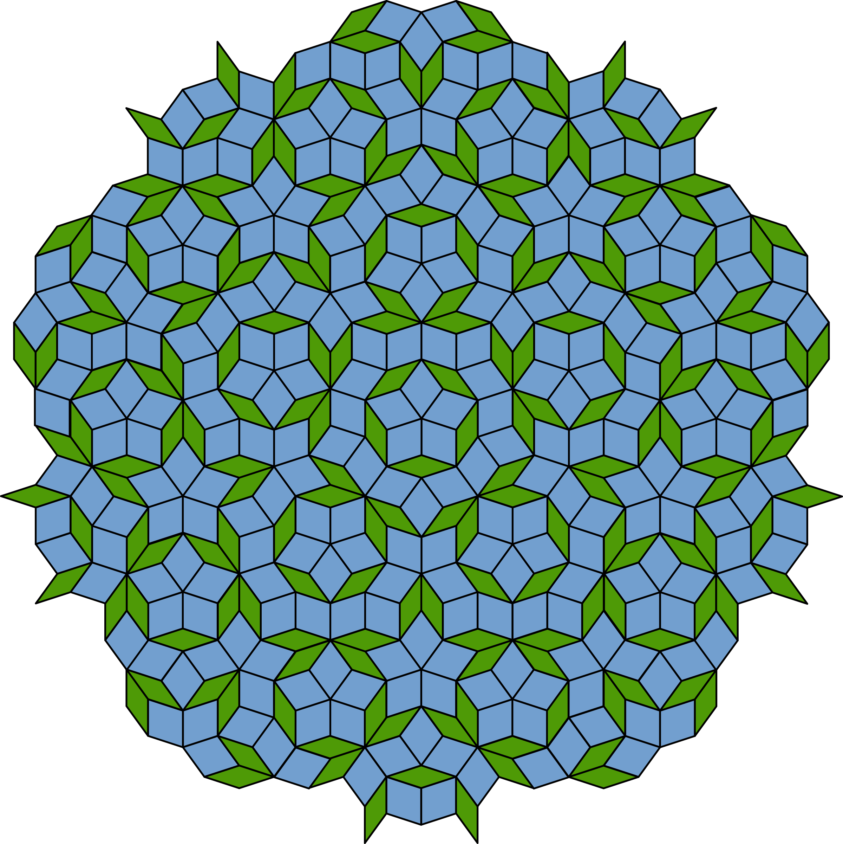

Climbing PR1
*Credit to Problem Solving in Mathematics, R.I.C. Publications

Problem:

Cathy Caterpillar wants to climb to the top of an 8-metre high tree. Each day she climbs forward 3 metres, but slips back 1 metre overnight. How long will it take her to reach the top of the tree?
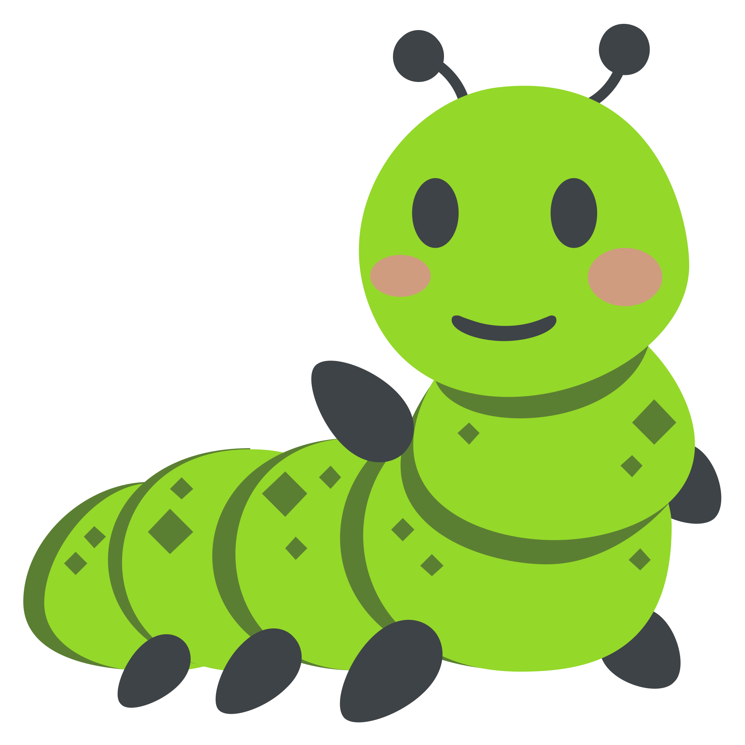
Problem:

Suzy Snail is climbing a steep 16-metre high rock wall. Each day she climbs forward 5 metres but slips back 2 metres overnight. How long will it take her to get to the top of the rock wall?

Problem:

A well is 10 feet deep. Frank the Frog climbs up 5 feet during the day but falls back down 4 feet during the night. Assuming that the frog starts at the bottom of the well, on which day does he get to the top?

Problem:

What if Inky Inchworm is climbing out of a glass that is 13 inches high and can climb 1 ½ inches in an hour but slides and falls back ¼ inch during the hour it rests? How long will it take the snail to climb to the top of the jar?

Extension:

Investigate different numbers, look for patterns, extend a pattern.
Can you make your own Climbing Problem?

Notes:

BACK

Tile Problem PR1 PR2
*Credit to Jo Boaler Stanford University and Carlos Cabana

Problem:

Facilitator: Make sure your group reads all the way through this card together before you begin. “Who wants to read? Does everyone get what to do?” Keep your group together. Make sure everyone’s ideas are heard. “Did anyone see it a different way? Are we ready to move on?”

Recorder/Reporter: Get your group started in organizing a poster with all your results. Your poster needs to show everyone’s ideas, be well-organized, and use color, arrows, and other math tools to communicate your mathematics, reasons, and connections. “How do we want to show that idea?”

Resource Manager: Get materials for your team. You are the only one who can ask the teacher any team questions. When your team is done, call the teacher over to debrief the mathematics (based on your poster).

Team Captain: Remind your team to find reasons for each mathematical statement and search for connections. Be ready to join the teacher for a huddle.

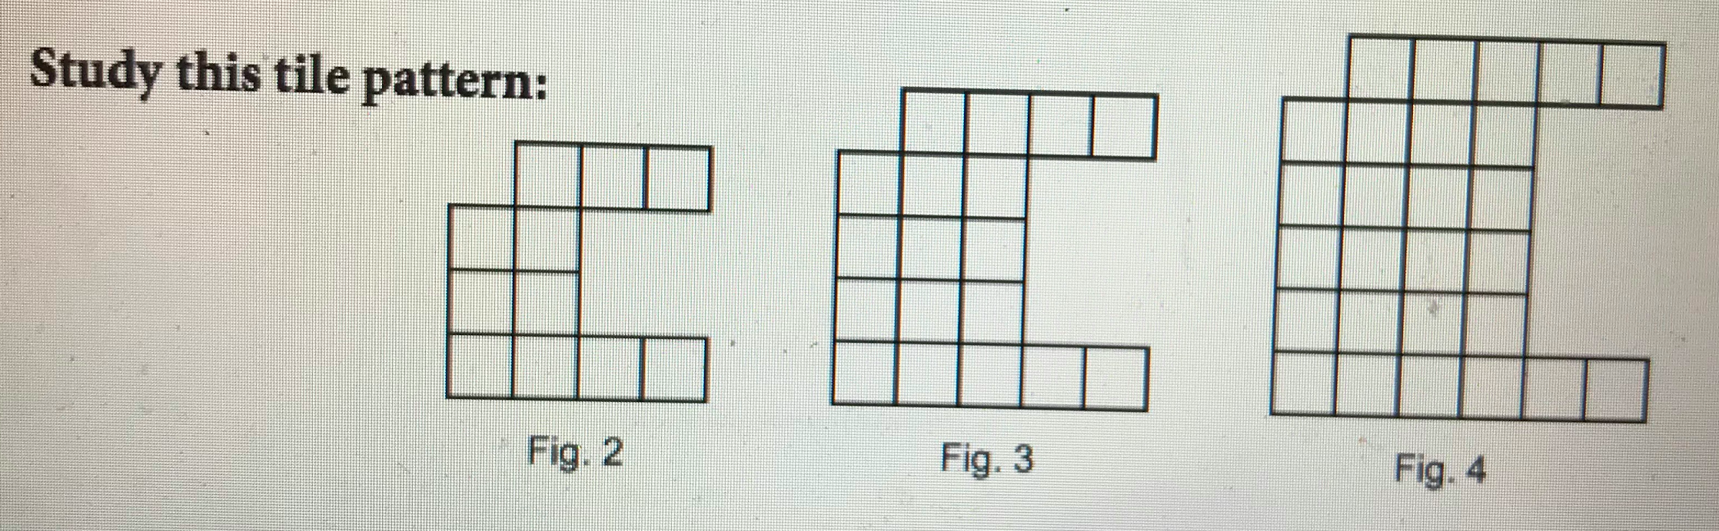

1. What would figure 100 look like?
2. Imagine you could continue your pattern backwards. How many tiles would there be in Fig. -1? (That’s Figure negative one, whatever that means)

Extension:

Creating a poster: Your poster should show, explain, justify and connect your ideas about this task!

Outcome Objectives:
PRP1. Demonstrate an understanding of increasing patterns by:
• describing • extending • comparing • creating
numerical (numbers to 1000) and non-numerical patterns using manipulatives, diagrams, sounds and actions.

PRP2. Demonstrate an understanding of decreasing patterns by:
• describing • extending • comparing • creating
numerical (numbers to 1000) and non-numerical patterns using manipulatives, diagrams, sounds and actions.

Notes:

BACK

Cubes Tower PR1
*Credit to Fawn Nguyen

Problem:
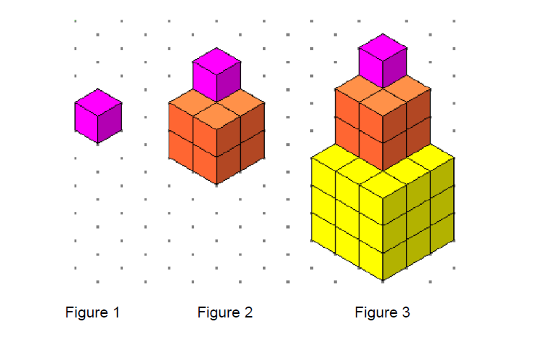
What do you notice? What do you wonder?

Extension:

Sketch what figure 4 might look like.
What would be an expression for this pattern?

Outcome Objectives:
PRP1. Demonstrate an understanding of increasing patterns by:
• describing • extending • comparing • creating
numerical (numbers to 1000) and non-numerical patterns using manipulatives, diagrams, sounds and actions.

Notes:

BACK

Pile of Fruit PR1
*Credit to http://www.problempictures.co.uk/examples/op09.htm

Problem:

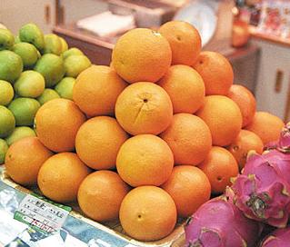

What do you notice?
What do you wonder?

Extension:
What size of pile could you build with a box of 200 oranges?

Outcome Objectives:
PRP1. Demonstrate an understanding of increasing patterns by:
• describing • extending • comparing • creating
numerical (numbers to 1000) and non-numerical patterns using manipulatives, diagrams, sounds and actions.

Notes:

BACK

Visual Patterns - Froot Loops PR1
*Credit to Fawn Nguyen and http://www.visualpatterns.org/

Problem:
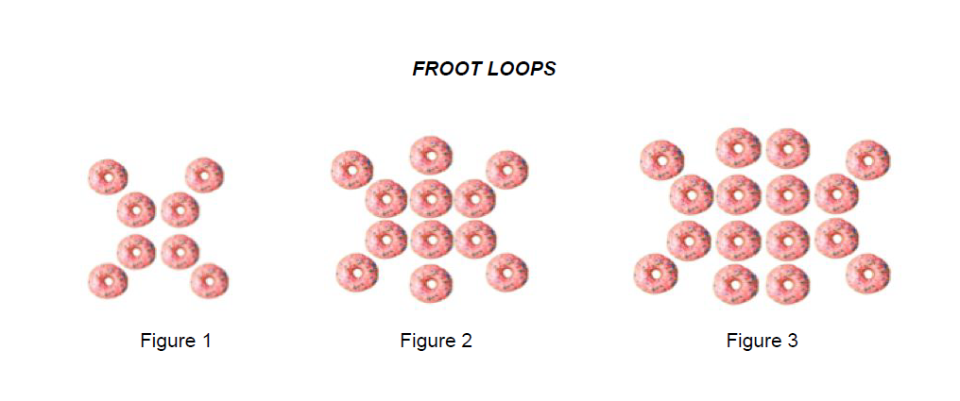

What do you notice? What do you wonder?

Extension:

What would another figure look like?
Which figure has 324 fruit loops?

Outcome Objectives:
PRP1. Demonstrate an understanding of increasing patterns by:
• describing • extending • comparing • creating
numerical (numbers to 1000) and non-numerical patterns using manipulatives, diagrams, sounds and actions.

Notes:

Visit: http://www.visualpatterns.org/ for more visual patterns!

BACK

Points on a Circle PR1
*Credit to Global Math Project
Problem:

How many regions do you get if you connect points on a circle?
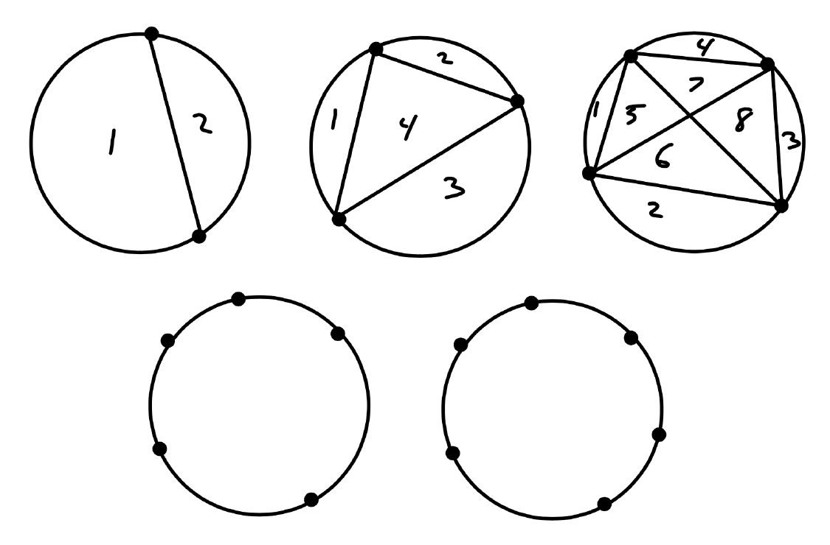

Extension:

Outcome Objectives:
PRP1. Demonstrate an understanding of increasing patterns by:
• describing • extending • comparing • creating
numerical (numbers to 1000) and non-numerical patterns using manipulatives, diagrams, sounds and actions.

Notes:

Find the maximum number, so avoid too much symmetry!

BACK

The Twelve Days of Christmas PR1
*Credit to Murray Bourne

Problem: How many gifts are given by the twelfth day of Christmas?

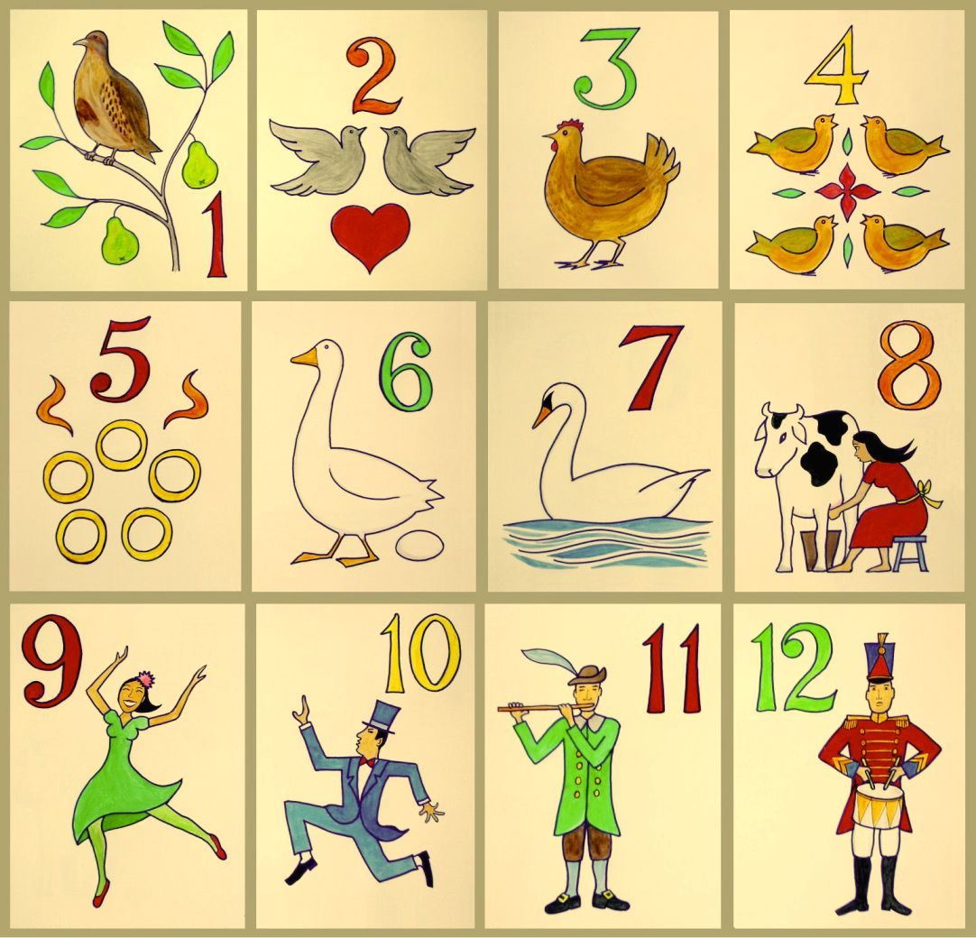

Extension:

What if there were 13 days? 20 days? 100 days?

Outcome Objectives:
PRP1. Demonstrate an understanding of increasing patterns by:
• describing • extending • comparing • creating
numerical (numbers to 1000) and non-numerical patterns using manipulatives, diagrams, sounds and actions.

Extension:

Notes:

https://www.intmath.com/blog/mathematics/the-twelve-days-of-christmas-how-many-presents-1686

BACK

Triangular and Square Numbers PR1
*Credit to Rina Zazkis

Problem:

There are several interesting connections between these 2 sets of numbers, and also among the numbers in each set. Your task is to identify several connections and explain why they exist.

Extension:

Outcome Objectives:
PRP1. Demonstrate an understanding of increasing patterns by:
• describing • extending • comparing • creating
numerical (numbers to 1000) and non-numerical patterns using manipulatives, diagrams, sounds and actions.

Notes:

BACK

Shapes and Space- Measurement

Garden Fence SSM5
*Credit to Unknown

Problem: You are building a rectangular garden. You have 40 meters of fencing. How many different ways can you build a rectangular garden with this amount of fencing?
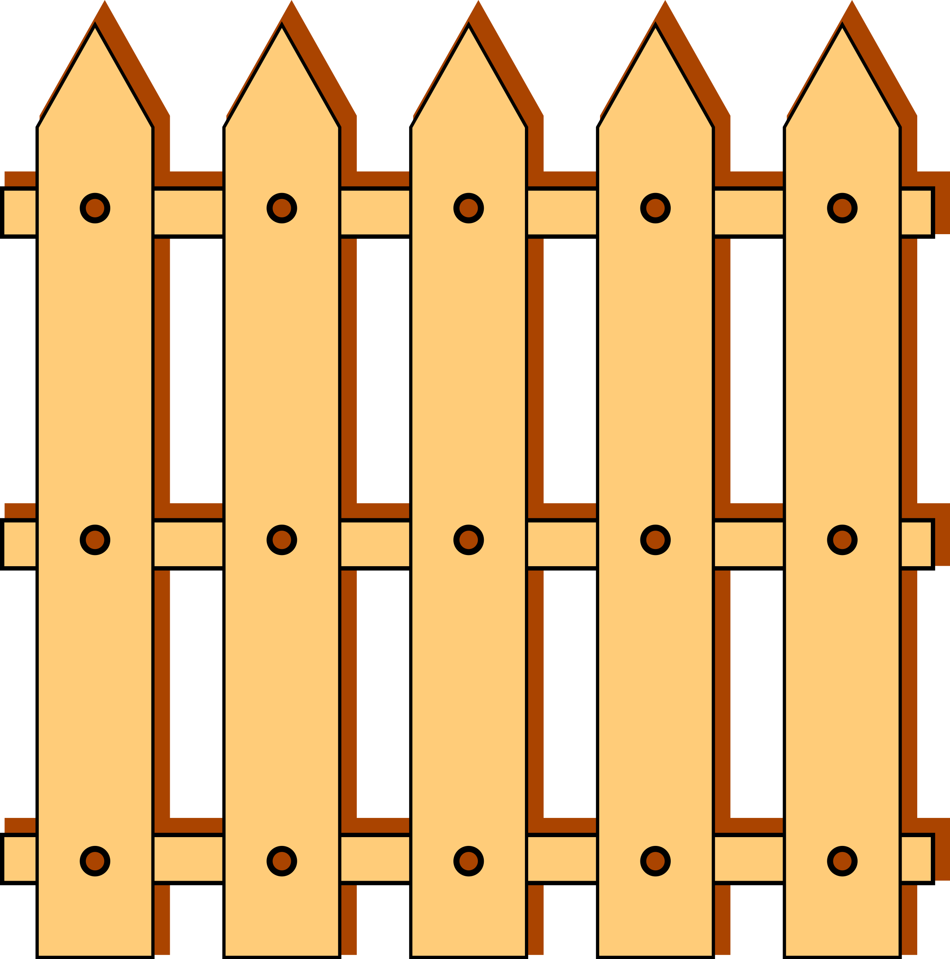

Extension: An easy way to extend this problem is to increase the number of meters the students have to build the fence with, ask them if the number of ways increased from the previous number.

You could also change the shape of the garden and have students see what that does to the number of ways they can build the fence.

Outcome Objectives:
SSM5: Demonstrate an understanding of perimeter of regular and irregular shapes by:
- Estimating perimeter, using referents for cm orm
- Measuring and recording perimeter (cm, m)
- Constructing different shapes for a given perimeter (cm, m) to demonstrate that many shapes are possible for a perimeter.

Material Suggestions:
- Having some man manipulatives to represent 1-meter pieces of fencing can help students find more ways to solve the problem.
  - Snap Cubes, Base Ten Blocks

Notes:

BACK

Pentominoes SSM5
*Credit to Peter Liljedahl and Wikipedia

Problem:

A pentomino is a plane geometric figure formed by joining five equal squares edge to edge. Using snap cubes, how many different 3-D “pentominoes” can you make? (The pentomino obtained by reflecting or rotating a pentomino does not count as a different pentomino). Does each shape created have the same perimeter and area? How do you know?

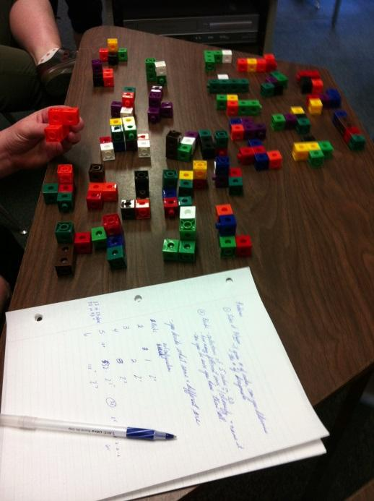

Extension:

Can you tile a rectangular box with each pentomino? Can you tile a rectangular box with a mix of pentominoes? Can you use all of the pentominoes once to fill a rectangular box?

Outcome Objectives:
SSM5: Demonstrate an understanding of perimeter of regular and irregular shapes by:
- Estimating perimeter, using referents for cm orm
- Measuring and recording perimeter (cm, m)
- Constructing different shapes for a given perimeter (cm, m) to demonstrate that many shapes are possible for a perimeter.

Material Suggestions:
- Snap cubes
- Masking Tape to make a rectangle
- blank 6x10, 5x12, 4x15, and 3x20 grids for building rectangles

Sample Solutions:
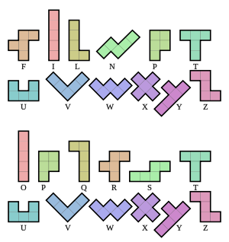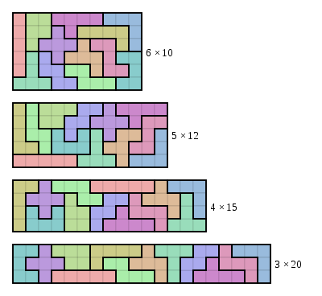

Notes:
More information, challenges, sample solutions:
http://www.mathematische-basteleien.de/pentominos.htm
BACK

9 Square Tiles SSM5
*Credit to Mathematical Reasoning for Elementary School Teachers (6th Edition) by Chegg

Problem: Nine square tiles are laid out on a table so that they make a solid pattern. Each tile must touch at least one other tile along an entire edge. The squares all have side lengths of 1.

Ex.

What are the possible perimeters of the figures that can be formed?

Extension: What is the figure that has the smallest perimeter?

Outcome Objectives:
SSM5: Demonstrate an understanding of perimeter of regular and irregular shapes by:
- Estimating perimeter, using referents for cm orm
- Measuring and recording perimeter (cm, m)
- Constructing different shapes for a given perimeter (cm, m) to demonstrate that many shapes are possible for a perimeter.
Material Suggestions:
- Square tiles or snap cubes
BACK

News Years Resolution SSM1 NS9 NS11 NS12
*Credit to Mathematical Challenges for Able Pupils

Problem: At what time of day will be 2000 seconds after the start of 2019?

Extension:
- 2,000 hours?
- 20,000 seconds?
- How many hours in a year?

Outcome Objectives:
SSM1: Relate the passage of time to common activities, using nonstandard and standard units (minutes, hours, days, weeks, months, years).
NS9: Demonstrate an understanding of addition and subtraction of numbers with answers to 1000 (limited to 1-, 2-, and 3-digit numerals), concretely, pictorially and symbolically, by: using personal strategies for adding and subtracting with and without the support of manipulatives. Creating and solving problems in context that involve addition and subtraction of numbers. [C, CN, ME, PS, R, V]
NS11: Demonstrate an understanding of multiplication to 5x5 by: representing and explaining multiplication using equal grouping and arrays. Creating and solving problems in context that involve multiplication. Modelling multiplication using concrete and visual representations, and recording the process symbolically. Relating multiplication to repeated addition. Relating multiplication to division. [C, CN, PS, R]
NS12: Demonstrate an understanding of division (limited to division related to multiplication facts up to 5x5) by: representing and explaining division using equal sharing and equal grouping. Creating and solving problems in context that involve equal sharing and equal grouping. Modelling equal sharing and equal grouping using concrete and visual representations, and recording the process symbolically. Relating division to repeated subtraction. Relating division to multiplication. [C, CN, PS, R]

Material Suggestions:
- Calculators

BACK

City Planner (Project) SSM3
*Credit to
Problem: Your hometown is growing quickly, and we need your help to plan the new part of the town. Using a large piece of bristol board we need your classes help to submit a design for the addition onto our town. Your job is to design some of the streets that will be added to make our town larger. The most important thing we need to know is how long each of the streets will be, so you need to make sure that you are using a ruler when drawing your roads and that you are taking your time to make sure your streets are as neat as possible.

We have given you a list of things that your design must have in order to be submitted:

- You need to give your part of town its own name, that name needs to be underlined at the top of your page in the exemplar.
- A large rectangular area in the middle of the bristol board where you will design your addition to the city.
- You must have at least two roads going up and down. As well as 2 roads running sideways. This means at least 4 roads in total.
- Each of your roads must have its own name, as well as the length of the road written in CMs.
- At the bottom of the page you need to record the length of each road and then find the total of all of your roads combined.

Extension:

- Suggest some buildings that could go along your roads. Where should we put a new: park, school, hockey arena, mall, grocery store, houses, and other buildings you want to see in your town.
- If you really want your design to stand out add some colour, colour the roads grey, make grassy areas green. ETC.

Outcome Objectives:
SSM3: Demonstrate an understanding of measuring length (cm, m) by:
- Selecting and justifying referents for the units cm and m.
- Modelling and describing the relationship between the units cm and m.
- Estimating length, using referents.
- Measuring and recording length, width and height.

Material Suggestions:
- White bristol board for students
- Rulers

Notes: This is a class project as opposed to a problem, but it gets students engaged in the learning and can have a big impact on student understanding.

It is helpful to model some strategies for drawing the map so students are able to create neat pieces of work. Tell students to place the ruler where they want the road, and trace a line on either side of the ruler to make sure you get nice even and straight lines, this will give all streets the same width.

Creating an exemplar is helpful for students. Timing: approx. 1 week
BACK

Passage of Time Activities SSM1
*Credit to Unknown
Problem: Below are some examples of activities that you can do in your classroom to get kids thinking about passage of time.

1. Have students put their head on their desk with eyes closed. Ask students to raise their hand when they think it has been a minute. Video the class and show them and discuss after.

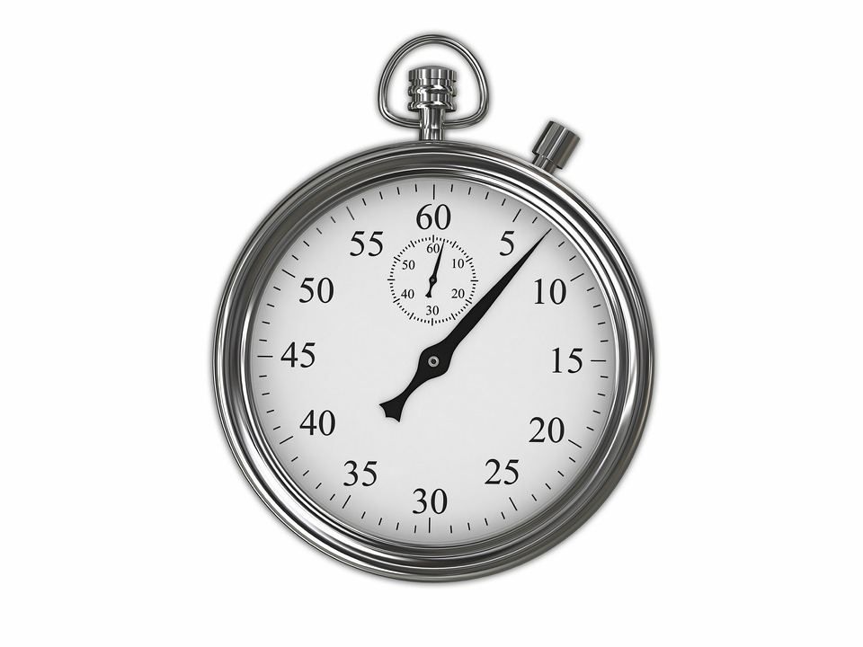
2. Have students estimate then time each other for how long it takes them to:
- Write their name 10 times
- 20 jumping jacks, etc.

3. How long would it take you to get to the moon?

4. How much time do you spend sleeping in a day?

5. How much time do you spend in a vehicle?

6. How long will it take to fill the jug?

Extension: Have the kids create their own passage of time questions.

Outcome Objectives:
SSM1: Relate the passage of time to common activities, using nonstandard and standard units (minutes, hours, days, weeks, months, years).

Material Suggestions:
- Stop watch

BACK

Approaching Midnight SSM1
*Credit to https://wild.maths.org/approaching-midnight

Problem: It’s 6:00AM. With a partner, take turns adding 15 min, 30 min, 45 min or 60 min to the clock. The first player to reach 12:00AM wins.

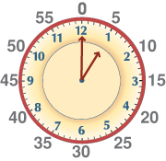

Extension: Is there a winning strategy? What if the player who reaches 12:00 loses.

Outcome Objectives:
SSM1: Relate the passage of time to common activities, using nonstandard and standard units (minutes, hours, days, weeks, months, years).

Material Suggestions:
- Teaching clocks for students t move the hands forward to the time they have chosen

Notes: This is more of an activity and game, it works well as an early finisher task for kids in the class.

BACK

Ping Pong Balls SS4
*Credit to Puzzle Box Volume 1 Peter and Serhiy Grabarchuk

Problem:

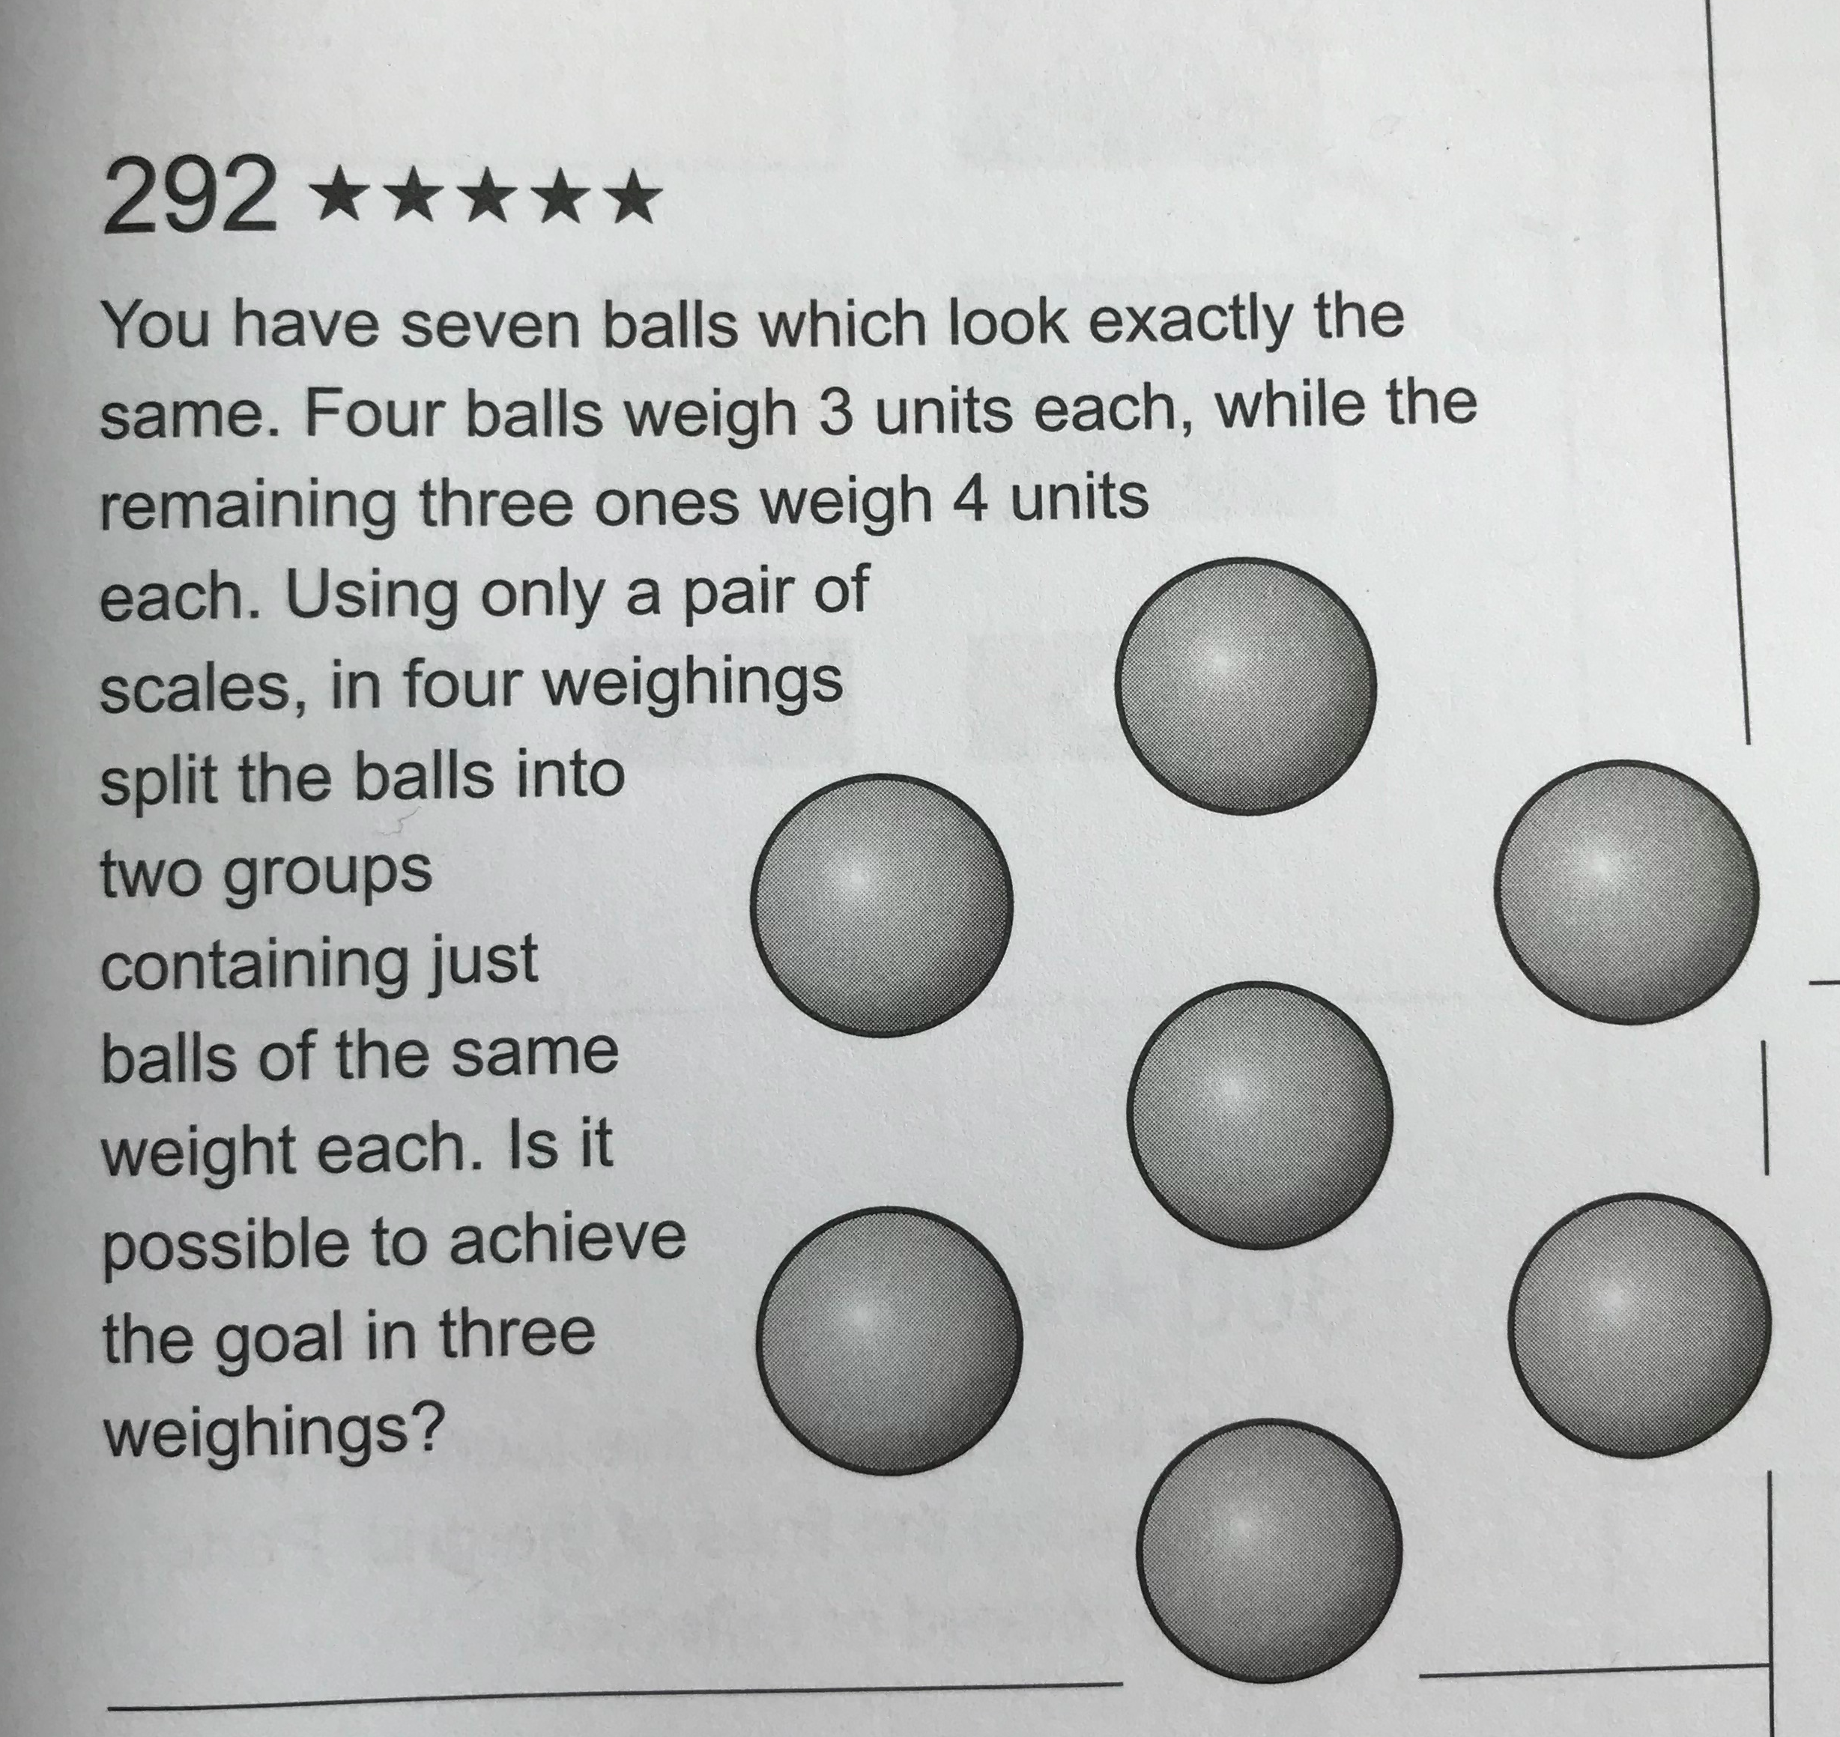

Outcome Objectives:
SSM4 Demonstrate an understanding of measuring mass (g, kg) by:
• selecting and justifying referents for the units g and kg
• modelling and describing the relationship between the units g and kg
• estimating mass, using referents
• measuring and recording mass.

Material Suggestions:
- 4 lighter and 3 heavier balls (or other objects that look exactly the same)
- Scales

Extension:

Notes:

BACK

Shapes and Space-

2D and 3D Shapes

Ship Shape SS6
*Credit to Mindset Mathematics Grade 5 Jo Boaler, Jen Munson and Cathy Williams

Problem:

Ship Shape is played in pairs. Each student will need two copies of Ship Shape Game Sheet 1 and a file folder. Partners will need to position themselves across from one another with file folders standing up to keep their game sheets private.

- Each partner gets two sheets, one to record their hunt for their partner’s shapes and the other to hide their own shapes. Partners each use a file folder to separate their planes from each others
- Before play begins, each partner must hide all the shapes shown on the right side of the game sheet on their own coordinate plane by drawing.Players may rotate the shapes when they place them, but not change their size or shape. Players mark the shapes clearly on the plane.
- Partners then begin play by taking turns guessing points on the coordinate plane, with the goal of finding a vertex of one of the shapes. Players should use the (x, y) convention in naming points.
- If a vertex is found, the partner says, “Nailed it!”
- If a point on a side or inside the shape is found, the partner says, “Ping!”
- If the point is outside of any shapes, the partner says, “Missed!”
- When all the vertices of a shape have been found, the partner says, “You found my triangle (square, trapezoid, and so on).”
- Players should develop ways to record the results of their guesses on their sheets.
- The first person to find all their partner’s shapes wins.

Students may play multiple rounds, and will need new game sheets for each round. After students have played with the game board with four shapes, they may want to try the board with six shapes.

Extension:
Partners can make their own shape set using the blank Make Your Own Ship Shape Game Sheet. Ask students, What kind of shapes can you make that will make it more challenging or interesting to play? Students may want to create and test a variety of ame sheets to develop an interesting or challenging game that others could play. You may want to photocopy students’ final designs so that can switch other groups and play.

Outcome Objectives:
6. Describe 3-D objects according to the shape of the faces and the number of edges and vertices. [C, CN, PS, R, V]

Material Suggestions:

- Ship Shape Game Sheets 1 and 2
- Make Your Own Ship Shape Game Sheet

Notes:

BACK

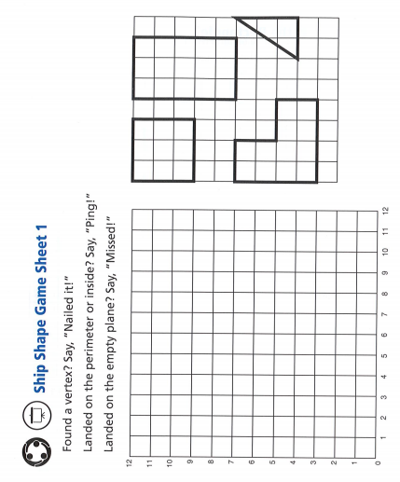
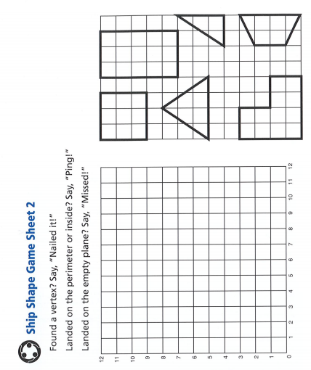
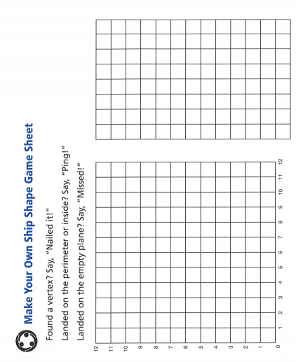
BACK

Folding Cubes SS6
*Credit to Puzzle Box Vol. 1 Peter and Serhiy Grabarchuk

Problem:

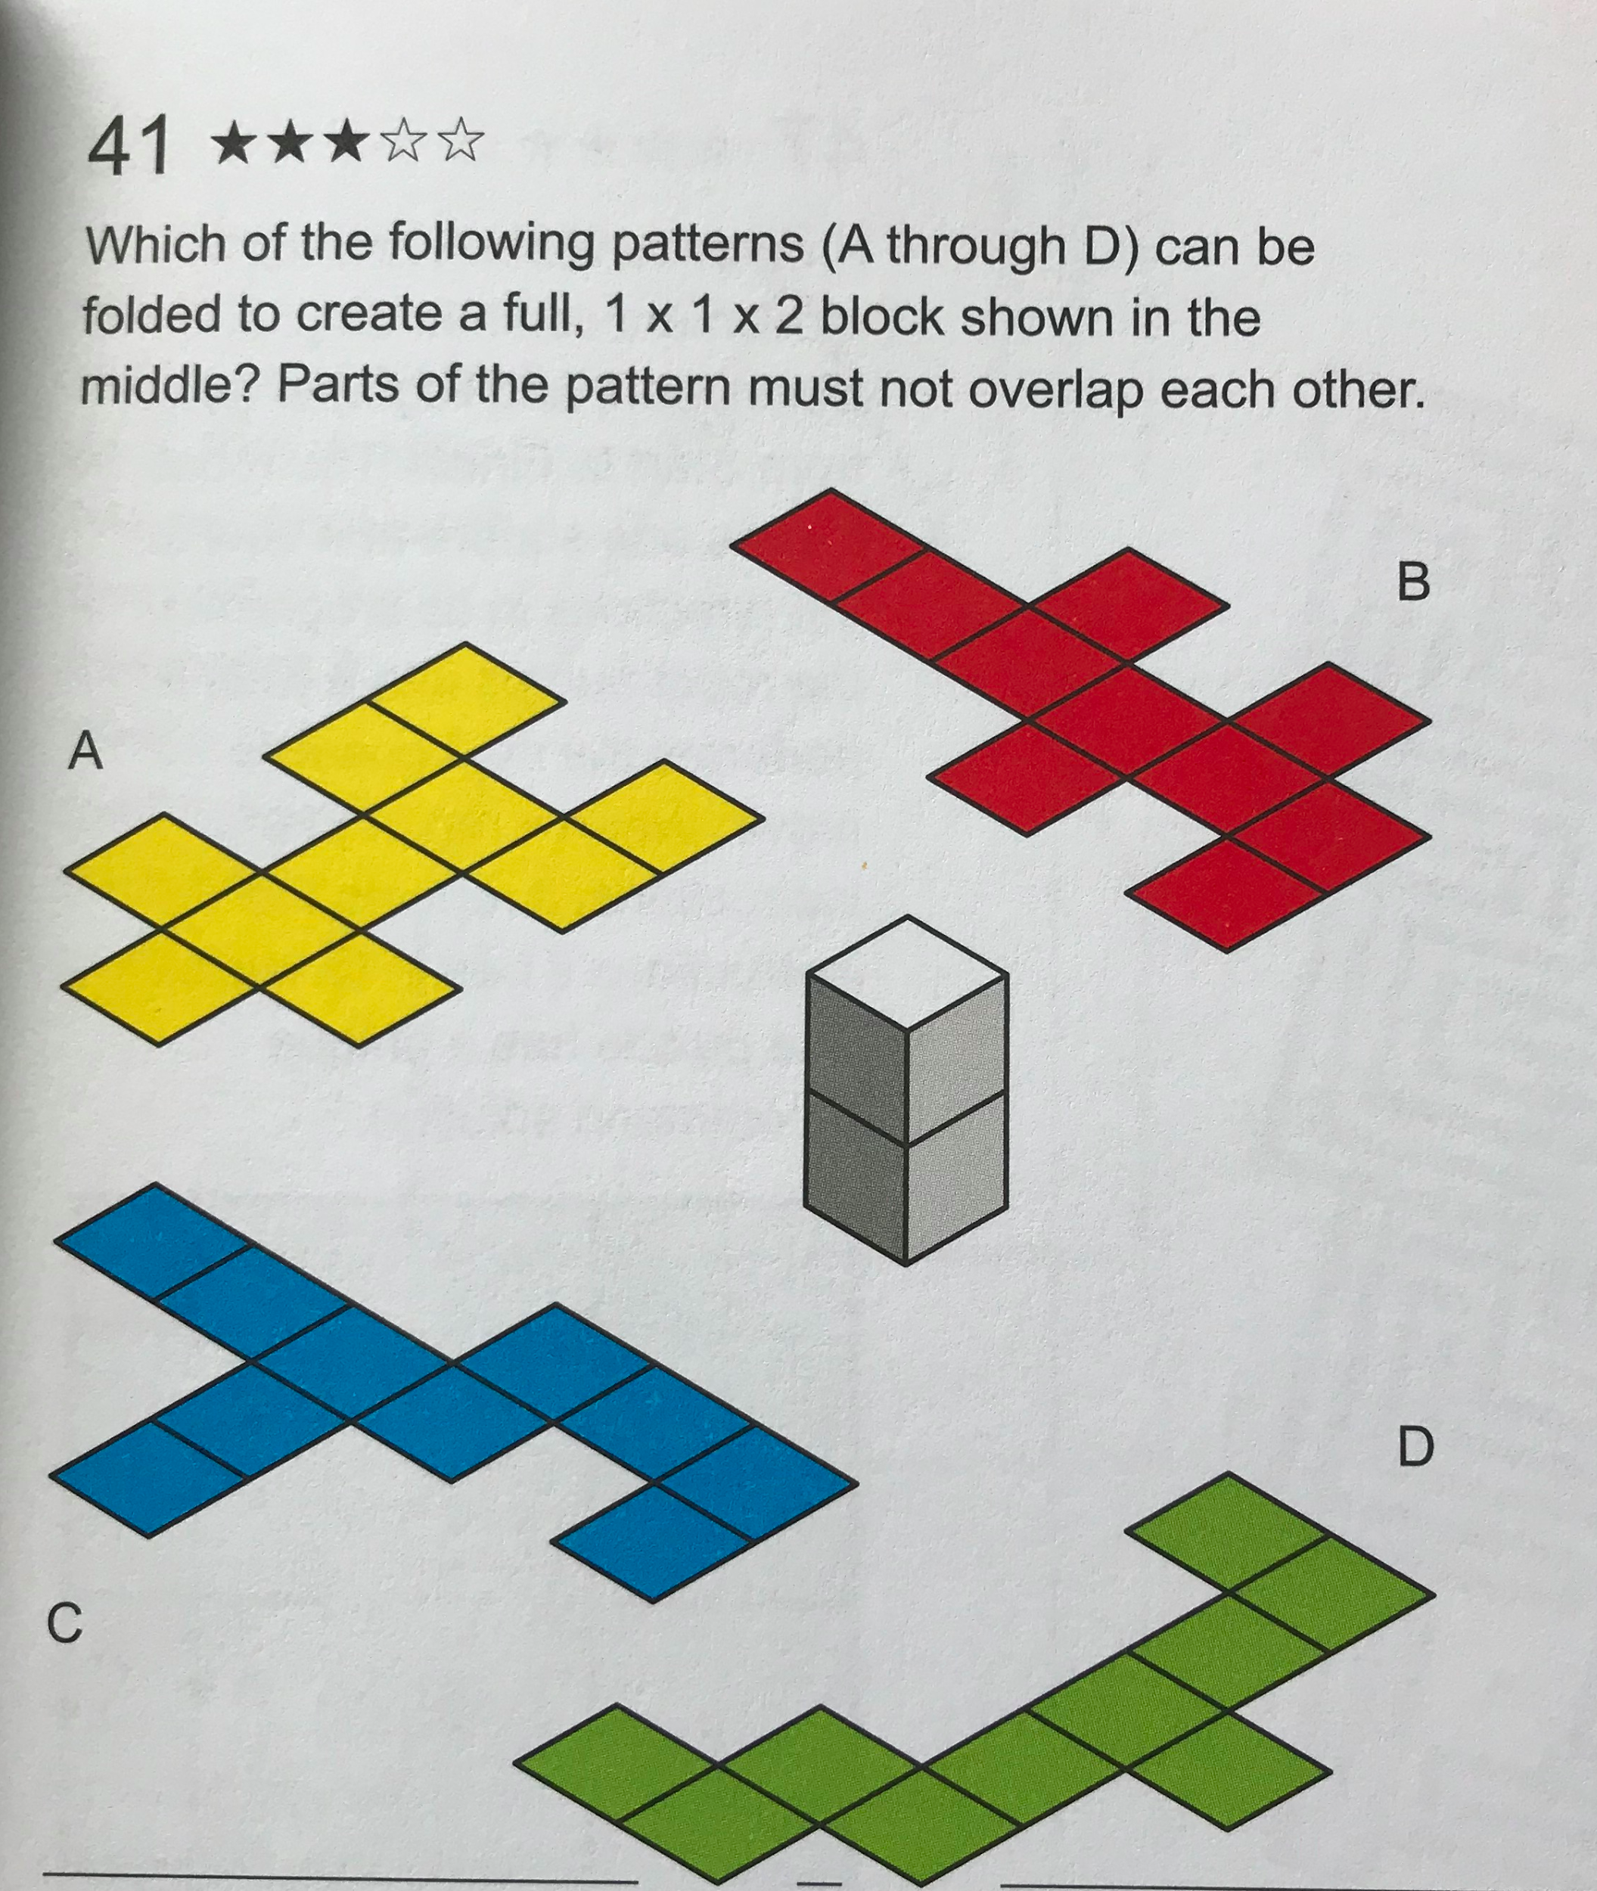

Outcome Objectives:
6. Describe 3-D objects according to the shape of the faces and the number of edges and vertices. [C, CN, PS, R, V]
Material Suggestions:
Provide paper copies of the patterns to fold for students who need it

Sample Solutions:
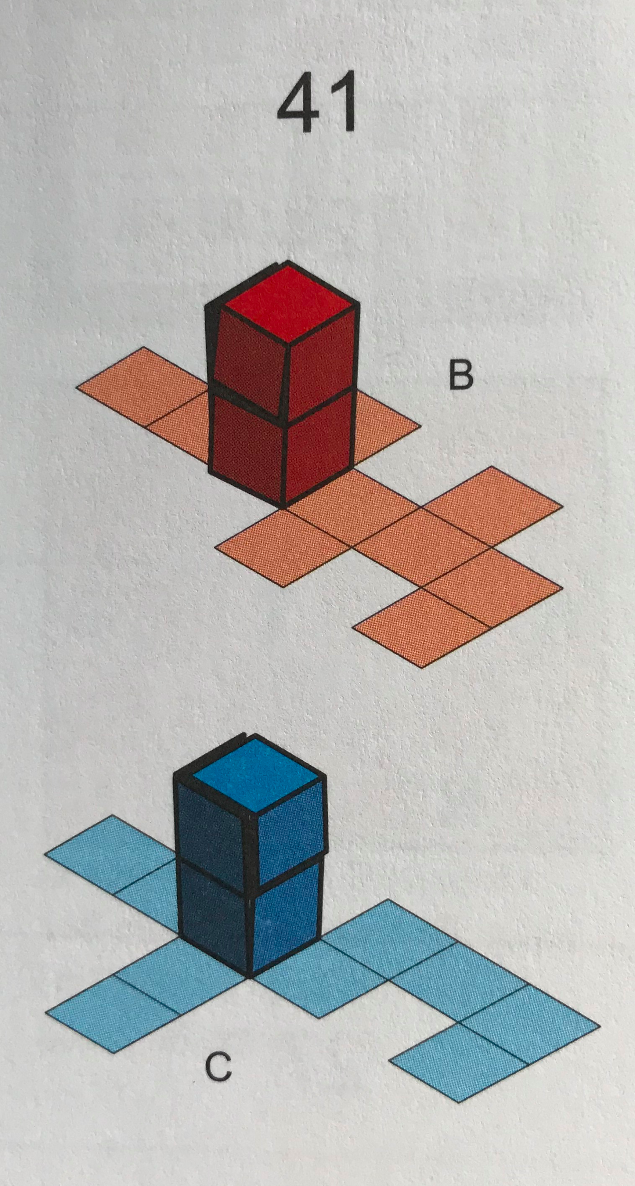

Notes:

BACK

2D Views SS6
*Credit to Puzzle Box Vol. 1 Peter and Serhiy Grabarchuk

Problem:

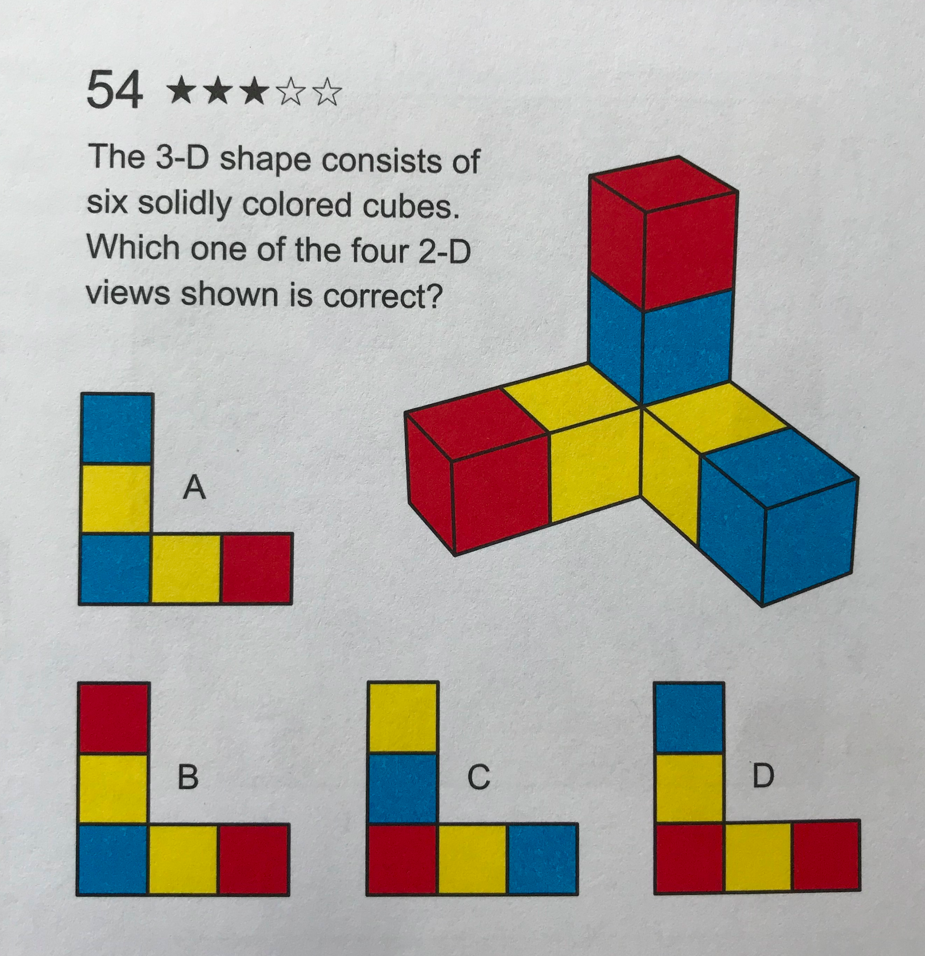

Outcome Objectives:
Describe 3-D objects according to the shape of the faces and the number of edges and vertices. [C, CN, PS, R, V]

Material Suggestions:
Snap Cubes

Sample Solutions:
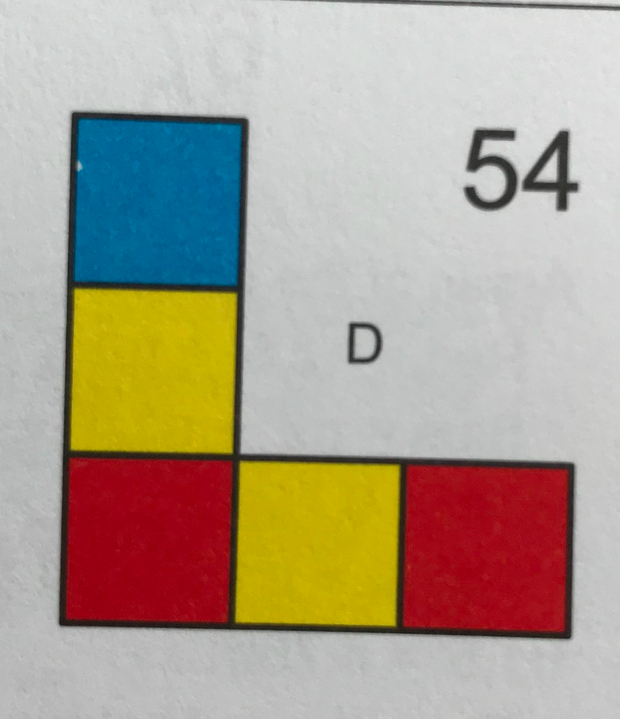

Notes:

BACK

Which One Doesn’t Belong? SS7
*Credit to http://wodb.ca/

Problem:

Which one doesn’t belong?

Extension:

How do you know?
Can you make your own?

Outcome Objectives:
7. Sort regular and irregular polygons, including: • triangles • quadrilaterals • pentagons • hexagons • octagons according to the number of sides. [C, CN, R, V]

Notes: Visit http://wodb.ca/ for more puzzles! BACK

How Many Triangles? SS7
*Credit to Jim Matthews @Sienna College

Problem:
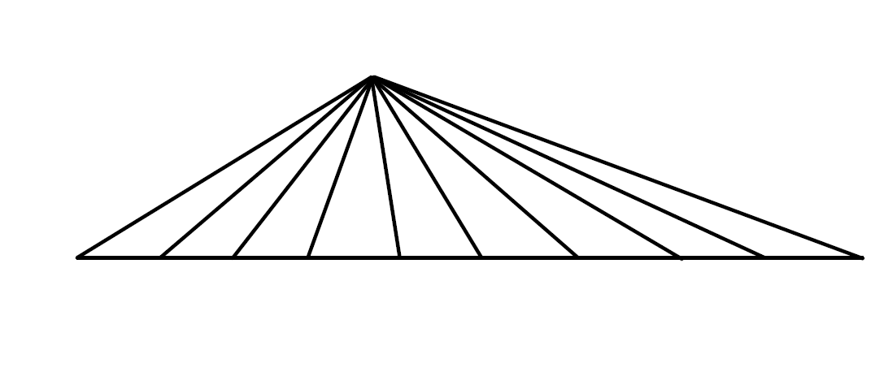

Extension:

Outcome Objectives:
7. Sort regular and irregular polygons, including: • triangles • quadrilaterals • pentagons • hexagons • octagons according to the number of sides. [C, CN, R, V]

Notes:

BACK

Statistics and Probability

Horse Races SP1 SP2
*Credit to https://www.tes.com/teaching-resource/probability-horse-racing-game-6338302

Problem:

Line up 12 horses along the 12x8 grid game board and label each horse 1-12. Each player takes turns rolling the two dice. If the number of the horse is rolled, that horse can move forward one space. The horse that makes it to the other side of the board first wins.

1
3
4
5
6
7
8
9
10
11
12
2

Extension:

Record the results of the race(s) and organize the data.

Construct, label and interpret a bar graph to organize the data.

Which horse usually wins? Why do you think that is?

Why didn’t the #1 horse move?

How can you change the game board so that it’s fair for all horses?

Outcome Objectives:

SP1. Collect first-hand data and organize it using:
• tally marks • line plots • charts • lists to answer questions.
SP2. Construct, label and interpret bar graphs to solve problems.

Material Suggestions:
- A large 12X8 grid for a game board.
- “Horses” that will be racing.
- Two dice

Extension:

Notes:

BACK

The T-Shirt Order SP1 SP2
*Credit to Alberta Assessment Consortium https://aac.ab.ca/assessment-material/the-t-shirt-order-grade-3/

Problem:
The T-Shirt Order

You and your classmates have just received brand new school t-shirts. Now you’ve decided to raise money so you can get your names printed on the back of your shirts. The cost of printing each name depends on how long the name is. There are 3 different prices:

Number of Letters | Cost
Up to 4 letters | $2
5 or 6 letters | $3
7 or more letters | $5

Your job is to find out how many names fit into each category, and how much it will cost to print all the names on t-shirts.
For this activity:
· Organize the data from the class list using tally marks, a line plot, a chart or a list.
· Use the data to solve a problem.
· Describe your strategy for adding the numbers.

Extension:

- How many names will cost $2? How many will cost $3? How many will cost $5? Use a chart and organize the information to make it easy for someone else to understand.

2. How much will it cost altogether to print all the names on t-shirts? Show and explain your strategy for finding the answer.

Outcome Objectives:

SP1. Collect first-hand data and organize it using:
• tally marks • line plots • charts • lists to answer questions.
SP2. Construct, label and interpret bar graphs to solve problems.

Notes:

BACK

Prize Inside SP1 SP2
*Credit to The Super Source Snap Cubes
Problem:

A cereal company decides to include a free animal sticker inside each box of cereal. There are three different kinds of stickers.

How many boxes of cereal do you think you will have to buy to get a complete set of the three different stickers?

Extension:

What there were 5 different stickers?

Outcome Objectives:

SP1. Collect first-hand data and organize it using:
• tally marks • line plots • charts • lists to answer questions.
SP2. Construct, label and interpret bar graphs to solve problems.

Materials:
- A paper bag
- Snap cubes - one of each colour

Notes:

BACK

Ice Cream Scoop SP1 SP2
*Credit to youcubed.com

Problem:

In shops with lots of ice-cream flavors there are many different flavor combinations, even with only a 2-scoop cone. With 1 ice-cream flavor there is 1 kind of 2-scoop ice cream, but with 2 flavors there are 3 possible combinations (eg vanilla/vanilla, chocolate/chocolate, and vanilla/chocolate).

- Create a poster that represents your group’s thinking.
- Create a graph to display your results.

Extension:

- How many kinds of 2-scoop cones are there with 10 flavors?
- What about “n” flavors?

Outcome Objectives:

SP1. Collect first-hand data and organize it using:
• tally marks • line plots • charts • lists to answer questions.
SP2. Construct, label and interpret bar graphs to solve problems.

Materials:
- Snap cubes - one of each flavor if needed

Notes:
BACK

BACK to the Front Page

